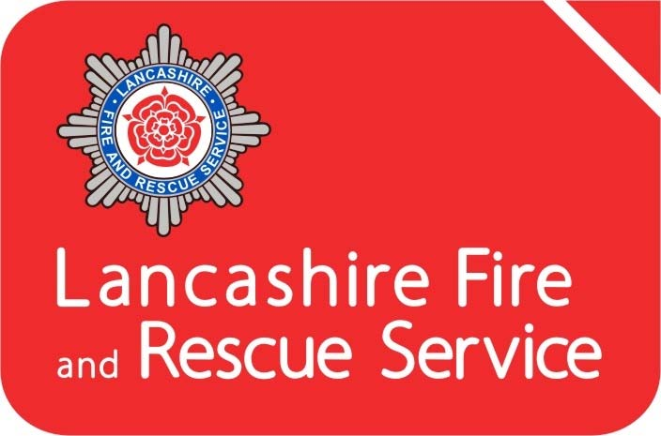

Annual Statement of Assurance 2024-25

Contents
Introduction 3
The County of Lancashire 3
Governance 4
Lancashire Combined Fire Authority 4
Lancashire Fire and Rescue Service (LFRS) 4
Community Risk Management Plan (CRMP) 5
Planning and Performance 6
Consultation 6
Community Risk Management 7
Assurance on Governance 8
Financial Assurance 10
In our opinion, the financial statements: 10
Organisational Assurance 11
HMICFRS Inspection 11
Operational Assurance 12
Prevention and Protection 13
Mutual Aid Agreements 15
National Resilience 15
Business Continuity 15
Safety, Health, and Environment 16
Leadership and Development 18
Assurance Declaration 19

Introduction
The Fire and Rescue National Framework for England (2018) provides overall strategic direction to English Fire and Rescue Authorities (FRA). It sets out the Government’s priorities and objectives and places a requirement on all FRA’s to provide assurance to their communities and to Government on financial, governance and operational matters.
This Statement of Assurance aims to provide the necessary accountability and transparency to the people of Lancashire and evidence that their Fire and Rescue Service continues to deliver under the expectations detailed within both the National Framework and our own Community Risk Management Plan (CRMP).
This statement sits alongside our CRMP, Statement of Accounts, the Annual Governance Statement and the Annual Service Plan and Annual Service Report. It details what measures are in place to assure that the Combined Fire Authority’s performance is efficient, economic, and effective.

The County of Lancashire
Lancashire comprises of 14 districts, 12 of which are within the Lancashire County Council area (Burnley, Chorley, Fylde, Hyndburn, Lancaster, Pendle, Preston, Ribble Valley, Rossendale, South Ribble, West Lancashire, and Wyre) and 2 unitary authorities of Blackpool and Blackburn-with-Darwen. The area is home to a resident population of circa 1.53 million people (Census 2021) and is one of the most populated and urbanised shire counties within Great Britain, with a legacy of historical, industrial heritage.
Lancashire covers just over 3,000 square kilometres including 123 kilometres of coastline stretching from Morecambe Bay in the north of the county, down to the sands of West Lancashire in the south. The County has an extensive motorway network, port facilities, nuclear installations and airports and is home to a diverse demographic, with just over 20% of our population being over retirement age and 10% representing Black Minority Ethnic (BME) communities.
The County is bordered by Cumbria to the north and North Yorkshire, West Yorkshire, Greater Manchester, and Merseyside moving from east to south. The major conurbations are Lancaster, Preston, Burnley, Blackburn, Accrington, Chorley, and the seasonal town of Blackpool which receives around 18 million visitors per year.

Governance

Lancashire Combined Fire Authority
Lancashire Combined Fire Authority (CFA) is made up of 25 elected councillors drawn from Lancashire County Council (19) and the unitary authorities of Blackburn-with-Darwen (3) and Blackpool (3). The CFA is responsible under the Fire and Rescue Services Act 2004 for providing a Fire and Rescue Service in Lancashire. This involves the provision, training and equipping of our staff to undertake firefighting operations, fire safety work, rescue of persons from road traffic collisions and preparing for our response to other emergency situations. The CFA is the body legally responsible for enforcing the Regulatory Reform (Fire Safety) Order 2005 and is a designated Category 1 responder under the Civil Contingencies Act 2004.
The CFA ensures that the work of the Fire and Rescue Service is efficient, effective and provides value for money. To achieve this, they operate under a framework of five full meetings each year which are supplemented by a number of smaller committees focusing upon Planning, Performance, Resources, Audit and Appeals.
Further information on the afore-mentioned committees is accessible via our website at https://cfa.lancsfirerescue.org.uk/

Lancashire Fire and Rescue Service (LFRS)
LFRS is the service provider on behalf of the CFA. We currently operate from 39 locations (with 58 front-line fire engines and a fleet of specialist vehicles), a specialist Urban Search and Rescue unit, Service Headquarters in Fulwood and our Leadership and Development Centre in Euxton, Chorley. LFRS staff deliver an extensive range of prevention, protection, and emergency response services throughout Lancashire.
To deliver these services, we employ circa 900 operational staff in a wide variety of roles using a variety of shift systems; Whole-time, On-Call, Flexible Day Crewed, Day Crewing Plus and Day Duty.
Our Mobilising and Control Centre moved to North West Fire Control (NWFC), Warrington in 2014. We work collaboratively with Cumbria, Greater Manchester and Cheshire Fire and Rescue Services.
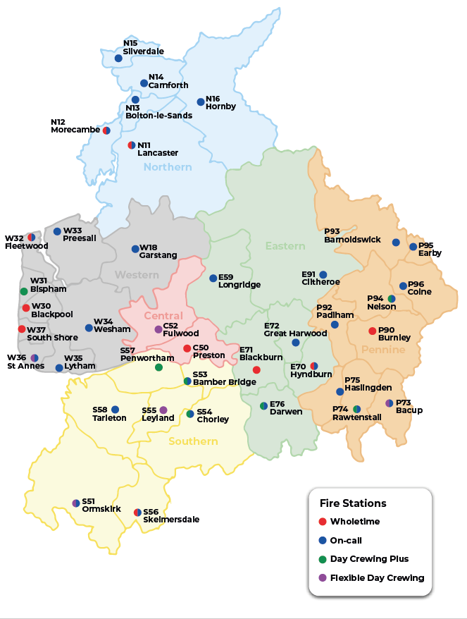
Figure 1 - Service Delivery Areas and Fire Station locations

Community Risk Management Plan (CRMP)
Our Community Risk Management Plan (CRMP) is a public facing document covering the period 2022-27. This plan is in place to provide the opportunity for LFRS to demonstrate how, we as an organisation, identify and assess all foreseeable fire and rescue related risks and challenges that could affect our communities over the 5-year period and how we plan to mitigate such risks or reduce their potential impact.
Key to the successful identification and management of risk is our ability to maintain a clear and current understanding of the present and future threats to Lancashire’s communities. Risk in Lancashire remains dynamic, constantly changing and differs between districts, which requires varying preventative activities. As a result, no single activity to reduce risk is adequate in all circumstances and a mix of prevention, protection and response activities delivered by a range of organisations is needed to reduce the likelihood of the risk event occurring or to lessen its consequences. This depth of understanding underpins everything we do, driving our governance and planning arrangements; our findings are published within the Strategic Assessment of Risk.

Planning and Performance
To meet the requirements of the CRMP the Service reviews its priorities and targets annually, this supports continual improvement and provides the opportunity to ensure that we undertake activities dependent on the requirements of our environment. Our corporate planning process has been developed to provide a rigorous yet flexible process that allows the Service to assess and respond to opportunities and threats as and when they emerge. Whilst the CRMP is in place to set out the strategic direction of the Service in the medium term, the Service also has in place a forward-looking Annual Service Plan which clearly sets out what we will deliver over the coming 12 months, this is complemented by the Annual Service Report which reflects our achievement against those objectives at the year end.
In addition to this on a quarterly basis, we produce a performance management report known as ‘Measuring Progress’. The content of this report is considered at Senior Management Team meetings and by the Performance Committee of the CFA. LFRS is open and transparent and ensures performance information is routinely made available on its website for any stakeholders, including communities, to scrutinise.

Consultation
External and internal consultation is an essential part of the development of the CRMP and subsequent reviews, and as such we have a clearly defined Consultation Strategy. We use a variety of methods for engaging with community members and for every consultation exercise completed, a summary report is provided to the relevant committee of the CFA. This process ensures that key stakeholders are consulted, involved, and informed of the proposals to ensure that their input is considered within the final plans.

Community Risk Management
Our approach to integrated risk management is supported by the use of modelling. The Office of National Statistics categorises every part of the UK into a small neighbourhood called a Lower Layer Super Output Area (LSOA). There are currently 941 LSOA’s in Lancashire, each containing an average of 1,500 people. We use information about where fires have taken place in the past and combine this with various social deprivation data to give each area a risk grade.
The information is then used to identify geographic areas at higher risk where a combination of Prevention, Protection and Response activities can have the greatest impact.
This is utilised alongside the provision of tailored Safe and Well visits or Home Fire Safety Check service (HFSC) which is geared towards occupant risk and importantly, to those in greatest need and at greatest risk of fire.
We update the risk model on a regular basis and use the outcomes to direct and re-prioritise our activities. Risk reduction progress over the last 10 years is depicted in the table below.

 | Very High | High | Medium | Low | Overall Score
 | SOA Count | SOA Count | SOA Count | SOA Count | Risk Score Change
2016 | 32 | 76 | 314 | 519 | 32,990
2017 | 25 | 74 | 321 | 521 | 32,398
2018 | 22 | 74 | 321 | 524 | 32,114
2019 | 21 | 68 | 310 | 542 | 31,816
2020 | 23 | 74 | 324 | 520 | 32,448
2021 | 21 | 61 | 338 | 521 | 31,862
2022 | 25 | 47 | 333 | 536 | 31,576
2023 | 15 | 59 | 331 | 536 | 31,170
2024 | 11 | 54 | 340 | 536 | 30,750
2025 | 12 | 51 | 333 | 545 | 30,532
Overall change | -62.5% | -32.9% | 6.1% | 5.0% | -7.5%
 | Overall reduction in very high risk SOAS | Overall reduction in high risk SOAS | Overall increase in medium risk SOAS | Overall increase in low risk SOAS | Overall reduction in risk score
Figure 2 - Changes in Fire Risk 2016-2025
* Previous comparisons have been made to the 2010 data which shows even larger reductions in very high risk SOAs (-82%), high risk SOAs (-54%) and the overall risk score (-16%). A slightly smaller increase in medium SOAs is also seen (10%) along with a larger increase in low risk SOAs (19%).

Assurance on Governance
The Accounts and Audit Regulations 2015 require the CFA to publish an Annual Governance Statement along with the Authority’s financial statements, following a review of the effectiveness of the internal controls in place. It sets out the key elements of the Authority’s governance framework, how these have been evaluated, the outcome of the assessment of effectiveness and any areas for improvement.
The Audit Committee has previously approved and adopted a Code of Corporate Governance, in line with guidance produced jointly by CIPFA (Chartered Institute of Public Finance Accountants) and SOLACE (Society of Local Authority Chief Executives). The Code defines corporate governance as the way an authority ensures that it is doing the right things, in the right way, for the right people, in a timely, inclusive, open, honest, and accountable manner.
Included within the Code are the following core principles: -
- Behaving with integrity, demonstrating strong commitment to ethical values, and respecting the rule of law
- Ensuring openness and comprehensive stakeholder engagement
- Defining outcomes in terms of sustainable economic, social, and environmental benefits
- Determining the interventions necessary to optimise the achievement of the intended outcomes
- Developing the entity’s capacity, including the capability of its leadership and the individuals within it
- Managing risks and performance through robust internal control and strong public financial management
- Implementing good practices in transparency, reporting, and audit to deliver effective accountability.
The code also sets out the principles which support each of these core elements, as well as how the Authority will address each of these.
The Audit Committee also receives regular reports from Internal Audit, work which is undertaken by Lancashire County Council. The Internal Audit Service is an assurance function designed to evaluate and improve the effectiveness of risk management, control and governance processes. Public Sector Internal Audit Standards (PSIAS) require the Head of Internal Audit to provide an opinion on the frameworks of governance, risk management and control of Lancashire Combined Fire Authority and a written report to those charged with governance, timed to support the annual governance statement. On the basis of the programme of work for the year, the Head of Internal Audit provided substantial assurance regarding the adequacy of design and effectiveness in operation of the organisation's frameworks of governance, risk management and control.
The Authority has responsibility for conducting, at least annually, a review of the effectiveness of its governance framework including the system of internal control. The 2024/25 review was supported and informed by the work of both internal and external audit. This self-assessment formed the basis of the Authority’s Annual Governance Statement for 2024/25 which concluded that Lancashire Combined Fire Authority and Lancashire Fire and Rescue Service has in place a satisfactory system of internal control which facilitates the effective exercise of its functions, and which includes arrangements for the management of risk.
Under the National Audit Office Code of Audit Practice, the external auditor considers whether the Service has put in place arrangements to secure economy, efficiency, and effectiveness in its use of resources and specifically reports on whether the Authority has proper governance arrangements in place. On 11th December 2025 the external auditor reported to the Audit Committee that the Authority has established governance arrangements, with clear structures and processes supporting effective decision-making, risk management, oversight of internal controls, financial sustainability, performance and standards of behaviour. Appropriate arrangements are in place to prevent and detect fraud. The external auditors work did not identify any evidence of significant weakness within the arrangements in place.

Financial Assurance
All local authority accounts are required to adopt ‘proper accounting practice’ based on either statutory requirements or the code of practice on local authority accounting. These specify the principles and practices of accounting required to prepare a Statement of Accounts that ‘present a true and fair view’.
The Treasurer to the CFA provides publicly available annual accounts which are approved by the Audit Committee.
An independent audit of the accounts is undertaken by an external auditing body, Grant Thornton. The external auditor undertakes a review of the accounts and forms an overall opinion which is published each year. The audit for 2024/25 was conducted in accordance with International Standards on Auditing and applicable law and provided the following opinions –

In our opinion, the financial statements:
- Give a true and fair view of the financial position of the Authority as at 31 March 2025 and of its expenditure and income for the year ended;
- Have been properly prepared in accordance with the Code of Practice on Local Authority in the United Kingdon 2024/25; and
- Have been prepared in accordance with the requirements of the Local Audit and Accountability Act 2014.

Organisational Assurance

HMICFRS Inspection
His Majesty’s Inspectorate of Constabulary and Fire and Rescue Services’ (HMICFRS) assessment examines the service’s effectiveness, efficiency and how well it looks after its people. It is designed to give the public information about how their local fire and rescue service is performing in several important areas, in a way that is comparable with other services across England.
LFRS was in the first tranche of fire and rescue services to be inspected by HMICFRS in 2018. LFRS was rated as ‘outstanding’ for promoting its values and culture. In all other areas, the Service was rated as ‘good’ with no areas that ‘require improvement’ in any of the 11 categories that were assessed.
Following the 2018 inspection, LFRS was reassessed in 2021/22 and once again received an ‘outstanding’ rating for its culture and values. In all other ten categories, the service was rated ‘good’ with no areas identified as ‘require improvement’.
In the most recent inspection, carried out in 2025 Lancashire Fire and Rescue Service received the best ratings of any fire and rescue service in England. We achieved an unprecedented six ‘Outstanding’ and five ‘Good’ ratings across all 11 inspection areas. We are the only service in the country to be rated no lower than Good in any area.
Some of the highlights from the report include:
- Our excellent performance at keeping people safe and secure from fire and other risks
- Our outstanding understanding of risk and how we use data and technology to keep our communities safe.
- Our sector-leading protection work, including our risk-based intervention programme and our commitment to reducing unwanted fire signals.
- Our strong values and inclusive culture, with staff feeling supported, listened to, and proud to work here.
- Our innovative use of resources, from mobile data terminals and drones to our investment in training and development.
The inspectors recognised our commitment to continuous improvement, our collaborative approach with partners, and our ability to adapt to new challenges and legislation. They also praised our leadership, our culture of learning, and our focus on wellbeing and fairness. A full copy of the most recent HMICFRS inspection report can be found on our website.
LFRS is next due to be inspected again during 2027.

Operational Assurance
The National Framework outlines the requirement placed upon Fire and Rescue Authorities (FRAs) to provide assurance on operational matters which are determined locally by them in partnership with their local communities, citizens, businesses, and others.
FRA’s function within a clearly defined statutory and policy framework of which the key legislative documents defining these responsibilities are:
- Fire and Rescue Services Act 2004
- Civil Contingencies Act 2004
- Regulatory Reform (Fire Safety) Order 2005
- Fire and Rescue Services (Emergencies) (England) Order 2007
- Localism Act 2011
- Policing and Crime Act 2017
- Fire and Rescue National Framework for England 2018
- Building Safety Act 2022
- Fire Safety (England) Regulations 2022
This section aims to provide assurance that our service is delivered in line with our statutory responsibilities and with due regard to the expectations set out in our CRMP including cross-border, multi-authority, and national incident arrangements. The key components, known as pillars, for operational assurance are as follows:
1. Operational Preparedness Assurance - This is the ‘before’ aspect of the assurance framework delivered through station-based assurance visits which focus on core work that is aligned to reducing risk and our capability to respond effectively and efficiently when the need arises.
2. Operational Response Assurance - This is the ‘during’ aspect of the assurance framework, which is delivered through assurance monitoring during the response phase of an incident or exercise.
3. Operational Learning - This is the ‘after’ aspect of the assurance framework, which is delivered through our debrief systems and by learning from safety events in LFRS, other Fire and Rescue Services, NFCC Organisational Learning (OL), and Joint Organisational Learning (JOL).
The data and findings from these are analysed with key learning provided for staff in a quarterly report to support improvement, and items meeting the criteria are reported to OL and/or JOL. Additionally, themes are considered for inclusion in training programmes.

Prevention and Protection
Our Prevention and Protection strategies set out how we will continue to evolve and improve the way we educate, support and, where appropriate, enforce to stop incidents occurring and protect life. Our interventions continue to evolve in line with changing societal risk, and are shaped by data, intelligence, and equality impact assessment.
Our person-centred Home Fire Safety Check (HFSC) service continues to include Safe and Well interventions including, where appropriate, falls risk assessments, alcohol, and mental health advice. LFRS remains focussed on identifying those most at risk from fire and continues to refine thematic campaigns and referral generation approaches to achieve this. In addition to delivering our role within Community Safety Partnerships our District based teams work with multi-disciplinary teams to ensure that the fire risk component of complex cases is recognised.
Education continues to be a priority and the Service has fire, water and road safety packages tailored for all Key Stages of education. The Service runs and supports a wide range of campaigns for all road users based on the National Police Chiefs Council campaign calendar whilst also taking an active role in the Lancashire Water Safety Partnership.
We continue to provide the Kings Trust Team program and have Fire Cadet Units at a range of locations across Lancashire, complemented by a range of other youth engagement activities tailored to local need.
Our Incident Intelligence Team continues to investigate fires, gathering evidence to assist arson investigations, and intelligence to drive the continual development of prevention activities which keep pace with the perpetually evolving nature of risk in our society.
The Grenfell Tragedy in 2017, and the resultant public enquiries and technical reviews, has initiated the most far reaching and fundamental changes to Building Regulations and Fire Safety legislation seen in decades. To support change LFRS has invested in transformation to ensure it is well placed to meet future challenges. 2023 saw the Service become a joint regulator with the Health and Safety Executive and Building Controls at all stages of the design, construction, occupation, and operation of Higher Risk Residential Buildings.
Whilst this increased focus on the safety of residential buildings is welcome, such buildings make up only a proportion of Lancashire’s built environment. The Service will continue to utilise a risk-based approach to identify the wider range of premises at risk from fire and undertake fire safety interventions to assure compliance. Support to business and commerce continues to remain a priority and we will maintain the ability to enforce and indeed prosecute where fire safety law has been ignored or flouted. Business support will continue to be provided by our Business Safety Advisors, campaign activity and website support, and we will continue to contribute to the principles of better regulation through our Primary Authority Schemes.
Whilst specialist and highly skilled Fire Safety Inspectors will undertake ‘audits’ we have increased our ability to ‘check’ compliance through our Business Fire Safety Check service which is undertaken by our Operational Crews. These visits evaluate simple measures linked to effective fire safety management and provide an opportunity to collect risk information and provide arson risk reduction advice.

Mutual Aid Agreements
The National Framework states that Fire and Rescue Authorities must make provision to respond to incidents such as fires, road traffic collisions and other emergencies within their area and in other areas in line with mutual aid agreements. LFRS maintain mutual agreements for reinforcements with our five bordering Fire and Rescue Authorities - Cumbria, Greater Manchester, Merseyside, North Yorkshire, and West Yorkshire. These agreements are periodically reviewed to maintain currency and provide optimal response arrangements.

National Resilience
For the purposes of this document, National Resilience (NR) is defined as the capacity and capability of Fire and Rescue Authorities to work together and with other Category 1 and 2 responders to deliver a sustained, effective response to major incidents, emergencies, and disruptive challenges, such as (but not limited to) those identified in the National Risk Register of Civil Emergencies. It refers to risks that need to be planned for on a strategic, national basis because their impacts and consequences would be of such scale and / or complexity that local resources would be insufficient, even when considering mutual aid arrangements.
LFRS is a signatory to the National Mutual Aid protocol and has deployed assets to major incidents outside the region. The costs of such mobilisations are borne by the FRA within whose area the incident occurs and are therefore re-claimed by LFRS.
We remain subject to the NR audit processes which test the various aspects of our NR capabilities. Merseyside Fire & Rescue Service assumed the lead authority role for National Resilience on behalf of the Home Office in 2016. This includes taking responsibility for assurance, training, long-term capability management and Fire Control with regard to National resilience.

Business Continuity
Business Continuity Management (BCM) is a core element of Lancashire Fire and Rescue Service’s corporate risk management framework and supports compliance with the Civil Contingencies Act 2004 and the Fire and Rescue Services Act 2004, including the requirement to plan for periods of industrial action.
The Service operates a structured BCM framework aligned to the Business Continuity Institute’s Good Practice Guidelines and the principles of ISO 22301. This framework enables the identification and prioritisation of critical activities, assessment of risks to service continuity, and the development, testing and maintenance of proportionate continuity plans. Clear arrangements are in place for plan invocation, governance, training and accountability.
During the year, BCM arrangements continued to evolve in response to an increasingly complex risk environment, with greater emphasis on organisational resilience, system dependencies, workforce availability and alignment with wider risk management and emergency planning activity.
The Service’s BCM arrangements were subject to internal audit during the year and received a Substantial Assurance opinion, providing confidence that controls are well designed and operating effectively. Plans are reviewed and exercised at least annually, with learning incorporated to ensure arrangements remain current and effective.
Overall, the Service remains confident that its BCM arrangements are robust, compliant with statutory requirements, and capable of supporting the continuity of critical functions during periods of disruption.

Safety, Health, and Environment
The Combined Fire Authority meets regularly to provide strategic political leadership to the Service. The Authority has overall responsibility for the effective governance of Safety, Health, and Environment (SHE), including:
- Agreeing the SHE Policy which outlines their commitments and ensuring adequate resources are available for the establishment, ongoing implementation and control of a Safety, Health, Environment and Wellbeing (SHE) Management System.
- Providing a clear direction for the Executive Board and Senior Management Team to establish policies and manage safety, health and environmental responsibilities effectively.
- Consideration of local and national issues which impact on Safety, Health, Environment and Wellbeing within the Service.
- Monitoring performance through receipt of the Annual SHE Report, to provide governance and assurance that an effective SHE Management System is operational within LFRS.
Our health and safety arrangements are based on the model Plan, Do, Check, Act set out in the Health and Safety Executive publication HS(G)65 – Successful Health and Safety Management and written and implemented to the International Standard for Health and Safety Management Systems, ISO 45001:2018. The environmental aspects of the management system are written and implemented to the International Standard ISO 14001:2015.
External Certification for both standards has been in place since 2011 with re-certification taking place every 3 years followed by annual surveillance audits. The last successful audit took place in 2025, where certification was extended by the external audit team. As part of the audit process, the auditors visit a range of stations and departments and examined the ‘Full provision of fire, rescue and supporting services across Lancashire’ delivered by the Combined Fire Authority from a health and safety, wellbeing and environmental perspective.
We have procedures in place to report and investigate safety events, both events which have resulted in an injury to an individual or ‘near miss’ events which had the potential to cause harm. These processes allow us to identify areas where improvements to our arrangements can be made.
The Deputy Chief Fire Officer has director level responsibility for health, safety, wellbeing and environmental compliance. They chair our internal group, the Health, Safety and Environment Advisory Group which meets quarterly to monitor and review our compliance, undertake horizon changes for changes to legislation and guidance and identify corrective actions to improve our performance. We also have arrangements in place for consultation on health and safety issues with the representative bodies, ensuring we have a collaborative approach to ensuring the health, safety and wellbeing of our staff.
Each year a performance review of Safety, Health and Environment is carried out and reported to the Combined Fire Authority in the Annual SHE Report. Part of business-as-usual is the review of policies, procedures, support for staff wellbeing and guidance to ensure that we continue to meet our legal obligations in respect of safety, health and environment and we validate this by a system of internal and external audits.
To ensure continuous improvement is made across safety, health, environment and wellbeing, we have developed aspirational 5-year delivery plans, supported by objectives and actions each year to assist in delivering future improvements.

Leadership and Development
The Leadership and Development Department works in conjunction with other departments within the Service, such as Human Resources and the Safety, Health, and Environment Department, to provide training and development for all members of staff. This includes corporate induction, health and safety, data protection, and safeguarding, to ensure compliance, reduce risk, and maintain competence within each role.
As defined in the Fire and Rescue Services Act 2004, FRAs have a duty to secure the provision of training for personnel in relation to fighting fires, road traffic collisions (RTCs) and emergencies other than fires and RTCs. To comply with the elements of fighting fires and RTCs, the Service provides training in:
- Breathing apparatus and fire behaviour
- Incident command
- Blue light driving
- RTC
- Trauma care
- Firefighter core skills.
In relation to emergencies other than fires and RTCs, our CRMP identifies emergency special services to include flooding and water rescue incidents, wildfires, animal rescue, rope rescue, hazardous materials/spills and assisting other agencies.
Training programmes are designed to align with organisational requirements, prioritising the safety and competency of personnel in delivering prevention, protection, and response services.
The Leadership and Development Centre supports continual learning and organisational development. Training programmes are designed using insights gained from Joint Operational Learning, National Operational Learning, internal operational and organisational reviews, and reports on significant national events. Ongoing development and maintenance of competence is a key focus, and this is facilitated through a robust maintenance of skills programme linked to an e-learning system, which is continually updated. Programmes are tailored to each role and responsibility, with a particular focus on leadership development across the Service.
Trainers are selected and developed across a diverse range of specialisms, from the intricacies of boat handling and rope rescue to the complexities of mounting a successful fire safety prosecution. Where necessary, support is commissioned from specialist providers.

Assurance Declaration
The Chair of Lancashire Combined Fire Authority and Chief Fire Officer of Lancashire Fire and Rescue Service are satisfied that the Authority’s financial, governance and operational assurance arrangements are adequate and operating effectively and meet the requirements detailed within the Fire and Rescue National Framework.
Jon Charters - Chief Fire Officer Ged Mirfin – CFA Chair

Date:

