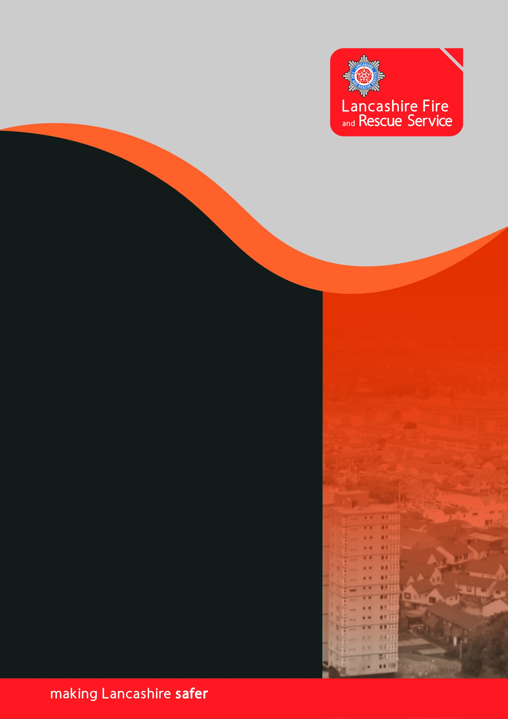

Lancashire Fire and Rescue Service
Risk Based Inspection Programme

Contents
Abbreviations and definitions 3
How we manage risk 5
Overview 7
Datasets 7
Calculating the overall risk score 8
Selection of Premises 9
Appendix B – Categories of Harm 11
Appendix C – Additional Markers 12

Abbreviations and definitions
AddressBase | The Ordnance Survey national gazetteer of all UK postal addresses.
Attribute | A feature of a premises which has influence on the degree of harm that may be sustained in the event of fire.
(the) Authority | The public body, holding the functions of a Fire and Rescue Authority, with a statutory duty to enforce the provisions of the RR(FS)O. (Also, the Enforcing Authority).
CFRMIS | Community Fire Risk Management Information System. A database that Lancashire Fire and Rescue use to record work activity and information, including that which relates to Fire Safety.
Dwelling | A domestic premises as defined in Article 2 of The Regulatory Reform (Fire Safety) Order 2005.
Fire Safety Inspection | An on-site engagement undertaken to support or check compliance or to capture data for the Protection Risk Model
FSEC (Categories) | Fire Service Emergency Cover is a robust, third-party validated risk assessment and resource deployment tool which breaks down premises into Risk Groups and Supplementary Line numbers.
Harm | The adverse impact on one of six categories of value, namely Public Life, Emergency Responder, Economic, Environmental, Heritage and Social Community (each defined within the document).
Likelihood | The relative probability that an event will occur based on historical data.
Lower Layer Super Output Area (LSOA) | LSOA are a geographic hierarchy designed to improve the reporting of small area statistics in England and Wales. A lot more data is available directly at LSOA level as LSOA have an average population of 1500 people or 650 households.
Mott MacDonald | Refers to values given to premises to determine risk, taken from national incident data published in ‘Update of response time loss relationships for the Fire Service Emergency Cover toolkit’ (Department for Communities and Local Government, 2010)
Regulated | A premises to which the Regulatory Reform (Fire Safety) Order 2005 apply but not including, in this guidance, dwellings to any extent.
Relevant Person | The Regulatory Reform (Fire Safety) Order 2005 outlines a relevant person, however, in the simplest terms, the relevant person is anyone that could possibly affected by fire (or related) problems at the premises.
Risk | A combination of Severity and Likelihood; the likelihood that a fire will cause harm, together with a measure of the effect.
Risk Based Inspection Programme | Pre-planned Fire Safety Inspections based upon the Protection risk profile which is refreshed at least every three years.
Risk Data Capture | An activity whereby information is collected and recorded and forming the foundation of risk profiling.
Risk Profile | The value assigned to one or more premises record(s) allowing comparison between individual premises, types of premises or geographic locations.
(the) Service | Lancashire Fire and Rescue Service (LFRS).
Severity | A value representing the potential maximum harm in the event of fire.

How we manage risk
To manage risk, and allocate inspection resources effectively, it is first necessary to define what constitutes risk. LFRS operates a Risk Based Inspection Program (RBIP) based on nationally recognised principles refined further at a local level using data and intelligence relevant to risk in Lancashire.

As Lancashire has over sixty thousand regulated premises it is not possible to audit them all. Indeed, attempting to do so would inevitably be ineffective as valuable resources would be allocated to very low risk premises that have minimal potential to cause harm, at the expense of very high-risk ones where occupants are at significant risk of harm if a fire occurs. The RBIP ensures the pre-planned use of Officer and Operational Crew time is focussed on the premises which have the greatest potential to cause harm ‘if’ risk is not being managed effectively by premises management. Taking this approach enables us to continually suppress risk in the built environment and ensure that potential to cause harm is sustained at levels which are as low as reasonably practicable.

In general terms, the premises which are audited most frequently are those in which:
- Occupant's sleep, are unfamiliar with the premises and unable to escape without significant assistance and pre-planning (e.g. Hospitals, Nursing & Care Homes)
- Occupants sleep and are unfamiliar with the premises (e.g. Hotels and Hostels)
- Occupants sleep and are familiar with the premises (e.g. blocks of flats)
- Occupants are awake but unfamiliar with the premises (e.g. theatres, pubs, clubs)

In determining inspection priority further within those definitions, the RBIP also considers:
- History of previous fires in the premises (indicative of future likelihood)
- History of previous fires in the vicinity of the premises (indicative of arson risk)
- Distance from a fire station (indicative of the length of time the building will have to perform to protect its occupants before firefighting interventions can be made)
- Flood risk (as fire risk intensifies significantly during flooding when power fails, and reliance is placed on fire safety systems working on back-up power supplies)
- The height of the premises (taller premises place greater reliance on fire safety systems and building construction and management to protect their occupants).
- The date and outcome of previous inspections
- Other data which is relevant to specific premises types (e.g. Care Home inspection data from the Care Quality Commission indicating poor safety management).

The RBIP sits within our wider Inspection Framework and determines how we pre-plan the allocation of inspecting officer time. We also recognise that use of historical data is not always indicative of future events and consequently retain the ability to respond in an agile way to partner referrals, post fire audits, fire safety complaints and where emerging local or national intelligence suggests certain premises should be targeted irrespective of their position in the RBIP e.g. previously unknown concerns emerge over a particular external wall (cladding) system.

Overview
Fire is a ‘hazard’. The combination of the harm caused by a hazard combined with the likelihood of the harm occurring leads to a level of ‘risk’.

The ‘overall score’ described in this document represents the overall level of risk and is used to determine the priority in which premises are inspected. The overall score is calculated by assigning an initial value which is taken from national incident data published in ‘Update of response time loss relationships for the Fire Service Emergency Cover toolkit’ (Department for Communities and Local Government, 2010), in consultation with the Mott MacDonald Ltd. The final risk score is then calculated by applying an additional series of determinants which are relevant to fire risk in Lancashire and represent different ‘Categories of Harm’ (Appendix A) reflecting the broader impact of fires when they occur.

The overall score is not used in isolation to target higher risks premises. Additional information relating to fire risk is also included in the data presented to Fire Safety Inspectors (Appendix C) which might otherwise skew the overall model but allows local prioritisation when inspections are being allocated.

Datasets
CFRMIS holds data for approximately 25% of the regulated premises in Lancashire. As such, this dataset is not robust enough to be able to calculate risk on both premises the service is aware of and those it not aware of.

AddressBase is a product from Ordnance Survey which provides users with a gazetteer of all postal addresses. It is the most comprehensive and reliable database of properties available to the Service.

AddressBase is continually updated; the custodian, responsible for the currency and accuracy of the dataset, is the Local Authority.

The Service uses the AddressBase gazetteer to create a record for each listed address in Lancashire. One of the key pieces of information in this is the Basic Land and Property Unit (BLPU) classification which is used to ascertain the FSEC information for the premises. Once this information is linked, it is then possible to differentiate between Unregulated Premises (Private Dwellings) and Regulated Premises (Premises falling under the Fire Safety Order).

As every premises LFRS inspect has a record created in CFRMIS, information and characteristics can be associated with each address, allowing the Service to create a more detailed profile of each individual premises overtime.

Calculating the overall risk score
In 2018, LFRS developed a new methodology that started with the Mott MacDonald (Median) score and then multiplied by a series of weighting factors:
    - Public Harm (Score of up to 3)
    - Emergency Responder (Score of up to 1.5)
    - Economic Value (Score of up to 1.5)
    - Environment (Score of up to 1.5)
    - Heritage (Score of up to 1.5)
    - Social and Community (Score of up to 1.5)
The resulting score was used to rank premises in order of risk. Scores that achieved a value of 9 or above were included in the Risk Based Inspection Programme.

The Mott MacDonald value system has a bandwidth of 2.0 between the highest score for each FSEC code and the lowest, i.e. Purpose-Built Flats (VH=6.03, VL=4.03). Each of these values also has a median score, i.e. Purpose-Built Flats =5.03.

As each of the scores from the Category of Harm can have the maximum effect of changing the score by +/-0.2, the combined effect of the full range of scores (5) will not change the score by more than +/-1.0, i.e. a Purpose-Built flats premises with a median score of 5.03, which achieves the highest score in EVERY of the Categories of Harm, would achieve a score of 6.03 (equal to the Mott MacDonald VH value), the same premises, achieving the lowest score in EVERY of the Categories of Harm, would achieve a score of 4.03 (equal to the Mott MacDonald VL value)
The resulting score can be remapped against the full range of Mott MacDonald values and a risk level (VH, H, M, L, VL) can be applied.

By taking the median Mott MacDonald value, we start our calculation by using a well-researched and value-based score. We then add our Categories of Harm, which we consider to be apposite to Lancashire Risks. The resultant score is a blend of both Nationally based and service-based data. This is the COMBINED SCORE.

Figure 1 – Application of Mott MacDonald and Lancashire FRS Categories of Harm
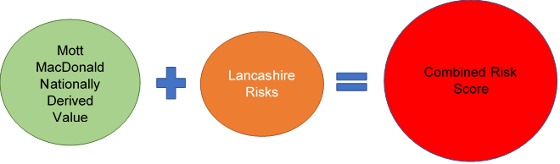

Selection of Premises
Based on the Mott MacDonald table and the National Fire Chiefs Council (NFCC) Competency Framework which provides a clear framework for Enforcing Authorities to follow to achieve, maintain and demonstrate appropriate standards of competency within their workforce, the scored premises are divided into several discrete work areas aligned to the competence of staff:

High Risk Residential Premises These are all 7 storeys and above residential, high-rise premises across Lancashire. Currently these are the only premises types defined by NFCC as ‘in scope’, however there is potential that more premises may come into scope.

Level 4/3 (qualified inspectors) (FSEC codes A, B, C, E, F, H) – these premises are split to ensure that the competency of the inspector is aligned to the risk/value. For premises that fall below the Mott MacDonald (Median) score for the lowest FSEC category for sleeping risk (H) are included in the Sampling work area, together with any remaining premises more than 18m in height and (FSEC codes D, X, L). Premises that fall below the Mott MacDonald (Low) score for the highest FSEC category for sleeping familiar risk (D) are also included in the Secondary Risk work area.

Business Fire Safety Check (BFSC) (FSEC codes J, K, M, N, P, R, S, T) – these premises fall below the Mott MacDonald (High) score for the highest FSEC category for public unfamiliar/workplace familiar risk (J).

Heritage – Grade 1 and 2* premises not already included in High-Risk Residential Premise.

Targeting – this work area is used to empower local Fire Safety Team Leaders and Community Protection Managers to use local knowledge and intelligence to target premises that are known to be higher risk together with the facility to include premises that are highlighted due to national emerging trends.

Sampling – this work area is used to test the efficacy of the Inspection Programme. Local Fire Safety Team Leaders will select 5% of the lower score sleeping risks that have been allocated to the Secondary Risk area.

Secondary Risk – all other premises not included in the above. This work area has been devised to empower Fire Safety Team Leaders and Community Protection Managers with ability to include other premises that have not been captured in A – E, above.

Appendix B – Categories of Harm
The risk-based approach is founded upon the concept that fire has the potential to harm not only the life safety of occupants and other ‘relevant persons’ but also other people and community assets.

The Inspection Programme identifies a total of five potential categories of harm:

  - Primary Fires
  - Secondary Fires
  - Emergency Responder
  - Flood Risk
  - Social & Community

Category of Harm | Definition | Attributes
Public Life | Occupants and other persons who would need to escape to a place of safety in the event of fire | - Primary Fires  - Secondary Fires
Emergency Responder | Responders from the Emergency Services who may have to enter a hazardous area in the event of fire | - Emergency Response Times
Environment | Air, water and land | - Flood Risk Areas (taken from environmental health data)
Social & Community | A perceived value that causes public, political and/or media reaction which may also include community disruption. | - LSOA Risk Information  - Mott MacDonald Score

Appendix C – Additional Markers
Additional markers are included to inform the Service and Inspecting Officers:
  - Combined Code – this is a combination of the FSEC code and the Supplementary Line Number for the Premises.
  - Enforcement Action – shows Y if the premises has had an enforcement notice issued during the previous 3 years.
  - Last Audit – shows the last date the premises had a fire safety audit, or blank if the premises has never been audited.
  - Building Height – gives the building height from the enhanced AddressBase gazetteer, together with the Estimated Number of Storeys.

