Keeping You Safe at Home.
Your home has been visited by Lancashire Fire and Rescue Service. To help keep you safe, you’ve been provided with specialist fire-retardant bedding and materials. These items are designed to reduce the risk of fire but only if used and cared for correctly.
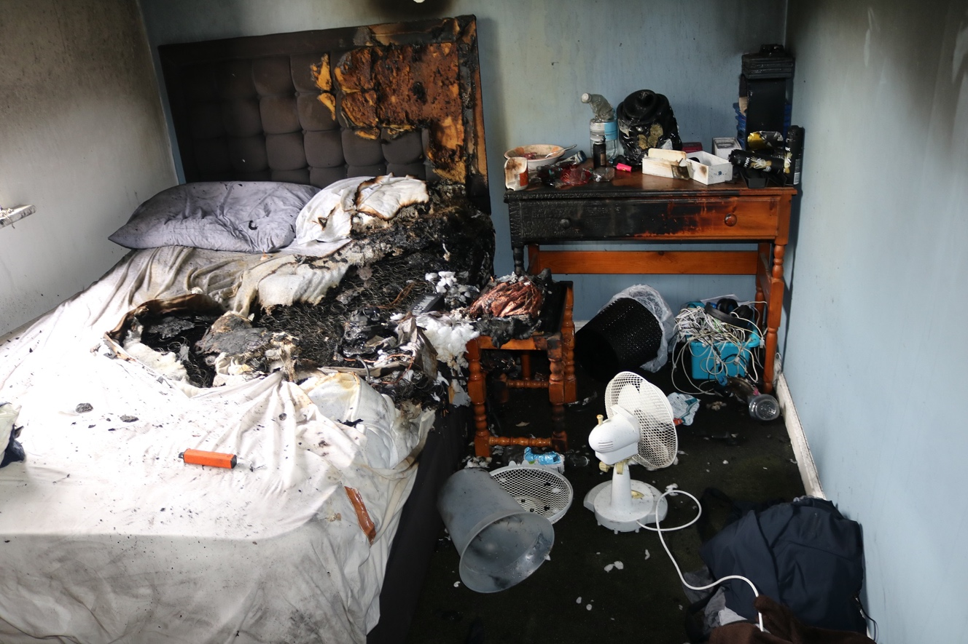
Fire-Retardant Items Provided

Fire-Retardant Bedding
- Includes duvet, pillow, and covers
- Must be kept on the bed
- Replace covers after washing

Fire-Retardant Throw
- Usually placed on a chair or sofa
- Keep it in place — it helps protect you

Fire-Retardant Blanket
- Provided to replace an existing blanket
- Use this instead of non-retardant alternatives

Smoking Safety
Smoking and smoking materials are the leading cause of fatal house fires. A recent incident involved a fire caused by smoking in bed — a reminder of how quickly things can go wrong.
Please avoid smoking in bed or near soft furnishings.

Important Safety Advice
- Do not cover fire-retardant items with non-retardant materials — this reduces their protection
- Replace any fire-retardant items that become damaged
- To request a Home Fire Safety Check call: 0800 169 1125

Washing & Care Instructions
To keep your fire-retardant products effective, follow these guidelines carefully.

Bedding (Covers, Sheets, Pillowcases, Throws, Blankets)

Washing
- Wash at 60°C (recommended)
- Can be washed at 74°C for NHS-level thermal disinfection
- Frequent washing does not reduce fire-retardancy if guidelines are followed

Drying & Ironing
- Tumble dry on low heat
- Iron on a cool setting

Do Not
- Use soap powders like LUX or Velvet
- Wash with other items — this can reduce fire-retardancy
- Use hypochlorite bleaches (e.g., Domestos Vortex, supermarket brands)
- Use tumble-dry sheets

Fire-Retardant Duvets & Pillows

Washing
- Wash at 60°C
- Fire-retardant for up to 50 washes, but filling becomes lumpy
- Recommended: wash no more than 3–5 times, then replace

Drying
- Tumble dry on low heat

Do Not
- Use LUX or Velvet soap powders
- Use hypochlorite bleaches or Persil

Emollients & Fire Risk
Emollients (creams, gels, sprays, bath/shower products) can soak into clothing, bedding, and bandages.
- Emollients are not flammable on their own
- BUT once dried into fabric, they make it burn hotter and faster if exposed to a flame

Safety Tips
- Avoid smoking or going near naked flames when using these products
- Wash clothing and bedding frequently
- Use the highest temperature recommended on the label
Note: Washing reduces but does not remove all emollient build-up.

