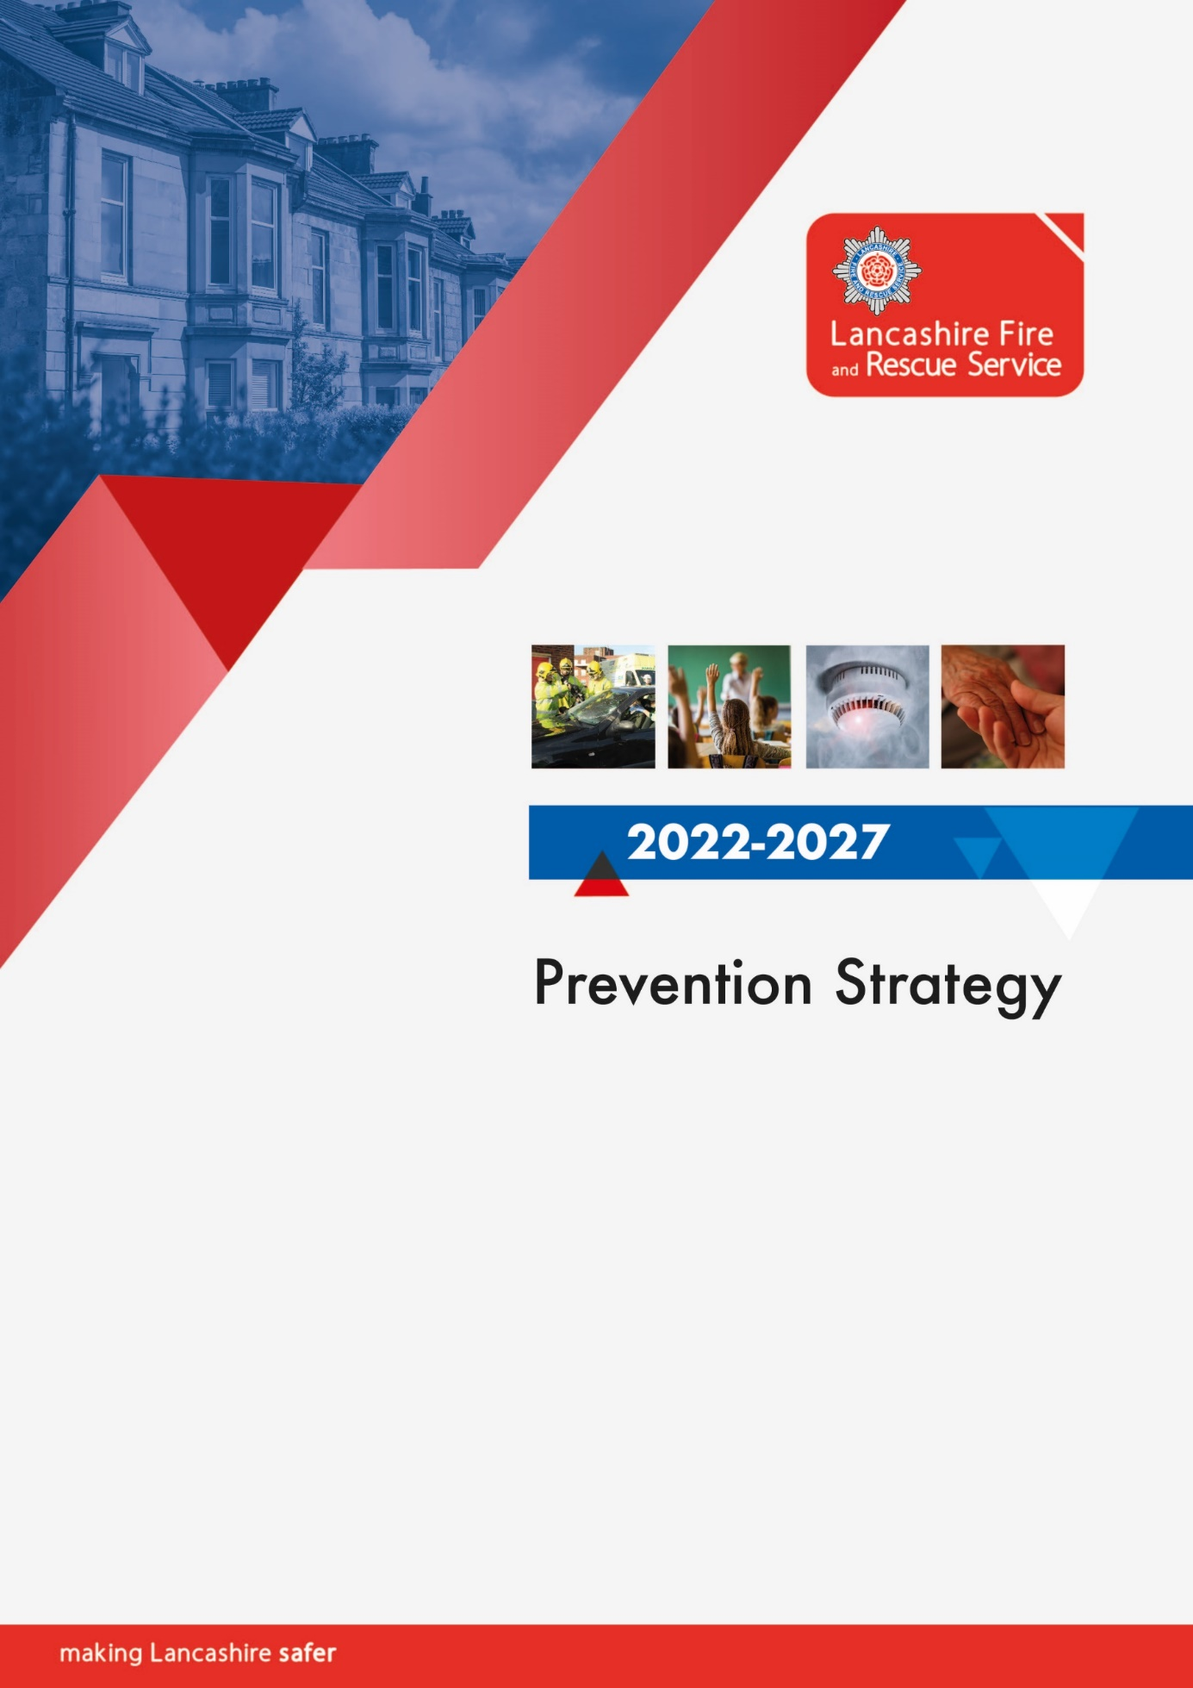

Prevention strategy 2022/2027 3
Introduction 3
Our commitment to prevention and community safety 4
Delivering community safety intelligently and collaboratively 5
Our core prevention offer. 9
Our home fire safety check service incorporating safe and well 9
Telecare systems 11
Campaigns 11
Thematic groups 12
Start safe 13
Live safe 13
Age safe 13
Road safety 13
Water safety 14
Mental health task group 17
Arson risk reduction plan 19
Reducing the frequency and consequence of accidental fires – incident intelligence 21
How will we measure success? 22
Who are we? 23
Relevant Legislation 23

Prevention strategy 2022/2027

Introduction
Our prevention strategy 2022-27 encompasses the following key areas.
- Working collaboratively with our partners and communities
- Using incident intelligence and data to drive our activities
- Fire safety in the home
- Arson risk in the home, built environment and outdoors
- Road safety
- Water safety
- Wildfire safety
- Early action, education, and youth engagement
Fire and rescue authorities (FRAs) are required by the National Framework to produce a local Community Risk Management Plan (CRMP) that sets out the authority’s strategy, in collaboration with other agencies, for reducing the commercial, economic and social impact of fires and other emergency incidents.
Our CRMP sets the overall direction and is informed by a Strategic Assessment of Risk (SAoR). This prevention strategy provides more detail on how we will deliver and develop prevention services during the period and our annual service plans will describe the continuous improvements we intend to make to achieve this.
Undertaking a strategic assessment of risk is a vital foundation to both the CRMP and this strategy as certain risks in our communities are highly foreseeable. By analysing national and local data and intelligence we can predict the types of emergencies that are most likely to occur, when they are likely to happen, and the individuals or groups most likely to be at risk. In our fast moving and constantly changing world we also recognise that historical data doesn’t always shape future events. Accordingly, we still recognise the importance of being agile and maintaining the capability to identify emerging trends so we can evolve and deliver our prevention activities flexibly and proactively.
The SAoR and accompanying district intelligence profiles (which are refreshed annually) will ensure prevention services remain tailored to the needs of Lancashire. Aspects of this strategy further recognise that LFRS is one of many fire and rescue services nationally and consistency of approach and messaging is vital to ensure the best overall service to both Lancashire’s residents and its visitors. Accordingly, this strategy will be accompanied by an equality impact assessment and shaped in accordance with national fire standards.

Our commitment to prevention and community safety
We constantly strive to prevent fires and other emergencies from happening. Prevention is always preferable to response and is by far the most effective way to make Lancashire safer. By taking this approach we seek to protect the health and wellbeing of our communities and staff, and by doing so also lessen what might otherwise be more significant adverse impacts on other entities such as the NHS, social care, police and commerce.
Lancashire is a diverse and culturally rich county. In seeking to identify those who are most at risk in our communities, and target and shape our prevention activities accordingly, we will ensure we always act in a non-discriminatory way and provide equality of access to all prevention approaches. We recognise the importance of ensuring our workforce is representative of the society we serve, so that we are able to engage effectively with our communities, understand their needs, and how best to meet them. The National Fire Chiefs Council (NFCC) Equality of Access to Services guidance and our Equality, Diversity and Inclusion action plan acknowledges the links that exist to fire and other hazards, ensuring these are considered when planning our prevention activities.
Taking this approach enables us to address common risk factors which are present in a significant number of fires and other emergencies, which relate to one or more aspects of inequality, so we can then take action to target and address the them in our Home Fire Safety Check (HFSC) and broader prevention work with partners, for example (but not limited to) fuel poverty, poor physical and mental health, and social isolation.
Over the course of this strategy, we will:
Ensure our prevention activities are targeted, shaped and refined using the principles of equality impact assessment.

Delivering community safety intelligently and collaboratively
We will work collaboratively with a wide range of stakeholders and partners so that collectively we can maximise our resources to identify those most at risk and thereafter plan, promote, support and deliver prevention activities effectively and efficiently. We will produce service wide and district intelligence profiles to ensure prevention activities are audience specific and targeted behaviourally, geographically, demographically, and thematically. Focussing resources in this manner enables evidence driven activity which relates to proven risk factors such as (but not limited to) drug and alcohol misuse, health inequalities, deprivation, smoking, and individual risk factors relating to underrepresented groups.
We will carefully maintain and nurture our culture and operating structures to celebrate the importance of organisational learning and refine our ability to capture feedback and intelligence from a range of sources. Thereafter we will evaluate this intelligence, share and act upon it to drive innovation, continuous improvement and future performance.
Wherever appropriate to do so we will adopt the NFCC principle of a person-centred approach that places individuals, and the communities in which they live, at the core of our prevention activities. We will seek to contribute to the continual improvement of prevention activities by taking guidance from and contributing to the NFCC network.
We recognise that we may not always have the capacity to engage directly with all at risk groups, or indeed be the best people or agency to undertake a particular form of engagement. Consequently, we will always carefully consider how best to engage, and who is best placed to work with defined risk groups, and where appropriate will seek to work with relevant partners to develop and provide prevention training and support materials for others to deliver e.g. sharing knowledge and empowering social media influencers to share safety messages within communities in a way that means more to them.
We will train our fire investigators in accordance with national standards as we recognise understanding the underlying causes of fire remains fundamental to our ability to shape future prevention activities. We recognise the importance of not only being able to differentiate between accidental and deliberate causes of fire but also to be able to call upon and refer to appropriate partners and experts so that accurate and timely learning is gathered and shared both locally and nationally. We will maintain and develop partnerships which will help us reduce risk e.g. with trading standards for potentially defective products. We will maintain and develop our close working relationship with Lancashire Constabulary to ensure deliberate fires result in crime detections and successful prosecutions and to enable police officers to make rapid referrals to us where use of fire as a weapon has been threatened.
Understanding the causes of other emergencies (such as accidental drownings and road traffic collisions) is also vital to ensure we can deploy our ‘brand’ and finite resources to best effect. Rather than duplicate the work of other agencies and third sector organisations who already work in a particular space or have statutory duties, we will seek to use and share data and business intelligence to drive evidence-based decision making on the role we can play.
Although our focus remains making Lancashire safer from fires and other emergencies, we recognise the natural link between successfully achieving our objectives and the resultant cashable benefits to health and social care in terms of less people entering those services with acute and critical needs after a fire or road traffic collision etc or more chronic needs which are addressed by elements of our Home Fire Safety Check (incorporating safe and well) such as social isolation and falls prevention.
In a similar manner we recognise the role our education and youth engagement activities play in contributing to social cohesion and reducing the incidence and impact of anti-social behaviour in our districts. To ensure our offer remains current, informed and targeted, we will continue to engage in national, regional, Lancashire, and district level meetings with stakeholders and partners where there are clear and mutually compatible objectives.
Recognising that such structures are continually evolving and differ significantly across the county based on health, social care, policing and district council footprints, we will evaluate the contribution we can make on a case-by-case basis. Where a compelling case exists, we will consider the benefits of co-location with other agencies. Irrespective of whether we are working alongside partners in a shared workspace, attending meetings together or simply generating contacts, a key area of focus for us will always be to generate high quality ‘preferred partners’ with whom we can work to train their staff and volunteers as fire safety advocates, who are then able to identify their service users who are living with elevated fire risk and make a referral for a HFSC. In turn we will also look to add to the suite of partners to whom we can refer recipients of our HFSC based on their person-centred needs.
We will continue to invest in appropriate face to face and on-line training for all staff who deliver our community safety activities. In considering broader staff development, we recognise that societal risk is never one dimensional and that what may constitute risk for one organisation may well have different impacts for another e.g. in a health sense fuel poverty and deprivation contribute to poor health outcomes and chronic illnesses, from a fire risk perspective the same determinant typically leads to unsafe forms of heating and serious fires with acute injuries. Recognising these interdependencies is a vital component of being able to work with partners to best overall effect. Consequently, we will support our staff to develop their skills and expertise in broader but nonetheless essential community safety activities such as awareness of adverse childhood experiences, identifying and raising safeguarding issues, preventing extremism, and being able to identify, and refer appropriately, potential signs of human trafficking and modern slavery etc.
The term ‘built environment’ is used to describe the structures society creates for homes and to accommodate retail, education, industry etc. We recognise that a prevention strategy cannot sit in isolation and must acknowledge the significance and variance in risk associated with the different ways dwellings can be provided and in particular where they are provided within multi-occupied buildings such as houses of multiple occupation, buildings converted to flats and those which are purpose built.
This prevention strategy focusses on working with partners to raise fire safety awareness and effect behavioural change to reduce risk to individuals and families due to personal factors related to health, age and lifestyle choices etc and the provision of equipment and alarms needed within their own dwelling to help achieve this. Our protection strategy compliments this approach and focuses on the way buildings in their entirety should perform in fires to protect all their occupants and ensuring owners and managers understand their responsibilities and discharge them effectively. As the built environment landscape changes so must our services to the community of Lancashire. The variety of premises in occupation across the county is such that both prevention and protection activity must complement one another to ensure a holistic approach is taken to the building and its occupation. Prevention and protection staff co-ordinate their work to ensure that, where appropriate, cross referrals are made, and all services are applied to reduce the risk of a fire occurring and improve the outcomes if one does.
Making Lancashire safer is at the heart of all we do, this is supported through both prevention and regulatory activity along with being data and intelligence driven to focus on the highest risk and the most vulnerable.
Over the course of this strategy, we will:
Continue to develop our operational and community safety staff in the field of fire safety regulation and hazards in the built environment to increase our effectiveness, risk intelligence and referrals to fire protection.
Improvement and innovation
LFRS has a strong history of seeking continuous improvement and delivering prevention activities innovatively. We were one of the first services to conduct home safety visits electronically using portable devices so community safety advisors (CSAs) and fire crews could record outcomes and make referrals to other agencies promptly and effectively.
We will continue to evolve and innovate in this way and will be paying regard to the learning we acquired through our experiences during the pandemic. An early example of this is the way we evolved delivery of our school education packages from a face-to-face model, involving an operational crew or CSA visiting a single school, into a digital method wherein CSAs delivered on-line to several schools and in some cases direct to home schooling households. Future innovation will remain aligned to the fundamental objectives of community safety; raising awareness, improving understanding and changing behaviours now and for generations to come. We will ensure we continue to liaise with key stakeholders when we develop our delivery methods and will continue to measure ‘pre’ and ‘post’ understanding of the issues covered with the young people we engage with to check that any new approaches remain as effective as they are efficient.
Over the course of this strategy, we will:
Seek to build on learning acquired during the pandemic and develop new and innovative ways to deliver our community safety activities, ensuring the focus remains on engaging our target groups and delivering effective outcomes.

Our core prevention offer.
Our community fire safety teams and operational crews deliver a range of prevention activities that sit at the heart of our prevention offer;
- Targeted home fire safety checks, incorporating safe and well visits
- Child safe; fire safety education to Year 2
- Road sense; fire and road safety education to Year 6
- Teen safe; choices & consequences and water safety talks to Year 7 to 10
- Wasted lives; road safety education to Year 10 and 11
- Road safety education to colleges, universities and employers
- Biker down; motorcycle safety education
- FIRES; fire setting intervention package

Our home fire safety check service incorporating safe and well
Bringing about positive change in behaviours within people’s homes is central to improving community safety and our core offer is the home fire safety check incorporating a safe and well visit. The service can be accessed in a range of ways:
- Self service via our website or telephone call to our contact centre
- Referral on a service users behalf by a ‘preferred partner’ working independantly
- Referral by a partner agancy with whom we meet, or in some cases co-locate
- (e.g. integtrated care communities with GPs, social care early action teams etc)
- Data sharing agreement with a service provider (e.g. oxygen suppliers)
- Following a fire or other incident in the home or in households nearby (a ‘hot strike’)
- Following campaign activity
Although the self-service offer is available to the whole of Lancashire, our campaigns are targetted to raise awareness of the HFSC (Safe and well) service within specific groups or areas known to be at greater risk from fire.
Fire risk is linked to a range of factors including deprivation, health inequalities, lifestyle choices and age. The overriding objective is to attract higher risk referrals so we are using our finite resources as effectively as possible. Lower risk referrals receive targeted advice by letter or e-mail and higher risk ones receive a home visit tailored to their needs. The person centred nature of the visit ensures tailored advice is provided and where apporpiate, and with consent, referrals are made to other agencies and services to further reduce risk and improve health outcomes e.g. social care and telecare providers.
Self referrals, and those from partner agencies, are our preferred source as these come with the explicit consent of the householder to deliver the service. Other targetting methods, such as using demographic and fire data to target certain areas for leaflet drops have their place however this approach has to be used carefully to ensure the amount of resource invested is repaid in terms of higher risk households consenting for the service to be delivered.
The safe and well component of the visit includes identification of additional risk factors and vulnerabilities that not only increase the risk of fire but may also have an adverse impact on an individual’s health and well-being. This enables us to make brief interventions and referrals on behalf of NHS and social care providers with respect to:
- Falls prevention
- Social isolation
- Dementia
- Diabetes
- Healthy homes/winter pressures
- Home security
- Mental health
Over the course of this strategy we will:
Continue to refine our home fire safety check and safe and well service in line with evolving national guidance to ensure the offer remains person centred, and risk is evaluated in a manner that reflects best practice.
Refine and expand our preferred partner register to ensure we work with a range of organisations whose service users' needs align to recognised fire risk factors.
Identify and review opportunities for sharing data and risk intelligence with organisations who work with people who are at significant risk from fire.

Telecare systems
The person-centred visit can result in referral for a telecare system via social care in Lancashire and the two unitary authorities. As well as being a key referring partner, LFRS is also one of the main agencies that responds to actuations of systems with linked smoke alarms. Whilst such systems undoubtedly reduce risk and enable people to live in their own homes safely for longer, the number of emergency calls they generate has risen significantly in recent years. Whilst most calls are genuine and represent a system recognising the early stages of a fire, some are false alarms. Differentiating between actuations that are genuine and may be a sign that further support is required, and those which are false and may be a sign that a system is defective or installed incorrectly, will be vital if emergency response resources and community safety activity are to remain effective and targeted.
Over the course of this strategy we will:
Seek to strengthen our links with Lancashire’s telecare providers to collectively build and operate a domestic automatic fire alarm policy.

Campaigns
Our community safety campaigns focus on particular risk or target audiences, are driven by intelligence and aligned to risk in Lancashire and its districts. Our annual campaign plan is shaped around relevant national strategies (e.g. Home Office Fire Kills, NFCC water safety, National Police Chiefs road safety, electrical fire safety etc) and is refined by district based staff using the tailored intelligence profiles to identify cultural, seasonal and locally driven risks (e.g. use of candles during religious festivals, student safety etc) concluding in an annual plan which is categorised into various levels ranging from Service wide to local.
Service wide campaigns such as BrightSparx (bonfire period) clearly set out the actions that will be taken by different sections of the service including corporate communications, community safety, protection and operational teams to draw on relevant expertise and responsibilities and also captures the contribution that will be made by key stakeholders and partners.
Campaigns follow a structured planning approach which is held in one place on our SharePoint system for staff to use and update throughout the life cycle of the campaign. This approach also enables a comprehensive evaluation to be carried out so that lessons learned can be included in future campaigns.

Thematic groups
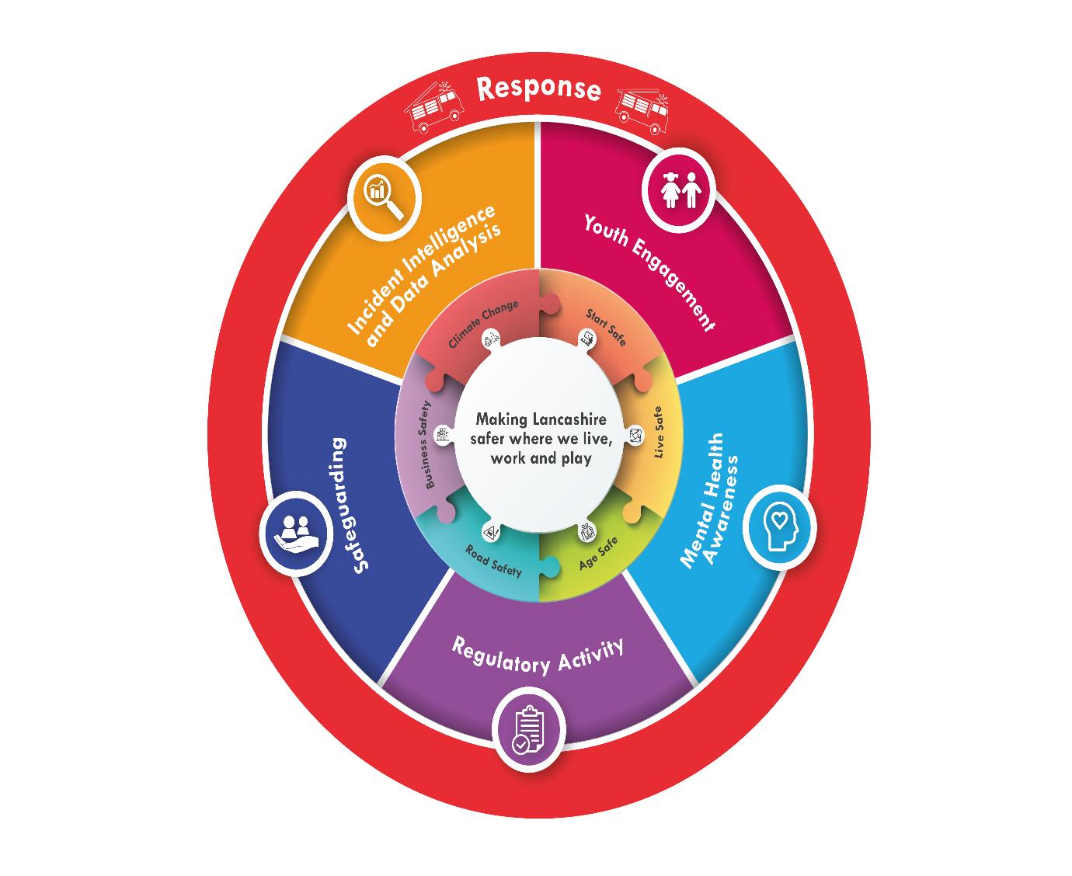
Our approach to supporting and developing our prevention services recognises life's different stages and the risks associated with these. The service operates thematic groups which are led by a prevention support officer and supported by stakeholder groups which include representation from operational and community safety staff, support departments and, on a task and finish basis, external stakeholders. The thematic groups review current practice, identify new areas of work and develop new approaches which are used to continually refine our community safety offer. Underpinning the work of the groups is our ‘partnership cycle’ which is used to bring on board new partners, train their staff and monitor the effectiveness of the collaboration in terms of subsequent number and quality of referrals.

Start safe
Focuses efforts and resources towards educating, supporting and protecting children and young people so that they are able to start their lives safely and grow up to be safe adults and good citizens. Work undertaken by this group supported our journey to become an adverse childhood experiences (ACE) aware organisation, and help our staff understand the impact these can have on wellbeing, life chances and fire risk. This work will now develop in line with broader partnership work towards a ‘Trauma Informed Lancashire.’ The group oversaw the implementation of our “teen safe” education packages and continual embedding and refinement of our “SEND safe” (Special educational needs and disabilities) programme which will continue to evolve over the course of the strategy. Increasing emphasis will be placed on quality assurance and evaluation of the effectiveness of our education packages particularly where these are delivered using different approaches (digital versus in person).

Live safe
Focuses efforts and resources towards assisting the people who live and work in our communities to minimise the risk of fire and other related accidents occurring. Work undertaken by this group includes a quality assure approach for our safe and well visits, working with care & health providers to ensure contemporary training packages and risk awareness and work with groups representing the needs of people living with disabilities.

Age safe
Focuses efforts and resources towards ensuring that our prevention work is delivered in the most effective way to support the individual needs of our older communities. Work undertaken by this group includes promoting dementia awareness and supporting resources to assist people living with dementia; ensuring we use the most appropriate communication methods when engaging with older people; educating our staff to be able to identify more complex needs of older people and the ability to signpost these to appropriate partner organisations who can provide continued and specific support to meet these needs.

Road safety
Road safety affects everyone in Lancashire and is not just about the mechanics of roads, vehicles and street design, but just as much about changing travel trends, attitudes, perceptions and the way that our communities and visitors value and share our roads. 'Towards Zero Lancashire' is the Lancashire Partnership for Road Safety joint response to road safety and has four priorities:
- Leading a co-ordinated and evidence-based response to road safety
- Enabling, engaging and educating individuals and communities to influence road user attitudes and behaviour
- Intelligence led enforcement
- Engineering for safety
LFRS is an active member of the partnership and the focus on co-ordination and a robust evidence base enables us to identify the optimal contribution we can make without fear of duplication or inefficiency. LFRS delivers educational packages on behalf of the partnership to primary, secondary and further education age groups as well as delivering targeted campaign and education work using material sourced from partners and road safety charities. Road risk continually evolves and via the intelligence and co-ordination afforded by the partnership, so too will LFRS’ role within it.

Water safety
Lancashire has a wide range of watercourses including canals, quarries, reservoirs, docks, harbours, coastal risks and both tidal and freshwater rivers. These give rise to a range of risks which vary with the seasons, weather and societal trends. Our strategy draws on the key elements of the National Water Safety Forum’s drowning prevention strategy. Nationally around 400 people lose their lives in water related accidents every year (over 40% of whom never intended to enter water). Water risk in Lancashire reflects the national findings and has at times featured in the upper quartile of national data.
Effective risk reduction relies on gathering accurate data, raising awareness of the problem, and creating successful networks and partnerships where each partner recognises the contribution they can make. LFRS recognises the power of the fire and rescue service brand and the platform this affords from which to deliver education and campaign activity. Although LFRS will continue to support calendar led campaign activity by the Royal Life Saving Society and NFCC, it is recognised that water risk is continually present and varies with the season and location.
LFRS considers itself to be an enabler and works with key stakeholders, landowners and other agencies to develop, promote and deliver water safety education, campaigns and initiatives. This includes supporting the installation of water safety boards at inland locations paid for by landowners and given a unique identification code which enables rapid emergency response to known high risk locations. Although the boards assist with this and provide a throwline to enable safe lifesaving interventions by members of the public already at the scene, their primary goal is to raise awareness of the hazards of open water.
We recognise that coastal risk management is led by the coastguard and RNLI but recognise the need for common safety messaging which applies across all water risks, particularly where tidal rivers and mud flats extend well inland to our cities.
The impact of climate change is increasingly being experienced in the context of local and wide area flooding events. When they occur, these events can lead to significant risk to life, damage to communities and infrastructure. LFRS is part of the Lancashire Resilience Forum and works with upper and lower tier councils and a wide range of partners to ensure communities are prepared. Areas of Lancashire which are known to be particularly vulnerable have established flood action groups and community resilience plans.
Over the course of this strategy, we will:
- Continue to act as an enabler and work with partners to reduce water risk.
- Continue to support the development of the Lancashire Water Safety Partnership.
- Continue to work within the Lancashire Resilience Forum framework to reduce the risk to life arising from flooding events.
Wildfire prevention
The impact of climate change appears to be increasing the number and the severity of wildfires. Including woodland and other land types, wildfires are uncontrolled vegetation fires. Although they can start naturally, the majority are caused by people, either accidentally or deliberately. Increasing leisure activity on open access land, in conjunction with societal trends such as careless use of disposable barbecues, is escalating the risk.
Wildfires destroy habitats, damage the natural and historic environment and release carbon dioxide stored in vegetation which further contributes to climate change. On the rural / urban boundary they can also impact on transport networks, telecommunication infrastructure, power lines, property and businesses, limit tourism and recreation, and ultimately threaten people's lives and longer-term health (through impact on air quality).
Due to the size and timescale of some wildfires, and the amount of emergency service and partner resources required to tackle them, a very significant impact is the reduction in emergency cover experienced by Lancashire’s communities when its fire service is engaged for extended time periods tackling large wildfires.
Supported by specialist Wildfire Officers, our local management teams are embedded within many groups which enable a pre-planned and co-ordinated response to the problem.
Our staff deliver education in schools using partner resources and our own ”teen safe” wildfires module. Annual wildfire prevention campaigns are delivered to local communities and the wider public across a variety of physical and social media platforms.
Over the course of this strategy, we will seek to reduce the number and scale of wildfire emergencies by:
- Working with partners to utilise existing legislation to increasing effect e.g. Landowners and local authorities to implement Public Space Protection Orders for known moorland risks with an associated capability to warn and prosecute offenders,
- Joint working with Police Rural Task Force and LFRS fire investigators to gather increasingly robust evidence to take more arson cases to the courts as a deterrent.
- Work with Landowners and Natural England for effective application of the Burn Code.
- Working with public and partners to change legislation and/or influence societal trends e.g.
  - Raise public awareness of wildfire safety
  - Support the development of the UK fire danger rating system
  - Seek to ban the use of disposable barbecues in defined open spaces
  - Support local authorities to create designated barbecue areas in country parks.
- Work with landowners to reduce the potential for damaging wildfires by:
  - Developing their prescribed burning capability
  - Developing their flail capability to undertake preventative cuts.

Mental health task group
Mental health is overarching across all the thematic groups and the task group considers how aspects of mental health manifest in the risks the other groups are working to mitigate. Trends and intelligence are drawn from the NFCC group and applied in a Lancashire context. This group considers the role LFRS can play as a component of routine day to day work to ensure our staff understand underlying causes of risk and identify opportunities to signpost appropriate support. Work undertaken by this group includes producing a signposting directory, developing hoarding and self-neglect policies, as well as supporting campaigns.
Early intervention, education and youth engagement
Early intervention
Understanding what is meant by the term ‘early intervention’ is helpful to put into context the contribution already made to this by our existing children and young people (CYP) education and engagement offers and what may be developed in the future as the workstream evolves.
The NFCC Children and Young People Early Intervention workstream sets out guiding principles to fire and rescue services as:
- Identifying CYP at risk of poor outcomes
- Tackling risk factors head on
- Prevent problems occurring by increasing protective factors*
- Fostering personal strengths and skills to prepare for adult life
*A range of factors proven to mitigate risk enabling children to be more resilient and to increase wellbeing.
Understanding risk factors is a vital component of this work and LFRS has already embarked on a programme to make LFRS staff ACE Aware.
Over the course of this strategy, we will:
Continue to recognise the importance of early intervention and identify the contribution LFRS can make to increasing protective factors, fostering personal strengths and helping children and young people prepare for a safe adult life.
Education
A range of education packages are delivered as a core prevention activity:
- Child safe; fire safety education to all Year 2
- Road safe; fire and road safety education to all Year 6
- Teen safe; choices and consequences and water safety talks to Year 7 to 10 on request
- Wasted lives; road safety education to Year 10 and 11 on request
- Road safety education to colleges, universities and employers on request
These packages have been developed with stakeholders and partners and in line with national guidance. Historically packages have been delivered within education settings by community safety advisors and operational staff. Future delivery methods will be explored and may evolve but will remain focused on end user engagement.
Over the course of this strategy, we will:
Continue to refine our core education offer and develop new products and delivery methods where the data and evidence demonstrates this is needed to help keep young people safe.
Youth engagement
LFRS have delivered a Prince’s Trust programme for over 20 years to more than 6,000 young people. The programme lasts twelve weeks and is delivered by LFRS staff working alongside secondees from organisations such as the DWP, Lancashire Constabulary and student social workers. It is free for any young person aged between 16 and 25 and aims to improve confidence, motivation and skills. The programme includes work experience, careers advice, community action projects and a team building residential culminating in a nationally recognised qualification. Nine programmes are run from sites across the county. These are predominantly fire stations although standalone sites are also operated. Some teams alternate between sites to ensure a broader offer.
Team staff work closely with further education colleges and local organisations to identify the young people who would most benefit from the programme. In addition to the tangible benefits for the individuals the community links formed reach far and wide and the resultant impact on local communities is significant.
Over the course of this strategy, we will:
Continue to deliver the team programme on behalf of the Prince’s Trust ensuring recruitment focuses on those who will benefit the most and community projects are aligned to mitigation of local risks.
LFRS provides a fire cadet offering which is aligned to the NFCC national guidance vision to provide a world class, inclusive and progressive youth organisation which inspires and empowers young people through nationally recognised community-centred programmes.
The offer is open to all and seeks to empower individuals to reach their full potential through a fun and progressive programme that delivers social action and skills development, contributing to safer, stronger and healthier communities. Skills for Justice qualifications are achieved and the programme can last one, two or three years.
Fire cadet schemes run from several fire stations and are operated by a combination of community safety and operational staff as well as volunteers.
Over the course of this strategy, we will:
Continue to develop our cadet offer in line with national guidance and expand the locations on offer in line with risk and resources.

Arson risk reduction plan
Drawing on the NFCC arson reduction strategy, our overarching objective is to;
Reduce the incidence of deliberate fires and their consequential impacts including personal and economic loss; contributing to community empowerment and economic growth and leading to safer homes, safer businesses and safer neighbourhoods.
Our arson risk reduction plan forms a component of the broader prevention strategy as the measures LFRS will put in place to deliver against the overarching objective span across many aspects of prevention & protection delivery;
To achieve safer homes, we will:
- Deliver tailored arson risk reduction advice as a component of our HFSC (Safe and well) visits
- Offer a prompt arson threat home fire safety check following a referral from the police
- Support multi-agency public protection arrangements on release of convicted arsonists
To achieve safer businesses, we will:
- Provide arson risk reduction advice via thematic and targeted visits by both operational crews undertaking business fire safety checks and business safety advisors
- Deliver tailored arson risk reduction advice as a component of fire safety audits by Inspectors
- Undertake an arson vulnerability assessment as a part of business fire safety checks by operational crews
- Offer arson risk reduction advise on our website and via social media
To achieve safer neighbourhoods, we will:
- Monitor deliberate fire activity to enable the early identification of emerging trends
- Undertake targeted & data driven campaigns to reduce arson and anti-social behaviour fires
- Undertake media campaigns to highlight the dangers of deliberate fires and the potential consequences to individuals and communities
- Recognise that deliberate fires impact our wildlife and moorland areas as well as buildings, street furniture and infrastructure and develop our initiatives accordingly
- Deliver the FIRES juvenile fire setters intervention program
- Deliver teen safe ‘Choices and Consequences’ education packages to key stage 3 pupils
- Undertake early interventions through our Fire Cadet, Princes Trust and other youth engagement projects to promote informed choices, social values and safer behaviours
- Maintain partnerships with local authorities for waste and fly-tipping removal schemes
- Work pro-actively within the local Community Safety Partnership frameworks (which depending on structure incorporate Crime and Disorder Partnerships)
Fire investigation, we will:
- Maintain and develop a fire investigation capability which aligns to national standards
- Ensures the accurate and early identification of deliberate fires and scene preservation
- Provides fire investigators trained to work with police and scenes of crime staff
- Aims to provide high quality submissions into the criminal justice system
- Works with police and scenes of crime to continually refine professional practice
Over the course of this strategy, we will:
Ensure the investigation of crime scenes involving fire conforms to evolving regulatory requirements.

Reducing the frequency and consequence of accidental fires – incident intelligence
Throughout this strategy significant emphasis has been placed on the importance of basing prevention activities and campaigns on data, intelligence and analysis. Data and intelligence is gathered from all incidents by response staff completing the national incident recording system. More serious incidents are attended or remotely supported by our incident intelligence officers whose role is to identify emerging issues or trends. How these are mitigated varies but work in this area includes sharing with regional FRS partners, referrals to trading standards or escalation to appropriate national recipients such as the Building Research Establishment, The Medicines and Healthcare products Regulatory Agency and the NFCC National Protection Learning User Group. The most serious fires, including those of a fatal nature, are subject to a detailed debrief process which considers all aspects of causation and potential future mitigations.
By analysing data from our own incidents and considering information shared by our partners and other FRS’ via NFCC, as well as Regulation 38 Prevention of Future Deaths Notices issued by Coroners, we are able to identify potential improvement themes which are considered by the Data and Intelligence Group and delivered via the Prevention and Protection Task and Group.
Over the course of this strategy, we will:
Continue to develop how we gather and use incident intelligence to refine our prevention and campaign approaches.

How will we measure success?
LFRS recognises the importance of monitoring and evaluating the effectiveness, efficiency and impact of its prevention activity.
Prevention activities are measured and reported via a suite of key performance indicators which are presented to the Combined Fire Authority (CFA) on a quarterly basis and subject to scrutiny by the Performance Committee.
External KPIs generally relate to activity for which the fire authority has direct statutory responsibility however the service also works with partners on a wide range of activities which are complementary to the CRMP and associated with national objectives e.g.
- Water safety: reducing accidental drownings in line with national drowning prevention strategy
- Road safety: reducing road casualties in line with the Lancashire Partnership for Road Safety strategy
Internal KPIs and measures are used to evaluate ongoing aspects of our activities to ensure they remain effective, including:
- HFSC (Safe and well) partnership referral quality, number and alignment to risk
- Behavioural change measured pre and post education sessions
We use quality assurance processes to ensure key aspects of our delivery of our services are delivered consistently and so that we can identify any training needs or changes required to our processes or systems. Amongst other areas these processes are applied to:
- HFSC (Safe and well)
- Education package delivery
All significant campaigns are evaluated to ensure resources are used effectively and learning from one campaign is used to build the next.
All data and information collated is compliant with General Data Protection Regulations (GDPR).

Who are we?
The lead officer for community safety in LFRS is the Head of Prevention and Protection who is accountable to the Director of Service Delivery.
Prevention activity is delivered by fire crews, community safety teams, protection fire safety team, princes trust teams and fire cadet units, distributed throughout Lancashire’s 14 Districts.
Activities are shaped and assisted by the Group Manager Prevention, the prevention support team, and our princes trust co-ordinators, based at Service Headquarters.

Relevant Legislation
- Fire and Rescue Service Act 2004
- Fire and Rescue National Framework for England 2012
- The 1988 Road Traffic Act, Section 39
- Home Safety Act 1961
- Housing Act 2004
- Children’s Act 1989 and 2004
- Working Together to Safeguard Children 2018
- Safeguarding Vulnerable Groups Act 2006 and the Protection of Freedoms Act 2012
- Human Rights Act 1998
- United Nations Human Rights Convention on the Rights of the Child 1989 (Article 12)
- Mental Capacity Act 2005 and Mental Health Act 2007
- Police & Crime Act 2017
- Modern Slavery Act 2015
- Crime and Disorder Act 1998 section 17
- Counter Terrorism and Security Act 2015
- The Data Protection Act 2018
- The Care Act 2014
- Equality Act 2010 Health and Safety at Work Act 1974
- The Management of Health and Safety at Work Regulations 1999
Linked qualifications, accreditations, or Fire Standards:
- Code of Ethics Fire Standard
- Community Risk Management Planning Fire Standard
- Fire Standards Board – Fire Investigation
- Fire Standards Board – Prevention

- DOCUMENT CONTROL
Contact
Department | Name | Email | Telephone
Prevention | Matthew Hamer | matthewhamer@lancsfirerescue.org.uk | 2-6931

Amendment History
Version | Date | Reasons for Change | Amended by
1.0 | 01/01/2022 | Initial Draft Document | AM Hutton
1.1 | 01/04/2022 | Final Document | AM Hutton
1.2 | 19/03/2024 | Yearly review and update document to reflect changes in legislation and synergy with protection services. | AM Hamer

Related Documents
Document Type | Reference Number | Title Document | Location
Equality Impact Assessment | V1 | Prevention Strategy | Internal recording

Fire Standards Board
Telecare services - Lancashire County Council
Adverse Childhood Experiences - Lancashire Safeguarding Children Board
Multi-agency public protection arrangements (MAPPA): Guidance - GOV.UK (www.gov.uk)

