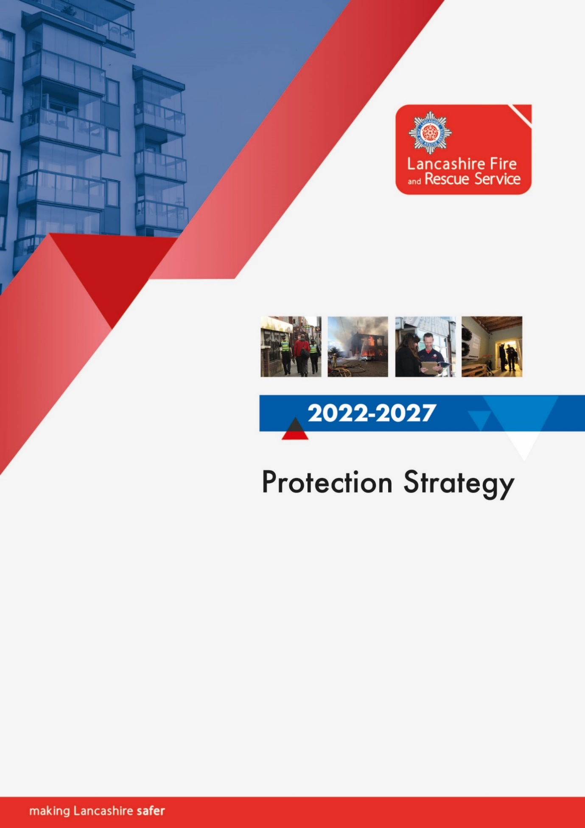

Contents
Protection and business safety strategy 2022/2027 3
Introduction 3
Our commitment to protection and community safety 5
Delivering protection services collaboratively 7
Delivering protection services intelligently - Use of systems, data, and intelligence 10
Improvement and innovation 11
Risk based intervention programme (RBIP) and district planning 12
Managing the risk created by automatic fire alarms and unwanted fire signals 15
Recruitment and workforce development 16
Grenfell Tower, new legislation, and legacy issues in the built environment 19
How business safety links to enforcement management and prosecutions 21
Business safety advisor key work areas 24
Primary authority schemes 27
Heritage plan 27
Links to community safety 28
Links to operations and operational preparedness 30
How will we measure success? 31
Who is responsible for delivering this strategy? 32
Relevant legislation 32

Protection and business safety strategy 2022/2027

Introduction
Fire and Rescue Authorities (FRAs) are required by the National Framework to produce a local Community Risk Management Plan that sets out the authority’s strategy, in collaboration with other agencies, for reducing the commercial, economic and social impact of fires and other emergency incidents.
The Protection Strategy 2022-27 explains how we intend to assess risk in Lancashire’s built environment and thereafter deploy fire protection, community safety and operational resources to manage that risk efficiently and effectively by:
- Working collaboratively
- Delivering our services intelligently
- Continuing to improve and innovate
- Operating a risk-based intervention programme
- Managing the risk created by unwanted fire signals
- Adapting to new legislation and responsibilities
- Recruiting, training, developing and retaining a competent workforce
- Supporting compliance through campaigns, business engagement and support
- Enforcing compliance through transparent enforcement management and prosecutions
- Linking protection activity to community safety
- Linking protection activity to response and preparedness
- Protecting Lancashire’s heritage
- Measuring and evaluating our performance
The Community Risk Management Plan (CRMP) sets out our overall direction and is informed by a Strategic Assessment of Risk. Driven by the CRMP, this protection strategy provides greater detail on how we will deliver and develop protection services during 2022-27.
Over this time our annual service plans will set out the continuous improvements we intend to make to achieve this so we can continually mitigate the potential impacts of risks relating to the built environment, the communities we serve and our employees.
Described in more detail later in this strategy our risk-based intervention programme enables us to determine which premises will be ‘audited’ by highly qualified inspectors, those which will be ‘inspected’ by business safety advisors, and those which will be ‘checked’ by operational crews.
Undertaking a strategic assessment of risk, maintaining a risk-based intervention programme, and utilising annually refreshed district intelligence profiles, is fundamental to the activities we undertake and the protection resources we deploy as certain risks in our built environment are reasonably foreseeable. By analysing national and local data, and using intelligence and learning derived from incidents, we aim to predict the types of emergencies that are most likely to occur and the premises, individuals or groups most likely to be at risk.
Notwithstanding the value of this approach, in our fast moving and constantly changing world we also recognise that historical data doesn’t always shape future events. Accordingly, we recognise the importance of being agile and maintaining the capability to identify emerging trends so we can continue to evolve and deliver our protection activities flexibly and proactively.
Using the risk-based intervention programme and district plans to shape how, when and where we deliver our protection services will ensure they remain appropriate to the needs of Lancashire’s communities and resources are continually allocated proportionately to existing and emerging risk in the built environment.
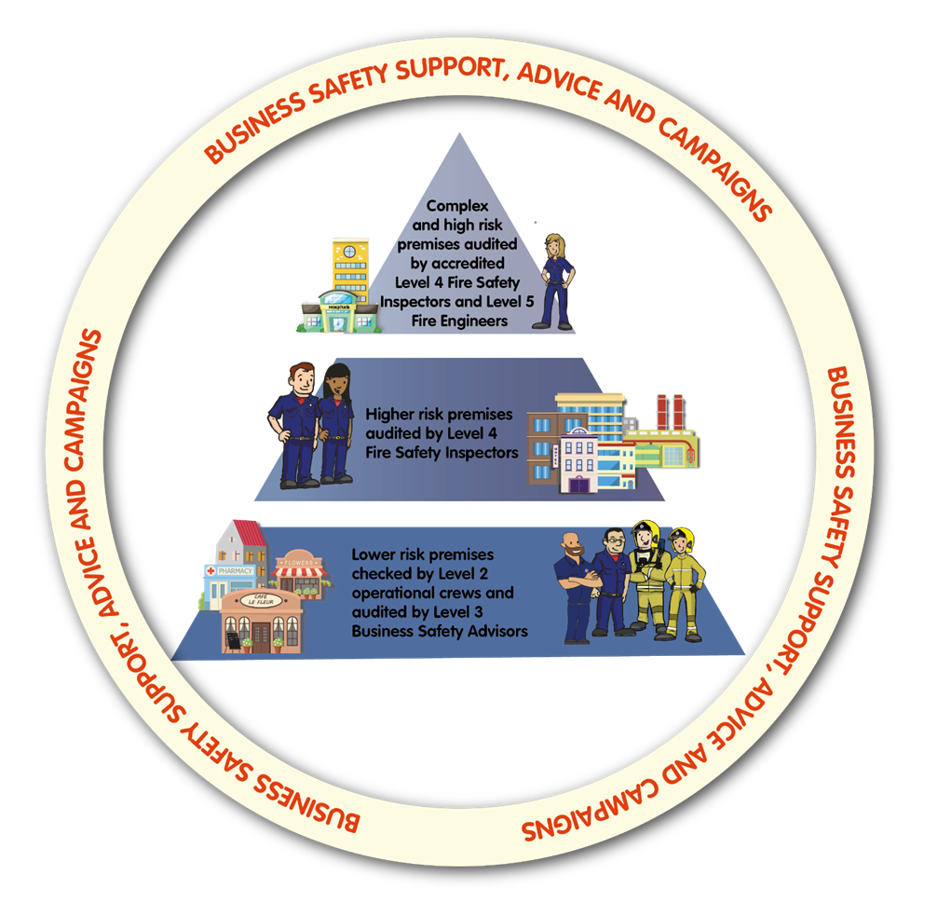

Our commitment to protection and community safety
Our overall aim is to:
“Ensure the authority’s statutory fire protection duties are discharged efficiently and effectively in order to reduce the incidence of fire and the effects of fire should it occur.”
Effective fire protection is not simply about application of fire safety law and enforcement of the Regulatory Reform (Fire Safety) Order 2005 (FSO). Although this is undoubtedly an essential component of how protection teams make Lancashire safer, it is only part of the approach.
Prevention is always preferable to response and is by far the most effective way to make Lancashire safer.
In the context of fire protection, preventative activity is undertaken by carefully targeting our campaign activities, business safety advice and use of regulatory powers to reduce the number of fires that occur in the first instance and be assured that when fire does occur, the resultant impact on life, property and business interruption is less than it would otherwise have been. Taking this approach ensures we protect the health and wellbeing of our communities and staff, and lessens what might otherwise be much more significant consequential adverse impacts on the NHS, social care, police, and commerce etc.
Lancashire is a diverse and culturally rich county. In seeking to identify those who are most at risk in our communities, and target and shape our protection activities accordingly, we will ensure we always act in a non-discriminatory way and provide equality of access to all protection approaches. We recognise the importance of ensuring our workforce is representative of the society we serve, so that we are able to engage effectively with our communities, understand their needs, and how best to meet them. The National Fire Chiefs Council (NFCC) Equality of Access to Services Guidance and our Equality, Diversity and Inclusion action plan acknowledges the links that exist to fire and other hazards, ensuring these are considered when planning our protection activities.
Lancashire Fire and Rescue Service (LFRS) is one of many fire and rescue services nationally and consequently consistency of approach and messaging is vital to ensure the best overall service, not only to Lancashire’s residents and visitors, but also to businesses and commerce who rightly expect to operate within a supportive, fair, transparent and consistently applied regulatory framework.
Accordingly, this strategy will be accompanied by an equality impact assessment and shaped in accordance with national fire standards. It should be read in conjunction with our fire safety enforcement and consultation policy, the risk-based intervention programme policy and our unwanted fire signal policy which are available on our website.
Over the course of this strategy, we will:
Ensure our protection activities are targeted, shaped and refined using the principles of equality impact assessment.

Delivering protection services collaboratively
We will continue to work collaboratively with a range of stakeholders and partners so that not only can we conduct our own business safety, regulatory inspection and enforcement activities in the most efficient and effective way possible, but also so that collectively we can maximise our resources to identify those most at risk from fire and thereafter plan, promote, support and deliver mutually beneficial and, wherever possible pro-active, protection related activities. At all times seeking to achieve the best outcomes with the minimum regulatory burden on businesses that are seeking to comply and keep their staff and visitors safe.
Although fire and rescue services have statutory responsibilities for promoting fire safety and enforcing the FSO the overarching objective of keeping people safe from fire and associated risks does not sit with fire and rescue services alone.
Fire safety legislation overlaps with a wide range of other regulation. Successful application of the FSO, and optimal use of resources to keep people safe from the risk of fire in the built environment and minimise regulatory burden for businesses, requires LFRS to work closely with a range of other regulators, including but not limited to:
- Local authority building controls - Local authorities have unique powers under the Building Act 1984 to enforce the building regulations and have non-compliant building work altered or removed.
- Approved inspectors - Approved inspectors are companies that can provide an alternative to obtaining building regulations approval from a local authority.
- The Care Quality Commission (CQC) - The CQC monitor, inspect and regulate services that provide health and social care.
- Local authority housing standards - Local authority housing provide advice, information and enforcement in relation to both the economic and consumer standards for social housing registered providers.
- Local authority environmental health - The local authority environmental health teams are responsible for the regulations and standards set by government for a wide range of business sectors and activities including, food safety, health and safety, environmental protection.
- Local authority and police licensing teams - The Local authority and police licensing teams provide support, guidance and regulate businesses, organisations and individuals who want to sell alcohol.
- Local authority trading standards - Within their role trading standards, amongst other things, enforce fair trading, monitor product safety, ensure age limits and restrictions are correct.
- Health and Safety Executive (HSE) - The HSE are the national regulator for workplace health and safety and the ‘Building Safety Regulator’
- Police - Detect and investigate criminal offences and case build for the Criminal Justice Service.
Although LFRS always works closely with other relevant regulators after a fire has occurred when a joint investigation is required, the preferred approach is always to share intelligence and pre-plan proactive inspection programs based on risk before an incident has happened. This pre-planning can take many forms including formal planning meetings (e.g. the LACORS approach for housing risks), multi-agency thematic inspections (e.g. peak risk inspections of licensed premises), using data sharing agreements or publicly published data (e.g. CQC Inspection outcomes) or simply via intelligence sharing from one agency to another after a poor inspection outcome or complaint received by one agency that highlights potential issues for another.
The overlap of legislation with other regulators provides an ongoing opportunity to conduct statutory and non-statutory consultations relating to proposed and actual building work and to proactively support future compliance by highlighting potential issues relating to forthcoming FSO compliance once premises are occupied.
Although LFRS is responsible for promoting and enforcing the FSO, the objective of keeping people safe from fire and associated risks is also shared by many organisations who do not necessarily have direct fire safety regulatory duties.
Utilising an intelligence led and risk-based approach we will also seek to identify the optimal organisations in this category with whom we can collaborate. In each case the objective being to ensure they are ‘aware’ of the built environment fire risks associated with their particular area of responsibility so that we can then support and ‘enable’ them to contribute to future risk reduction by co-developing approaches that help minimise the risk from fire in their part of the built environment where doing so is mutually beneficial.
By taking this approach we will create wider awareness of what ‘good compliance looks like’ and in addition to the obvious reductions in risk that come with this, the anticipated by-product is that when premises who are seeking to comply with their fire safety responsibilities are audited, they will require minimal auditors time and will attract good audit outcomes. This approach reduces the regulatory burden on premises and frees up inspecting officer time to deal with less compliant premises. We will seek to do this in increasingly innovative and engaging ways e.g. by delivering educational webinars. This approach will include but will be not limited to:
- Social Care Providers - commission specialised housing and care homes for both adults and children)
- Housing Associations - (provide social homes, shared ownership homes, and supported / specialist housing)
- Tenants Groups and Associations - (represent the voice and interests of residents and leaseholders)
Although our focus remains making Lancashire safer from fires and other emergencies, we recognise the natural link between successfully achieving our objectives and the resultant cashable benefits to health and social care in terms of less people entering their services with acute and critical needs after a fire. To ensure our offer remains current, informed and targeted, we will continue to engage in national, regional, Lancashire, and district level meetings with stakeholders and partners where there are clear and mutually compatible objectives.
Over the course of this strategy, we will:
Continue to develop strategic collaborations to raise fire safety awareness and improve fire safety standards in premises before inspections are undertaken.

Delivering protection services intelligently - Use of systems, data, and intelligence
We will gather and store evidence and information in a manner that is compliant with legislation and be able to extract, use and share that information to support our fire protection, prevention, emergency response crews and other functions.
We will continue to use a range of data sources and information management systems to plan and deliver protection services, these include but are by no means limited to:
- National Incident Recording System (IRS)
- LFRS Assurance Monitoring System (AMS)
- LFRS Community Fire Risk Management Information System (CFRMIS)
- LFRS Risk Based Intervention Programme (RBIP)
- LFRS Post Incident Action Log (PIAL)
- LFRS Provision of Risk Information to Staff system (PORIS)
- Land Registry and Companies House databases
- National Land and Property Gazetteer (NLPG)
Allied to use of such systems we recognise that systems are only as good as the data that is entered into them and the understanding of the staff who use them. Accordingly, we will carefully maintain and nurture our staff culture and operating structures to recognise the importance of organisational learning and will continually seek to refine our ability to capture feedback and intelligence from a range of internal and external sources. Thereafter we will evaluate this intelligence, share and act upon it to drive innovation, continuous improvement and future performance through three key operating structures:
- Organisational Assurance Group (OAG) - Utilises the Assurance Monitoring System to record and track protection learning.
- Prevention and Protection Task Group - Refines existing, and develops new, protection and prevention policy.
- Data and Intelligence Group - Receives incident intelligence reports from the Service’s incident intelligence officers.
LFRS operate a team of incident intelligence officers (IIOs). In addition to undertaking fire investigations in accordance with nationally recognised standards, the team are trained to identify new and emerging trends based on incidents in Lancashire, and elsewhere as reported within their fire investigation professional networks. Consequently, fire protection officers, incident intelligence officers, and operational fire crews can identify new and emerging issues which originate from audits or incidents within Lancashire that should be used to not only update the Lancashire risk profile but also be escalated to the national protection learning user group or other relevant organisations such as trading standards, the Crown Premises Inspectorate Group or Building Research Establishment.
Conversely where intelligence comes into the service from any source, or indeed from the national protection learning user group via the LFRS single point of contact, our Organisational Assurance Team will log and track the issue with our protection leadership team determining the appropriate action to take, by whom and appropriate timescales.
We will continually seek to contribute to the continual improvement of protection activities by taking guidance from, and contributing to, the NFCC network and the work of the protection reform unit, joining working groups and responding to consultation requests where appropriate.
Over the course of this strategy, we will:
Use local, regional, and national intelligence and learning to continually evolve and refine our protection services.

Improvement and innovation
Delivering effective improvement and innovation requires finance allocating, close project working and co-ordination with a range of internal departments and external product and service providers. To ensure this is co-ordinated effectively, LFRS operates a Corporate Programme Board (CPB) Structure.
Improvements and innovation in protection activity are identified across the department with viability, efficiency, and productivity improvements undertaken by the Protection Transformation Team (PTT). Improvements and ways of working are continually identified and implemented. Significant improvements which meet the services project management thresholds are reported through our Business Process Improvement Programme.
Project deliverables are approved by the CPB based on identified organisational need and leadership vision derived locally or nationally. In some cases, this is driven by internal requirements, learning and reviews, in others, objectives originate from external factors such as HMICFRS Inspection findings or the need to adapt systems in line with changing legislation and user needs. Like many organisations, the adaptations made during the pandemic response have accelerated business process change and created new visions in how we can use digital solutions to improve efficiency and effectiveness.
Although deliverables will inevitably evolve over time, those already being developed by the PTT at the commencement of this strategy included:
- Increasing utilisation of short audit and remote short audit principles where appropriate
- Refining the RBIP system and its associated internal and external guidance
- Refining automatic production of letters and notices following audits
- Creating a new business fire safety check app and allocation system for operational crews
- Developing a mobile working solution for fire safety inspectors
- Creating a digital storage solution for premises specific information and plans that is fit for the future, able to support mobile working and future regulatory change.
Over the course of this strategy, we will:
Seek to build on the learning acquired during the pandemic and create new and innovative ways to deliver protection services, adopting digital approaches where appropriate.

Risk based intervention programme (RBIP) and district planning
To manage risk, and allocate inspection resources effectively, it is first necessary to define what constitutes risk. LFRS operates a risk-based intervention programme based on nationally recognised principles refined further at a local level using data and intelligence relevant to risk in Lancashire.
As Lancashire has over sixty thousand regulated premises it is not possible to audit them all. Indeed, attempting to do so would inevitably be ineffective as valuable resources would be allocated to very low risk premises that have minimal potential to cause harm, at the expense of very high-risk ones where occupants are at significant risk of harm if a fire occurs. The RBIP ensures the pre-planned use of officer and Operational Crew time is focussed on the premises which have the greatest potential to cause harm if risk is not being managed effectively by premises management. Taking this approach enables us to continually suppress risk in the built environment and ensure that potential to cause harm is sustained at levels which are as low as reasonably practicable.
In general terms, the premises which are audited most frequently are those in which:
- Occupant's sleep, are unfamiliar with the premises and unable to escape without significant assistance and pre-planning (e.g. hospitals, nursing and care homes)
- Occupants sleep and are unfamiliar with the premises (e.g. hotels and hostels)
- Occupants sleep and are familiar with the premises (e.g. blocks of flats)
- Occupants are awake but unfamiliar with the premises (e.g. theatres, pubs, clubs)
In determining inspection priority further within those definitions, the RBIP also considers:
- History of previous fires in the premises (indicative of future likelihood)
- History of previous fires in the vicinity of the premises (indicative of arson risk)
- Distance from a fire station (indicative of the length of time the building will have to perform to protect its occupants before firefighting interventions can be made)
- Flood risk (as fire risk intensifies significantly during flooding when power fails and reliance is placed on fire safety systems working on back-up power supplies)
- The height of the premises (taller premises place greater reliance on fire safety systems and building construction and management to protect their occupants).
- The date and outcome of previous inspections
- Other data which is relevant to specific premises types (e.g. care home inspection data from the CQC indicating poor safety management).
Premises that present the highest risk will be audited and visited most frequently. Premises considered to be lower risk will be audited primarily in response to complaints, following incidents, or on a randomly sampled basis to verify their lower risk classification (circa 5% of all activity) and to confirm that the Responsible Person is complying with their statutory duty and requirements of fire safety legislation.
The RBIP sits within our wider intervention framework and determines how we pre-plan the allocation of both Operational crew and inspecting officer time. To support the provision of advice, fire safety compliance and public safety throughout the entirety of LFRS intervention programme the service operates a Business Fire Safety Check (BFSC). The application of local risk profiling enables service delivery managers (SDM) to target BFSC to premises which, by virtue of the outcome of our risk-based methodology being applied, are deemed low risk. The BFSC process enables Operational crews to provide relevant business support, reduce immediate risk by way of interventions, for instance advice on keeping exits clear or, where required, refer concerns to the relevant fire safety inspector.
We also recognise that use of historical data is not always indicative of future events and consequently retain the ability to respond in an agile way to partner referrals, post fire audits, fire safety complaints and where emerging local or national intelligence suggests certain premises should be targeted irrespective of their position in the RBIP e.g. previously unknown concerns emerge over a particular external wall (cladding) system.
The final component in pre-planning inspecting officer activity is to ensure a proportion (circa 10%) of audits reflect the needs of the local district plan, as driven by the data in the annually refreshed district intelligence profile. The district plan is owned by the local SDM and the data in the intelligence profile will include data on dwelling fire activity rates which will influence the geographic areas and type of premises audits will be booked in e.g. purpose built or converted flats, and houses in multiple occupation. It is probable that the premises or areas the SDM would wish to target already feature in the RBIP however having this local latitude ensures risk profiling to the lowest possible levels if this is not the case.
Over the course of this strategy, we will:
Contribute to the continual improvement of fire protection activities coordinated through the NFCC community risk programme and seek to refine the RBIP in line with emerging national guidance.
Review fire protection delivery arrangements to ensure inspection and consultation resources are aligned to risk and working practices are efficient and effective.

Managing the risk created by automatic fire alarms and unwanted fire signals
A false alarm or unwanted fire signal (UWFS) is defined as an alarm activation resulting from a cause other than a fire which is passed via a monitoring centre. If an automatic detection and fire alarm system is correctly planned, installed and maintained, it can significantly improve safety by detecting a fire and sounding the alarm at the initial stages of a fire's development. Unfortunately, this equipment can also produce unwanted or false alarms. UWFS have a major impact on fire and rescue services due to:
- diverting essential services from other emergency incidents
- placing operational crews and the public at risk whilst responding
- impacting on community engagement, arson reduction and training activities
- incurring a cost of attendance on taxpayers.
The broader impact of UWFS on the community includes:
- disruption to business
- disruption to customer activities
- cost to business with on-call firefighters being released from primary employment
- disruption to arson reduction, community safety and fire safety activities
- impact on the environment due to unnecessary vehicle movements
Nationally UWFS attribute circa 150,000 incidents per year to fire and rescue services. Over the previous five years UWFS have attributed circa 4,500 incidents per year to LFRS. Each one resulting in an avoidable cost to both the fire and rescue service and the public.
LFRS aims to support business and building owners to manage their premises effectively to reduce the number of UWFS along with the disruption and impacts incurred when they do. Business safety advisors (BSA) monitor incident data to ensure they can target advice and support towards the premises where UWFS begun to exceed tolerable levels.
Where UWFS levels continue to occur above tolerable levels, fire safety inspectors may utilise the FSO to take enforcement action to ensure fire alarms are installed, maintained and managed in accordance with recognised national standards.
Nationally the approach to managing the risk created by UWFS is subject to continual refinement through NFCC working groups. LFRS will engage with these groups to ensure our approaches remain aligned to risk and contemporary.
The previous approaches are reactive i.e. risk is managed after the event occurs. More proactive options for mitigating the risk associated with automatic fire alarms are available including the option to amend the fire engine attendance policy in line with risk. LFRS have taken this approach, following consultation with local commerce, supported by an agreed exemption policy that ensures normal attendance to high-risk premises such as hospitals, care homes, flats and other sleeping accommodation continue. Low, non-sleeping risk, premises such as factories, offices and shops may receive a reduced or no attendance unless a fire is confirmed.
Over the course of this strategy, we will continue to seek to reduce the risks associated with UWFS by;
Review fire engine attendance policy to automatic fire alarms and the associated unwanted fire signals policy

Recruitment and workforce development
Successfully delivering fire protection activities fundamentally depends on the recruitment, training, development and retention of a technically competent, professional, self-starting workforce who demonstrate behaviours consistent with the NFCC regulators code of ethics and LFRS’ own leadership framework and values.
We will maintain a competent fire protection workforce by adopting the NFCC competency framework for fire safety regulators (the framework) in full by:
- embedding it into policies, procedures, guidance, and training delivery and material
- ensuring employees have the appropriate skills, knowledge, experience and behaviours to be competent in their role by through training and continued professional development
- providing training on specialist premises
- recording and monitoring competence
- ensuring officers meet and maintain competence requirements by undertaking recognised prior learning (RPL) where required, and continued professional development (CPD)
- ensuring protection officers who work on higher-risk premises have the requisite competence and accreditation to do so
- ensuring access to a competent fire safety engineer for the purpose of assessing and regulating premises involving fire engineered solutions.
- ensuring developing staff are assigned to a fire safety competent manager as a mentor
- having an assurance process in place
The framework advocates national occupation standards and qualification expectations commensurate with the level of complexity of the work undertaken. The qualifications necessary to deliver the framework range from level 3 to level 7 which take many years to develop and therefore it is necessary to undertake succession planning and talent spotting to maintain a sustainable competent fire protection workforce. In turn this process shapes the balance of internal development versus external recruitment.
For all buildings regulated under the FSO:
- Business safety advisor – Level 3 Certificate in Fire Safety
- Fire safety inspector – Level 4 Diploma in Fire Safety
- Fire engineering design technician – Level 5 Diploma in Fire Engineering Design
- Fire safety engineer – Level 6 Degree Fire Safety Engineering and/or MSc fire engineering
- Senior fire safety engineer – Level 7 MSc in Fire Engineering
In addition, for higher risk buildings as defined as ‘in-scope’ by the Building Safety Act:
- Fire safety inspector – Level 4 Diploma in Fire Safety and relevant registration with a professional body
- Fire engineering design technician – Level 5 Diploma in Fire Engineering Design and registration as an engineering technician with the Engineering Council.
- Fire safety engineer - Level 6 Degree in Fire Engineering and/or MSc in Fire Engineering and working towards interim (or full) registration for Chartered Engineer with the Engineering Council.
In addition to the technical competence required to qualify as a fire safety inspector, and work with the HSE as part of the building regulator, specified LFRS inspectors will be required to accredit to a professional, independent third-party body.
Whilst most regulatory activity can be pre-planned and take place at predictable hours there are also circumstances where an out of hours capability is required. We will deliver an out of hours capability to ensure competent staff are available to investigate fire safety complaints and undertake scene preservation and evidence gathering at serious fires where buildings have not performed as expected and/or there are reasons to believe offences under the FSO may have been committed.
We will continue to invest in appropriate face to face and on-line training for all staff who deliver our protection services. In considering broader staff development, we recognise that societal risk is never one dimensional and that what may constitutes risk for one organisation may well have different impacts for another e.g. in a health sense fuel poverty and deprivation contribute to poor health outcomes and chronic illnesses, from a fire risk perspective the same determinant typically leads to unsafe forms of heating and serious fires with acute injuries. Recognising these interdependencies is a vital component of being able to work with partners to best overall effect. Consequently, we will support our staff to develop their skills and expertise in broader community safety issues such as adverse childhood experiences, safeguarding, preventing extremism, modern slavery etc.
Over the course of this strategy, we will:
Continue to adopt the NFCC Competency Framework for Fire Safety Regulators

Grenfell Tower, new legislation, and legacy issues in the built environment
We will continue to shape our services and adapt how we undertake our regulatory responsibilities following the Grenfell tragedy and Inquiry. We recognise the challenges experienced by tenants and leaseholders in buildings which have been found to have fire safety deficiencies and the importance of the tenants' voice. We further recognise that improving fire safety standards in residential buildings can be complex and time consuming and require the involvement of many stakeholders' including developers, leaseholders, freeholders, managing agents, tenant management companies and local authority housing. We will work with all stakeholders to secure the most effective solutions in both an interim and long-term sense applying national guidance throughout.
We will work with prevention, response, training and emergency planning colleagues within Lancashire and beyond to fully deliver the actions required from the Grenfell Tower Inquiry. Wherever possible we will ensure this work is undertaken collaboratively with regional and national partners to ensure effective and sustainable actions are consistently applied.
This strategy fully recognises that the period it covers has already, and will continue to, see the most fundamental changes in fire safety and construction industry regulation for decades.
The Fire Safety Bill received Royal assent in 2021. The Bill clarifies that for any building containing two or more sets of domestic premises the FSO applies to the building’s structure and external walls and any common parts, including the front doors of residential areas. It also clarifies that any references to external walls includes doors or windows, and anything attached to the exterior including balconies. Throughout 2021 and beyond, secondary fire safety legislation continued to be introduced on a range of specific matters identified in the Grenfell Inquiry relating to high-risk residential buildings including the need for secure information boxes, personal emergency evacuation plans etc.
The Building Safety Act 2022 commenced in 2023 following a transition period. The Act is far broader in scale and scope and created a new building regulator (led by the HSE and including building control and fire authorities). The Act is intended to ensure that there will always be an accountable person responsible and/or a principal accountable person for keeping residents safe in high rise buildings, and indeed for other buildings which are classed as being ‘in-scope’. The Act will apply to existing in scope premises and new builds. In the case of the latter the design, planning and construction phase will be far more stringent than previous regimes and includes gateways through which the design must successfully pass. The Act also includes provisions for controlling the charges residents pay for fire safety and for ensuring the ‘residents voice’ is listened to by the accountable person. Residents and leaseholders will have access to vital safety information about their building and new complaints handling requirements will be introduced to make sure effective action is taken where concerns are raised.
New multi occupied dwelling builds will have the benefit of the application of recent changes to building regulations banning the use of combustible cladding on high rise premises and lowering the height above which sprinklers are required. Existing multi occupied dwelling builds, and indeed other premises types, will not have benefitted from the amendments to building regulations and may not have compliant external wall systems. We will continue to build on the risk profiling exercise we undertook as part of the Home Office and MHCLG Building Risk Review in 2019-20 which saw us undertake a detailed audit of all high-rise residential premises in Lancashire. This process identified a relatively small number with non-compliant external wall systems with whom we will continue to work to support appropriate interim measures whilst remediation is planned, financed and undertaken. A cause for significant concern was the number of premises which were compliant in terms of external wall systems but had other significant failings in terms of breaches in compartmentation either during a flawed design and build process or due to the actions of tradespersons installing new cable and pipework whilst the building was in use.
To ensure LFRS can continue to adapt to the changes new legislation will inevitably bring we have introduced a protection transformation team which will remain in place throughout the period of regulatory change.
Over the course of this strategy, we will:
Complete the Protection actions required by virtue of the Grenfell Inquiry
Adapt our Regulatory services to the amended FSO and new fire safety legislation ensuring the availability of a sufficient number of suitably trained and accredited staff.

How business safety links to enforcement management and prosecutions
“Supporting compliance through campaigns, business engagement and tailored support. Enforcing compliance through transparent enforcement management and prosecutions.”
We recognise that most businesses acknowledge the importance of fire safety. Not just in a legal and regulatory sense, but also in terms of a desire to keep people safe, protect their premises and ensure business continuity for their activities. Consequently, we will continually seek to engage with the business community in a constructive and helpful way. We will also proactively support primary authority partnership schemes where appropriate.
Our main objective will always be to support compliance through campaigns and business engagement however as a regulator we recognise that we must maintain the capability to enforce compliance through transparent enforcement management and prosecutions where taking this approach is justified and supported by the enforcement concordat.
Maintaining the capability to investigate breaches in fire safety law in accordance with PACE codes of practice and being able to take prosecutions to magistrates and crown court is a fundamental component of business support and this strategy. Most businesses recognise fire safety as a legitimate business expense and invest in appropriate fire protection systems in both an initial capital and ongoing revenue sense. This inevitably has an impact on the cost of running the operation which is ultimately encapsulated in the pricing structure the business then offers for its goods or services. Businesses that fail to invest in fire safety, either by omission or conscious decision, may be capable of offering goods or services at lower prices but are doing so at the expense of safety for their staff and the people who use their premises. Such businesses undermine the economy of Lancashire and put its reputation as a safe place to live, work and visit at risk. Consequently, taking enforcement action and prosecutions, when justified, demonstrates that such omissions or conscious decisions ultimately have more expensive consequences than seeking to comply in the first instance - thereby incentivising compliance for those who might otherwise elect not to.
We will assist businesses toward compliance and contribute to an economically prosperous county by:
- Providing tailored fire safety advice via a variety of methods including phone conversations, visits, letters and e-mails, campaigns, social media platforms, events
- Supporting and recognising partnerships
- Developing campaigns and associated resources to help businesses understand what good compliance looks like and how they can most easily achieve and maintain it
- Setting out our commitment to priorities, planned interventions and targeting taking into account previous inspection history when planning inspection programmes
- Following the principles of better regulation set out in the Statutory Code of Compliance for Regulators and the Enforcement Concordat
- Using interventions, including enforcement action, in accordance with our enforcement policy and the principles of proportionality, accountability, consistency, transparency
- Our enforcement action will be achieved through the use of an Enforcement Management Model (EMM). Fundamental to this is the principle that enforcement action should be consistent and proportional to the fire safety risks and the seriousness of the breach
- Maintaining the capability to undertake prosecutions as a sole regulator or jointly when the EMM shows it is appropriate to do so
- Operating systems to train, appoint, authorise, monitor, and maintain a competent inspectorate, including operational personnel (where appropriately trained)
In addition to maintaining a workforce of fire safety inspectors (FSI) we will ensure each area has business safety advisors (BSAs). BSAs work with businesses to help them keep their premises safe from fire by offering tailored advice and education to reduce risk. BSAs may also undertake audits of simpler premises and are trained to recognise risk and non-compliance but must refer to fire safety inspectors if their findings indicate that enforcement action may subsequently be warranted. The role involves a diverse mix of work including visits to a wide spectrum of businesses and joint visits with other agencies to actively support and promote business safety. The role also involves proactive promotional work during campaigns and at events and reactive work after incidents.
As our ambassadors, BSAs are expected to demonstrate excellent customer service skills. From a ‘customer’ experience perspective, our initial approach to achieving safe premises and compliance will be proactive and will seek to engage our ‘customers’ and work with them to educate and encourage. The objective being making it easier for responsible persons to understand and comply with the regulations.
We recognise that providing such support is a significant use of resources. Whilst provision of education and encouragement can be very worthwhile and an effective use of time it is important that BSAs are able to establish when the responsible person they are working with may ultimately be resistant to achieving compliance or unwilling to do so, may be absorbing inappropriate amounts of BSA time, and by doing so placing the people who use their premises at risk and impacting on the wider ability of the BSA to support other businesses. Consequently, BSAs are trained to recognise ‘compliance characteristics’ and work with responsible persons in the green and yellow portions of the graphic below, referring onwards to fire safety inspectors for those potentially in amber or red.
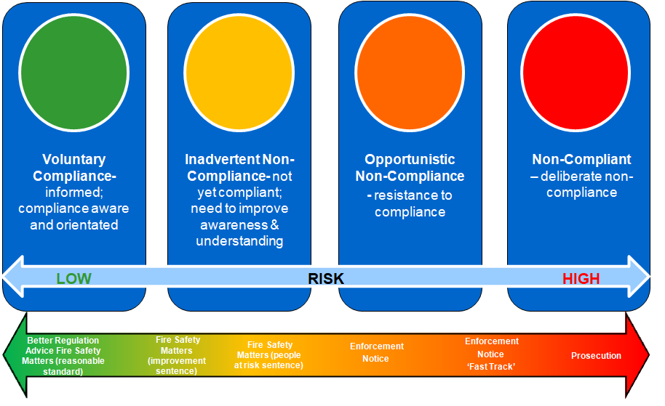
Working in this way ensures businesses are supported and the finite resource of fire safety inspecting officers is focussed on the audit of higher risk premises and undertaking enforcement action and prosecutions only when appropriate to do so based on the risk to occupants of the premises and the attitude of the responsible person/s. The graphic illustrates this approach and the type of regulatory activity appropriate for each ‘compliance characteristic’. The attitude of the responsible person is only a component part of the full audit process undertaken by a fire safety inspector and its contribution within our Enforcement Management Model.
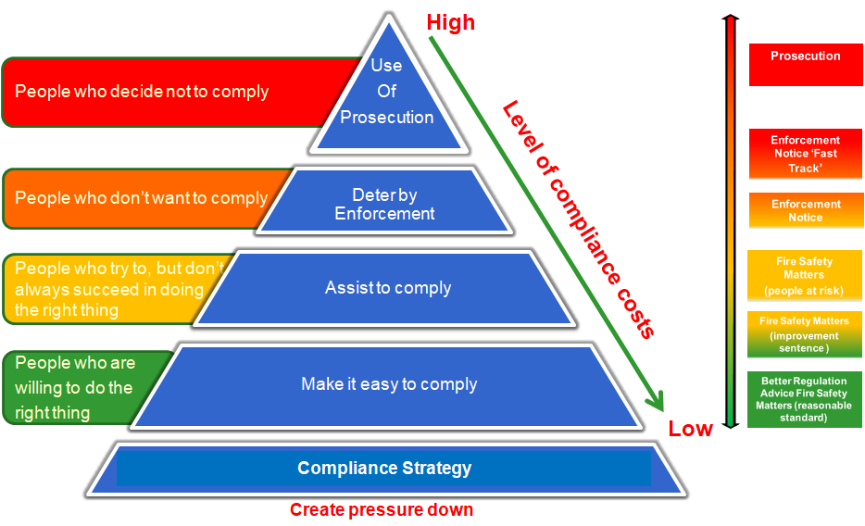

Business safety advisor key work areas
Advice and education: To support business owners and responsible persons to meet their statutory obligations under fire safety legislation. Providing fire safety advice via a variety of methods including phone, visits, letters, e-mails, campaigns, social media platforms and events. Promotion of the LFRS business safety website support.
Fire safety complaints: To ensure complaints are acknowledged, triaged and passed to an appropriate LFRS officer or partner agency to be investigated in accordance with policy.
Post fire intelligence and support: To visit regulated premises that have experienced a fire and provide fire safety and business continuity advice to owners and managers. To visit other regulated premises in the vicinity and provide wider advice and support particularly where the cause of fire may be related to arson vulnerability. Where significant non-compliance with regulation is known or suspected, particularly where people have been put at risk, the matter will be referred to a qualified FSI to undertake a post fire full audit. Outcomes will be recorded on the Post Incident Action Log and intelligence identified shared appropriately.
Unwanted fire signals: To interrogate management information systems and triage activity levels to identify commercial premises which are causing false alarms which exceed acceptable policy thresholds. Thereafter to work with business owners to reduce the number of unwanted fire signals from automatic fire detection and alarm systems in accordance with service policy.
Business continuity planning advice: To assist business owners and Responsible Persons with business continuity and emergency planning, this should include; general BCP, risk assessment, flood guidance and promotion of the workplace 1st responder and defibrillator allocation. The BSA will utilise a BCP information pack to help support businesses.
Campaigns: Under the direction of the Protection Support Station Manager develop and deliver service wide campaigns which are data led and targeted at specific premises types, audience groups and shaped around a relevant ‘call to action’. Under the direction of the community fire safety team leader develop and deliver local district level campaigns which are data led, aligned to the objectives in the district plan and targeted at specific premises types and audience groups and shaped around a relevant ‘call to action’.
Events and networking: Identify appropriate networking opportunities within chambers of commerce, business improvement districts and the like for the purpose of sharing business safety information and identify appropriate events to attend and promote business fire safety.
Risk profiling and monitoring: To identify and capture relevant information on regulated premises not currently on the service’s Community Risk Management Information System (CFRMIS) and record details as appropriate. Triaging those that may require inclusion in the risk-based intervention programme and sign posting to operational staff for site specific risk information and community safety for home fire safety checks.
Planning permissions: As fire and rescue services are not statutory consultees in the planning process BSAs will review district council online planning portals sending template letters to planning authorities where doing so assists the early identification of potential fire service access issues and water supply requirements and making recommendations for the early consideration of sprinkler systems. Reviewing planning application liaison with Fleet Department on water supplies and sharing information with the service’s water officer.
Licensing consultations: Fire and rescue services inspect licensed premises under the FSO which has sufficient powers to keep premises safe from the risk of fire. Although inspecting officers keep police and local authority licensing teams informed of ongoing issues, a license review will only be requested when an enforcement notice has not been complied with or a prohibition notice has been issued. Consequently, licensing consultations are an opportunity to arrange an inspection when a new premises is coming into use (should also have been subject to building regulations), or there is a significant change to an existing license. In most other cases the consultation will relate to a more minor change and letters advising of how to keep premises safe from the risk of fire are sent to the licensing authority for onward communication to the licensee. Where licensee details are known the letter is also sent directly to the premises. The BSA role is to triage the consultation and deal accordingly.
Audits of simple premises: BSAs are trained to Level 3 Fire Safety Certificate standard. Throughout their development and once competent in role they audit what are known as ‘simple premises’ whilst following up on issues identified as part of our BFSC service. Simple premises are those with simple layouts such as small shops, offices or industrial units with non-complex means of escape conforming to recognised code of practice e.g. approved document B, the local government guides or LACORS. The risk does not require compensatory features in order to make the fire safety strategy work. The occupants are generally awake/familiar but there may be well managed sleeping (e.g. small hotel or HMO). The numbers of relevant persons is low. Simultaneous evacuation is in place.
Over the course of this strategy, we will:
Refine our approach to business support to ensure our campaigns and associated resources meet the needs of customers as legislation and guidance continues to evolve and place greater expectations on responsible and accountable persons.

Primary authority schemes
We will continue to provide primary authority partnerships to provide assured, consistent regulatory advice that makes it simpler and easier for businesses who are signed up to the scheme to comply with fire safety legislation.
Over the course of this strategy, we will:
Review of primary authority scheme policy to ensure it remains fit for purpose.

Heritage plan
Lancashire’s heritage defines its history and identity, comprises some of its most identifiable national and internationally recognised landmarks, has a high financial and social value and in many cases drives aspects of the economies which fuel our districts.
As heritage premises are unlikely to be sleeping risks and therefore will not naturally be identified for audit by the risk-based intervention programme it is necessary to consider them separately. For the purpose of this strategy, LFRS defines heritage risk as Grade I and Grade II* premises and their contents where appropriate.
Whilst LFRS is directly not responsible for safeguarding heritage assets, having a policy, with a named heritage liaison officer, helps ensure that fire safety remains a priority for the organisations that manage them. In addition to securing compliance with the fire safety order audits are also used to convey wider risk reduction advice including signposting to specialist advice and the importance of arson risk reduction.
The strategy also includes links to operational preparedness to ensure site specific risk information remains current and appropriate.
Over the course of this strategy, we will:
Review our heritage policy to ensure it remains fit for purpose.

Links to community safety
Throughout this strategy reference has been made to the phrase ‘built environment’. The term is used to describe the structures society creates for our homes and to accommodate retail, education, industry etc. We recognise that a protection strategy cannot sit in isolation and must recognise the significance and variance in risk associated with the different ways dwellings can be provided including when they are provided within multi-occupied buildings such as houses of multiple occupation, buildings converted to flats and those which are purpose built.
Our prevention strategy focusses on working with partners to raise fire safety awareness and effect behavioural change to reduce risk to individuals and families in their individual homes due to personal factors related to health, age and lifestyle choices etc and the provision of equipment and alarms needed within their own dwelling to help achieve this.
Our protection strategy compliments this approach and focusses on the way buildings in their entirety should perform in fire conditions to protect all their occupants and ensuring owners and managers understand their responsibilities and discharge them effectively.
As the built environment landscape changes so must our services to the community of Lancashire. The variety of premises in occupation across the county is such that both prevention and protection activity must complement one another to ensure a holistic approach is taken to the building and its occupation. Prevention and protection staff co-ordinate their work to ensure that, where appropriate, cross referrals are made, and both services are applied to reduce the risk of a fire occurring and improve the outcomes if one does.
We recognise that sleeping accommodation is sometimes provided in premises that were not designed for that purpose and do not have fire precautions to safely support such use. The operators of these premises occasionally do so due to a lack of knowledge of legislation, but more usually as a deliberate attempt to ignore legal duties and cut costs. Such premises tend to be hazardous as they often mix high fire risk processes (such as cooking and manufacturing) with the provision of sleeping on upper floors without the appropriate protection of fire alarms, suitable compartmentation and escape routes etc. Creating a high likelihood of fire and a low prospect of escape. Both prevention and protection teams use partnership working, complaints, local networks and intelligence sharing to identify such premises. When discovered, the safety and wellbeing of the residents takes primacy and work is undertaken with local authority housing and homelessness teams to ensure displaced residents are re-homed if prohibition powers are necessary to protect life. Thereafter protection officers will utilise the full powers of the FSO to resolve fire safety issues and will refer to other regulators such as housing, planning and building control as appropriate.

Making Lancashire safer is at the heart of all we do, this is supported through both prevention and regulatory activity along with being data and intelligence driven to focus on the highest risk and the most vulnerable.

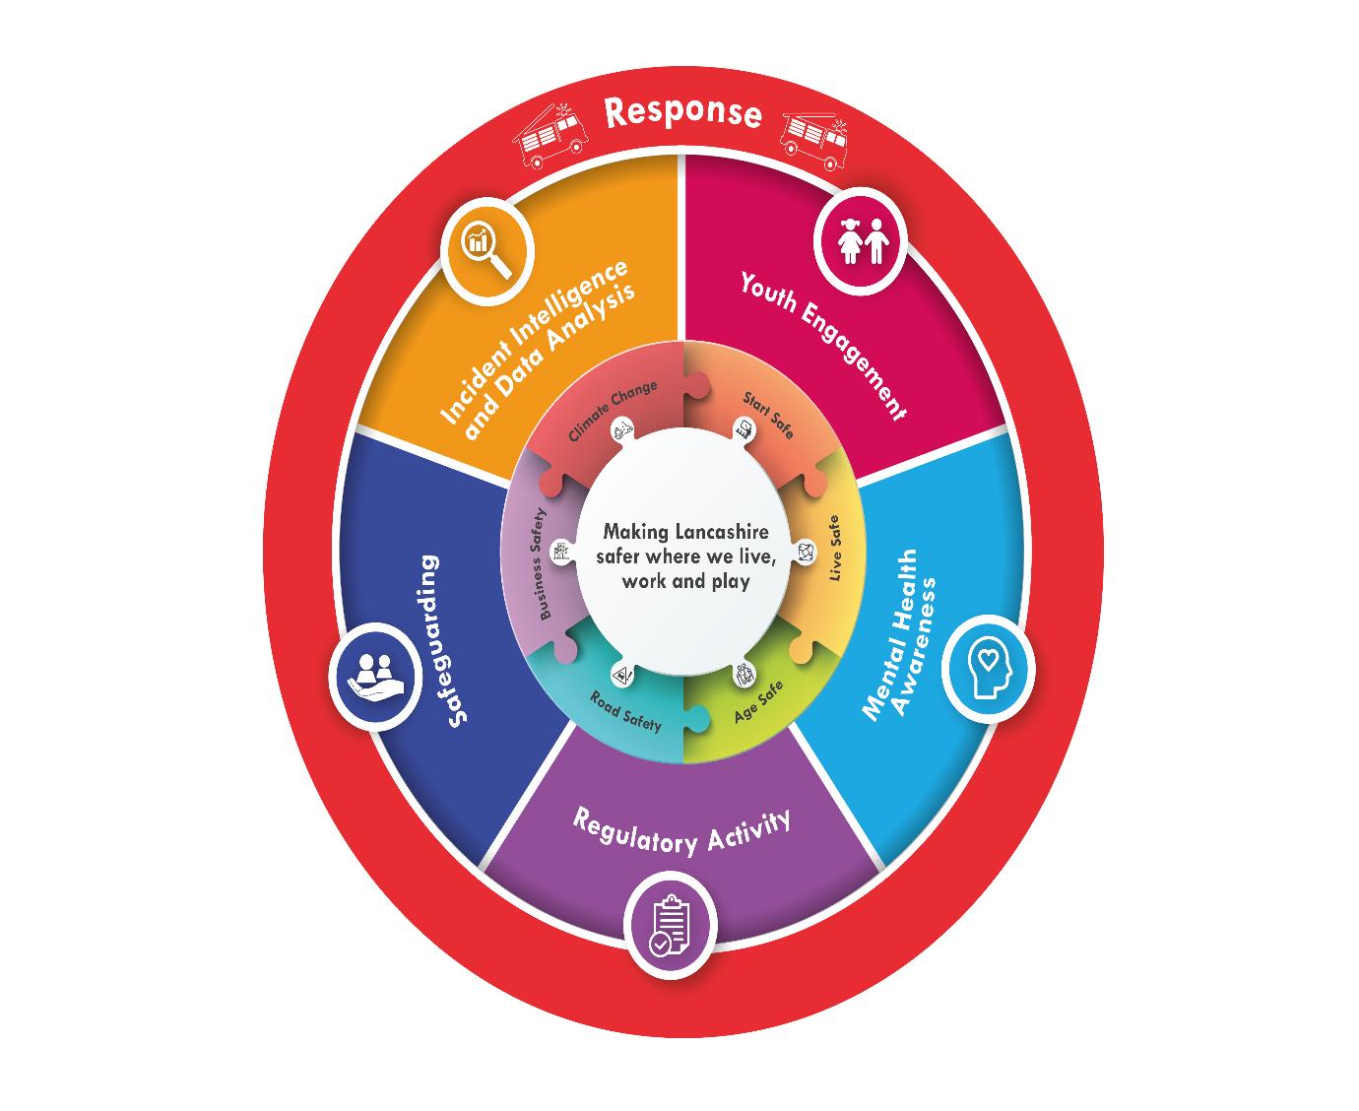

Links to operations and operational preparedness
Fire protection, operational preparedness and operational response are all intrinsically linked. By virtue of their knowledge of the built environment, and role in the building regulation and partnership consultation process, our protection teams are well positioned to ensure the provision of timely, accurate and relevant risk information to ensure operational crews can respond safely and effectively to all building types, but particularly to those of a complex and high-risk nature, where knowledge of the fire strategy and fire safety systems is a fundamental component of successful resident evacuation and emergency response.
Over the course of this strategy, we will seek to further embed our protection staff into our operational preparedness arrangements, contributing at an early stage to the site-specific risk information. Reciprocally we will also seek to expand the fire protection knowledge held by our operational and community safety staff to ensure existing and emerging risks in the built environment are understood to ensure operational tactics and decision making are adapted accordingly and maximum use is made of fire protection systems design to assist during emergency situations (e.g. smoke control systems, evacuation alert systems etc).
Our Organisational Assurance Team (OAT) collate learning across the national, regional, and local arena to prepare the service for foreseeable events. This learning is considered by our Organisational Assurance Group (OAG) which is represented by all departments including fire protection. Improvement actions are allocated and monitored via our Assurance Monitoring System. The group also coordinate the collation of national protection learning notes feeding into the National Protection Learning User Group (NPLUG).
Our team of operational assurance officers and group managers respond to operational incidents, including ‘significant incident fire safety’ (SIFS) incidents; these are operational incidents whereby the fire safety provision for the premises has not worked as intended or where the incident commander believes there may be breaches in fire safety compliance This procedure ensures appropriately trained officers respond to Incidents, gather evidence and identify emerging protection issues.
We will continue to seek out and operate information exchange processes which enable us to understand risk in the built environment e.g. the SiteSafe scheme which shares information on timber framed premises during both the construction and occupancy phases.
The intervention programme targets premises which pose the greatest risk to life and necessarily focusses on higher risk premises where people sleep and may be unfamiliar with their surroundings. Through the delivery of our BFSC service, delivered by our operational crews along with continuing to invest in training CSAs, we will increase our capacity and enable fire safety standards to be checked and evaluated in a much wider range of lower-risk premises (such as industrial units, offices, shops, simple houses in multiple occupation and hotels). The training to support our BFSC service promotes a broader understanding of fire safety legislation and built environment risk. The check also ensures that minor non-compliance is rectified immediately through advice and support, and more serious issues are referred to fully qualified fire safety inspectors. Whilst they are at the premises staff also undertake an arson vulnerability assessment and capture relevant risk information.
Over the course of this strategy, we will:
Introduce business fire safety checks for a range of premises delivered by our operational crews.
Upskill our operational and community safety staff with contemporary and relevant knowledge of fire safety legislation and fire risk in the built environment.

How will we measure success?
LFRS recognise the importance of monitoring and evaluating the effectiveness, efficiency and impact of its protection activity.
Protection activities are measured and reported via a suite of key performance indicators which are presented to the Combined Fire Authority (CFA) on a quarterly basis and subject to scrutiny by the Performance Committee.
A performance management framework is utilised to ensure finite inspection resources are used effectively, aligned to the national competency framework and the risk-based intervention programme. We closely monitor performance against this framework.
We regularly report our performance to the Home Office, NFCC Protection Reform Unit, and HMICFRS. Such reporting enables not only quantitative analysis of the number of audits and consultation activities but also qualitative analysis of the types of premises inspected, and the outcomes achieved.
We use quality assurance processes to ensure our services are delivered consistently and in accordance with the Enforcement Concordat and Enforcement Management Model.
All significant campaigns are evaluated to ensure resources are used effectively and learning from one campaign is used to build the next.
All data and information collated is compliant with General Data Protection Regulations (GDPR).

Who is responsible for delivering this strategy?
The lead for community safety in LFRS is the Head of Prevention and Protection who in turn is accountable to the Director of Service Delivery.
Performance is reported on a quarterly basis to the Combined Fire Authority via the Performance Committee.

Relevant legislation
Legal requirements or mandatory duties:
- Regulatory Reform (Fire Safety) Order 2005
- Environment and Safety Information Act 1988
- The Petroleum (Consolidation) Regulations 2014
- The Explosives Regulations 2014
- Fire and Rescue National Framework for England
- Building Safety Act 2022
- Fire Safety Act 2021
- Fire Safety (England) Regulations 2022
- Construction (Design and Management) Regulations 2015
- Fire Safety and Safety of Places of Sport Act 1987
- Fire Standards Board - Protection
- Police and Criminal Evidence Act 1984
- Regulators Code
- Fire Precautions (Sub-surface Railway Stations) (England) Regulations 2009
- Criminal Procedures and Investigations Act (CPIA)
Linked qualifications, accreditations, or Fire Standards:
- Code of Ethics Fire Standard
- Community Risk Management Planning Fire Standard
- Fire Standards Board – Fire Investigation
- Fire Standards Board – Prevention
Apprenticeships:
i. Fire Safety Advisor
ii. Fire Safety Inspector
iii. Fire Safety Engineer

- DOCUMENT CONTROL
Contact
Department | Name | Email | Telephone
Protection | Matthew Hamer | matthewhamer@lancsfirerescue.org.uk | 2-6931

Amendment History
Version | Date | Reasons for Change | Amended by
1.0 | 01/01/2022 | Initial Draft Document | AM Hutton
1.1 | 01/04/2022 | Final Document | AM Hutton
1.2 | 19/03/2024 | Yearly review and update document to reflect changes in legislation and synergy with prevention services. | AM Hamer

Related Documents
Document Type | Reference Number | Title Document | Location
Equality Impact Assessment | V1 | Protection Strategy | Internal recording

Building safety (hse.gov.uk)
Guidance on fire safety provisions for certain types of existing housing (cieh.org)
Privacy Notices - Lancashire Fire and Rescue Service (lancsfirerescue.org.uk)
Item_11_-_Competence_Framework_2020.pdf (nationalfirechiefs.org.uk)
Fire Safety Bill 2019-2021 - House of Commons Library (parliament.uk)
Building Safety Act 2022 (legislation.gov.uk).
Police and Criminal Evidence Act 1984 (PACE) codes of practice - GOV.UK (www.gov.uk)
Primary Authority (nationalfirechiefs.org.uk) & Primary Authority Register (beis.gov.uk)

