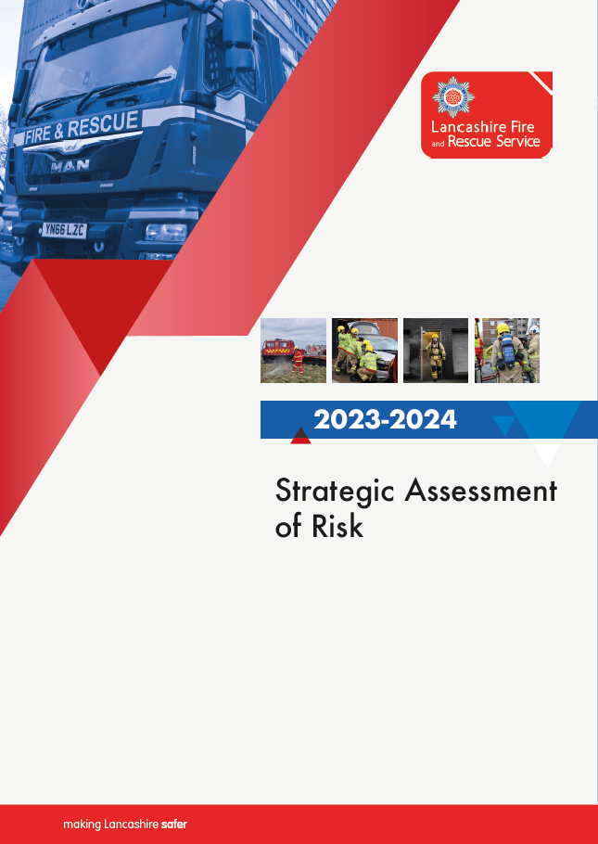

Contents
Glossary of Abbreviations 4
Executive Summary 5
Introduction 7
Lancashire Combined Fire Authority 8
About Lancashire 9
Populous 9
Deprivation 11
Health 12
Infrastructure 14
Built environment 16
Emerging Technology 16
Electric vehicles (EVs) and energy storage systems 16
Hydrogen 18
Climate change 18
Wildfires 18
Flooding 18
Historical Data 19
Injuries and fatalities 20
Resource to risk 21
National and local risks 22
National Risk Register 22
Lancashire Resilience Forum 24
Lancashire Fire and Rescue Service - community risk identification process 26
District profiles 26
Risk assessment methodology 27
Consequence score 28
Executive risk assessment summary 30
Commercial property fires 32
Wildfire 33
Accidental dwelling fires (ADF’s) 34
Flooding 35
Deliberate building fires 35
Road traffic collisions (RTC’s) 36
Rescue collapsed structure/confined space 37
Road vehicle fires 38
Assist other agencies 38
Industrial fires 39
Waste disposal site fires 40
High rise fires 41
Rescue from height 41
Hazardous materials incident (Hazmat) 42
Hazmat incident (Minor) 42
Hazmat incident (Major) 43
Building under construction fires 43
Other outdoor fires (Primary) 44
Removal of people from objects and Removal of objects from people 45
Animal rescue 46
Other transport fires (air, boat, train) 46
Secondary fires (accidental) and Secondary fires (anti-social behaviour - ASB) 47
Effecting entry/exit 48
Suicide or suicide attempts 49
Heritage fires 49
Rescue from water 50
Other transport or making safe (not fire) 51
Lift release 51
Malicious attacks/terrorist incidents 52
Rescue from depth 53
Rescue from mud 53

Glossary of Abbreviations
Acronym | Description
ADF | Accidental Dwelling Fire
BME | Black or Minority Ethnic groups
CBRNE | Chemical, Biological, Radiological, Nuclear and Explosives
CFA | Combined Fire Authority
CFRMIS | Community Fire Risk Management Information System
COMAH | Control of Major Accident Hazards
CRMP | Community Risk Management Plan
CRR | Community Risk Register
FRS’s | Fire and Rescue Services
GIS | Geographic Information System
Hazmat | Hazardous Materials
IMD | Indices of Multiple Deprivation
IRS | Incident Recording System
LFRS | Lancashire Fire and Rescue Service
LRF | Lancashire Resilience Forum
LSOA’s | Lower-layer Super Output Areas
MOU | Memorandum of Understanding
MTA | Marauding Terrorist Attack
NOG | National Operational Guidance
NRR | National Risk Register
NWAS | North West Ambulance Service
RTC | Road Traffic Collision
SAoR | Strategic Assessment of Risk

Executive Summary
This is the seventh edition of Lancashire Fire and Rescue Service’s (LFRS) ‘Strategic Assessment of Risk’ (SAoR).
The assessment seeks to underpin our Community Risk Management Plan (CRMP) by ensuring that risk management drives decision-making within LFRS.
Section1 describes the statutory responsibilities placed upon LFRS and the Combined Fire Authority (CFA) committee structure, the document then aims to provide detail across several areas of risk pertinent to the county of Lancashire.
The About Lancashire section explores ‘population and demographics, district make-up, deprivation and health’. Data is provided on population density across the 14 districts that make up Lancashire, in addition to information on aspects of ethnicity, religion and work-day populations. The chapter highlights the relevance of aspects of deprivation within Lancashire, not least the prevalence of fuel poverty across an ageing population profile; one which statistically looks to continue to increase significantly in age terms over the next fifteen years at least. The combination of such factors poses risks to members of the communities we serve and hence it is incumbent upon us to be aware of their changing needs and the potential for increased risk in areas traditionally seen as low risk.
The next section, national and local risk concentrates on risk profiles raised as high risk by a national risk assessment and more locally by our local resilience forum (LRF). The national risk assessment is a yearly process intended to identify, characterise, and compare all the major hazards and threats of national significance that may cause widespread impacts in the UK on a five-year horizon. It involves a large multi-agency process that allows ranking risks based on the likelihood and impact of the “reasonable worst-case scenario”. It provides a national picture of the risks we face and is designed to complement local risk assessments produced by the LRF.
The LRF considers the national issues alongside the local risk context, identifying the risks such as new issues or highlight situations where risk may be changing within the county. Each identified risk is then analysed and given a rating according to how likely the risk is to lead to an emergency and their potential impact on safety and security, health, economy, environment, and society. The LRF then evaluates the analysis and determines whether to include it in the community risk register, identifying where plans are needed, and arrangements required to deliver a multi-agency response.
Finally, we finish with a collation of our risk scores across our Response section which aims to illustrate via a risk matrix our most common responses and our highest risks within the fire sector. This matrix is the product of our novel risk methodology, which has been designed to incorporate the frequency and trends of incident activity in Lancashire with consequences of the same activity. The methodology classifies pump-attended activity into one of 32 incident types and ranks these incidents based on a calculated risk score. Each incident type has a respective consequence score which is based on the average consequence score of seven categories determined by a panel of industry professionals. This score is combined with a likelihood score calculated using the average incident frequency for the previous three years. We apply a directional multiplier determined through statistical analysis of long-term incident data to this likelihood score to identify incident types which represent emerging or declining risk and impact their order in the overall risk ranking.
The methodology utilises the experience and knowledge of industry professionals with the robustness of data-driven statistical analysis to rank the majority of LFRS activity by the risk they pose and therefore establishes an appropriate position of response from the service in mitigating the impacts of these risks on communities in Lancashire.

Introduction
The Fire and Rescue National Framework identifies challenges that we have to deal with such as the continued threat of terrorism, the impacts of climate change, impacts of an ageing population and the need to cut the national deficit. In pursuit of our vision of ‘Making Lancashire Safer’, it is important that these wider challenges are understood to help us plan to achieve our strategic objectives in a more informed manner.
To address these challenges LFRS carry out a periodic assessment of risk to help us to consider the potential impact of external factors that may be a risk to our business. Where we identify risks, we need to act. This may be to actively mitigate the risk or simply to monitor it, and indeed there may be risks that we choose to accept and to take no action. Ultimately, we must satisfy ourselves through this strategic assessment of risk that there is no threat to our vision and that our strategic objectives are not compromised.
As a service we review our assessment of risk at least annually by analysing our external and internal operating environments as part of our corporate planning process. This edition of Lancashire’s SAoR document aims to highlight the risks we face and how we intend to deal with them. The information is based on current and historical risk data which is presented to inform our plans and strategies both now and in the future. This SAoR underpins our corporate planning process and will strengthen our CRMP, which we have a statutory duty to provide. Whilst the CRMP summarises how, through planning, we consider fire and rescue related dangers that could affect our communities and how we aim to tackle them, the SAoR provides some of the detail on these risks and on where we are targeting our resources in the most efficient and effective way to manage the risk.
Each of the 14 district areas which make up the county faces its own unique risks. To effectively assess the risk, district plans are developed based on local intelligence and are supported by a district intelligence profile that is produced annually. The purpose of the profiles is to highlight activity and risk across each district both in terms of incident, geographical and people risk. This evidence-based document is designed to support the district plans by highlighting the most significant issues, the highest risk groups to target and the most significant areas to target.
The environment in which we operate is constantly changing and new risks to our communities will always emerge. It is our job to ensure that we continually assess these changing risks and ensure we keep the communities of Lancashire safe through our assessment of risk and prioritising our response to those risks. In addition to our annual process, we continue to analyse any emerging opportunities and threats throughout the year through our normal risk management processes.

Lancashire Combined Fire Authority
The CFA is responsible for leading and supporting LFRS. The CFA has a membership of 25 elected councillors consisting of 19 from Lancashire County Council, 3 from Blackburn with Darwen Council and 3 from Blackpool Council. Under the Fire and Rescue Services Act 2004 the CFA is legally required to enforce fire safety legislation and to reduce the risk of fire causing death, severe injury and property related losses to the community. It must also make provision for rescuing people in the event of road traffic collisions and for protecting people from serious harm arising from road traffic collisions in the Lancashire area.
The CFA is legally responsible for the enforcement of the Regulatory Reform 2005 (Fire Safety) Order which is applicable across England and Wales. This Order places the responsibility on individuals within an organisation to carry out risk assessments to identify, manage and reduce the risk of fire within public and commercial buildings.
The CFA governs LFRS, which is a designated Category 1 responder under the Civil Contingencies Act 2004. This Act requires emergency responders in England and Wales to co-operate in maintaining a public community risk register which is a product of the LRF. The LRF gives responders the opportunity to consult, collaborate and share information with each other to facilitate planning and response to emergencies.

About Lancashire
We respond to the area of Lancashire, covering 3,076 sq. km and with a large resident population, the Lancashire-14 area is one of the most populous and urbanised localities in Britain, but still manages to be an area of astonishing diversity. The 2021 Census usual resident population figure for Lancashire-14 area was 1,531,200; all of whom we aim to target and serve. This represented an increase of 70,300 people or a population growth rate of 4.8% since the last census in 2011.
Our service is split into six districts, all with their own unique challenges and risks that influence our prevention, protection, and response activities locally. These districts are Central, Eastern, Northern, Pennine, Southern and Western.
There is much to be admired in the traditional townscapes, however with a broad range of building types from stone-built dwellings and mills, timber frame apartments and iconic heritage listed buildings, the risk of the built environment is large and ever changing.
Lancashire is well connected to bordering counties with an expansive range of transport networks, including five motorways and 5091.7km of road. Key railway lines, shipping ports and airports can also be found within the region. These provide rapid access for both north-south and east-west travel, making Lancashire and other parts of the region easily accessible for work and tourism.
There is something for everyone in Lancashire, with countryside, canals, 123-km of coastline and towns attracting 51.51 million visitors per year (the most recent 2021 data shows a fall from pre-covid figures of 68.74 in 2018) with staying visitors accounting for approximately 11% (5.8 million).

Populous
In 2016 it was predicted that between 2016 – 2041 Lancashire’s dwellings would increase by 7.3% to 674,107. In 2021, the whole Lancashire-14 area had a total dwelling stock of 692,404 of which 87.3% was owner occupied or privately rented. Lancashire’s rise in dwellings has already surpassed the 2041 prediction just 6 years after it was made. This poses a risk to Lancashire, not only by increasing the number of dwellings we attend but this also impacts planning as the county continues to grow faster than estimated.
The latest population projections, covering the period from 2018 to 2043, for the Lancashire 14 authority areas show that growth rates across the county are expected to have distinct differences.
For the Lancashire-14 area, a 7.2% increase is projected over the 25-year period, resulting in an expected population total of 1.606 million by 2043. These increases have been revised up from the previous projections. Chorley (17.8%), Fylde (16%), Ribble Valley (13.3%) and Rossendale (12.6%) are predicted increases above the England average. Blackburn with Darwen (1%), Blackpool (1.6%) and West Lancashire (3.8%) are predicted the lowest increases.
When carrying out further comparisons with predicted population levels by age group analysis shows that the number of children aged 0 to 15 will peak in 2022 and then decline. The working age population is predicted to peak in 2032 and the older population are predicted to continue to increase. Statistics show that there are significant increases in predicted population groups over the age of 65 that become greater still as the age range increases, with more in the 85 and over bracket each year as life expectancy increases over the period. The old age dependency ratio (number of people on state pension per 1,000 people of working age), is predicted to increase in every district over the period of the projection, with Wyre seeing the largest increase from 489 in 2018 to 630 in 2043.
The growing number of people aged over 65 and above presents significant challenges not only for LFRS, but also for our partners as demand increases for services. To address this LFRS works collaboratively with partners to identify and support the most vulnerable individuals within our communities.
The 2021 census recorded:
- That across the 14 Lancashire Districts there were 90,590 (17.2%) of households with an adult living alone aged 65 or over.
- 17.42% of all households in Fylde and 17.40% of all households in Wyre had one person in this age-group, which are amongst the highest rates in England and Wales.
- An average life expectancy for males is 78.5 and for females 82.2 years old.
Living alone may not necessarily affect an individual’s fire risk; however, living alone combined with specific demographic characteristics can do so. Age, mental health, physical wellbeing and living environments can all play a part in contributing to an individual’s circumstances for them to be considered at a higher risk of death or injury caused by fire.
One person households in the Lancashire-12 area are projected to rise by 17.9% to 205,038 households, or 34.9% of all households, by 2043, slightly higher than the England projected average of 33%. Fylde (39.9%), Preston (38.7%), Hyndburn (37.2%), Burnley (37.7%) and Pendle (36.7%) are projected to have some of the largest percentages of one person households in England in 2043. Blackpool (41.2%), in the Lancashire-14 area, is projected to have the seventh highest percentage of one person households in England (out of 326 local authority areas).
From the 2021 Census, the largest ethnic group was white (88.9%). The black and minority ethnic (BME) group formed 11.1% of the population. Numerically, there were almost 136,756 black and minority ethnic people living in Lancashire.

Deprivation
Deprivation is measured across England through the combined index of multiple deprivation 2019 (IMD 2019) which is the official measure of relative deprivation for small areas known as lower-level super output areas (LSOAs) in England.
Since 2015, all of the Lancashire-14 authorities have become relatively more deprived on the IMD rank of average rank measure, apart from Chorley, West Lancashire and Ribble Valley. Preston has the greatest percentile change, -6%. Burnley and Hyndburn are both in the most deprived 10% of the lower-tier local authorities within England on the IMD rank of average rank measure, Pendle and Preston are both in the most deprived 20%. In contrast, Ribble Valley is in the least deprived 20% in England. Blackpool unitary authority is ranked as the most deprived lower-tier local authority in England on the IMD rank of average rank measure, plus seven other measures, including income, health, local concentration and the percentage of people employment deprived. Blackburn with Darwen is also in the most deprived 10% in England.
Lancaster joins Burnley, Hyndburn, Pendle and Preston in the 20% most deprived areas in England for the health deprivation and disability rank of average rank measure and the living environment rank of average rank measure.
A new fuel poverty metric Low Income Low Energy Efficiency (LILEE) indicator considers a household to be fuel poor if:
- it is living in a property with an energy efficiency rating of band D, E, F or G as determined by the most up-to-date Fuel Poverty Energy Efficiency Rating (FPEER) Methodology; and
- its disposable income (income after housing costs (AHC) and energy needs) would be below the poverty line.
The 2021 fuel poverty statistics indicate that 15.2% of households were fuel poor in the Lancashire-14 area compared to the national average of 13.1% (an increase from 12.6% of households in 2018).
Pendle (19.8%), Burnley (19.6%), Hyndburn (18.6%), Blackburn with Darwen (18.3%) and Blackpool (20.2%) had the highest proportion of fuel poverty in the Lancashire-14 area. South Ribble (10.0%) and Chorley (11.1%) had the lowest proportion of fuel poor households.

Health
The health and wellbeing of the people of Lancashire can be linked to lifestyle and behavioural factors but can also be linked to a wide variety of social, economic, and environmental factors such as poverty, deprivation, housing, environment, or ethnicity. All these factors can heighten the risk of individuals being more susceptible to requiring assistance from the emergency services.
The health of people in Lancashire varies when compared to England. Within the county there are wide differences between the most and least deprived areas. Blackpool (53.5 years) has the lowest male Healthy Life Expectancy (HLE) in England; Blackburn with Darwen (58.8 years) is also one of the lowest. Both are significantly worse than England (63.1 years). Blackpool (54.3 years) and Blackburn with Darwen (59.3 years) also have amongst the lowest HLE expectancy for females, with Blackpool having the lowest in England.
When looking at life expectancy at birth for men, at a district level, only Ribble Valley (81.0 years) has a significantly better male Life Expectancy when compared to England (79.4). Burnley (75.7), Hyndburn (76.6), Preston (76.7), Wyre (77.8), Rossendale (77.9), Pendle (78.0) and Lancaster (78.5) are all significantly worse. At district level, the Life Expectancy for females are significantly worse than England (83.1) for Burnley (80.3), Preston (80.5), Hyndburn (80.8), Rossendale (81.2), Pendle (81.5), Chorley (81.9), Lancaster (82.2) and Wyre (82.3).
The Active Lives Survey (202/22) estimates that 65.7% of the adult population (18+ years) in Lancashire-12, 68.4% in Blackburn with Darwen and 72.3% in Blackpool are classed as overweight or obese, significantly above the England estimate of 63.5%. Again, national trends indicate an increase overall in the numbers who are obese or overweight and it is expected the rates in Lancashire will also rise. Physical activity levels for adults are also low, although similar to England, and increasing these can be beneficial for health.
There are issues across the county around falls, unintentional injuries and hospital admissions. The highest risk of falls is in those aged 65 and above, and it is estimated that about 30% of people aged 65 and above living at home and about 50% of people aged 80 and above living at home or in residential care will experience an episode of fall at least once a year. Falls that result in injury can be very serious - approximately 1 in 20 older people living in the community experience a fracture or need hospitalisation after a fall. In the Lancashire-12 area the percentage of the 65+ population predicted to have a fall is projected to increase by 33% by 2035 and the percentage of these predicted to be admitted to hospital as a result is projected to increase by 40% by 2035 (from 2020).
The health of adults in the county is mixed; prevalence and incidence rates for many long-term conditions varies (although this may be indicative of effective screening in some districts) and residents in the more deprived areas of Lancashire tend to have higher levels of premature and overall mortality from these conditions.
The national average for people with limiting long-term illness from the 2011 Census is 8.5%, however Lancashire is above the national average with 10.3%.
There are issues around mental health and wellbeing, with residents in the most deprived areas of Lancashire nearly twice as likely to have mental health problems compared to those in the least deprived areas. This includes common mental health issues such as depression and anxiety, and more severe disorders such as schizophrenia.
Figures from the Primary Care Dementia Data show that on 31 March 2023 there were 11,031 known cases of dementia in the 65+ registered population across the Lancashire-12 area. For Blackburn with Darwen this was 1,077, and Blackpool was 1,453.
Adult social care is an important function of the county council, particularly with the expected rise in the older population. There are many factors which can influence whether an individual accesses social care including living arrangements and health status. In Lancashire, more people aged over-65 live alone compared to England and are more likely to have a limiting long-term illness or disability, requiring adult care services, a figure which is likely to increase.
The percentage of people aged 16 years and over and classed as long-term sick or disabled in the 2021 Census was 4.64% in Lancashire compared to 4.07% as an average in England.
The most up to date estimates (2016/17) indicate that there are 9.1 opiate and/or crack cocaine users (per 1,000 of the population aged 15-64) in the Lancashire-12 area, in line with the England estimate (8.9). Blackburn with Darwen (18.8) and Blackpool (23.5) both have significantly higher estimated rates of opiate and/or crack cocaine users.
In the Lancashire-12 area, an estimated 13.4% of adults (18+) smoke, which is in line with the England estimate of 12.7% (Annual Population Survey, 2022). Blackburn with Darwen (19.4%) and Blackpool (18.8%) have a significantly higher estimated proportion of adult smokers, compared to England.
At a district level, Fylde is significantly better than England (6.4%) whilst all remaining districts in Lancashire-12 all are statistically similar to England (the Ribble Valley value is not published and therefore not comparable).
Common factors present during Accidental Dwelling Fires. | The 7 determinants covered during Safe and Well visits.
Physical and mental health | Falls prevention
Hoarding and significant clutter | Social isolation
Substance misuse and/or alcohol | Living with dementia
Smoking | Diabetes
Elderly | Healthy homes/ winter pressures
Lone person | Home security/ arson vulnerability
- | Mental health

Infrastructure
There is a wide range of infrastructure risk within Lancashire in addition to the expansive range of transport networks including reservoirs, dams, and wind turbines.
The Lancashire economy relies strongly on the motorway network. The M6 runs from north to south, past Lancaster and Preston. The M55 connects Preston to Blackpool and is 11.5 miles (18.3 km) long. The M65 motorway from Colne, connects Burnley, Accrington, Blackburn and Preston. The M61 from Preston via Chorley and the M66 starting 500 metres (0.3 mi) inside the county boundary near Edenfield, provide links between Lancashire and Manchester, and the trans-Pennine M62. The M58 crosses the southernmost part of the county from the M6 near Wigan to Liverpool via Skelmersdale.
Other major roads include the east–west A59 between Liverpool in Merseyside and Skipton in North Yorkshire via Ormskirk, Preston and Clitheroe, and the connecting A565 to Southport; the A56 from Ramsbottom to Padiham via Haslingden and from Colne to Skipton; the A585 from Kirkham to Fleetwood; the A666 from the A59 north of Blackburn to Bolton via Darwen; and the A683 from Heysham to Kirkby Lonsdale via Lancaster.
Lancashire is home to 62 railway stations operating over 200 miles of track. These range from busy commuter stations such as Preston and Lancaster situated on the West Coast Mainline, to smaller stations (some unmanned) located in rural areas. Lancashire is also part host to a heritage rail line, the East Lancashire Railway, which runs from Rawtenstall on a 12-mile stretch to Heywood in Greater Manchester.
In addition to the rail network, Lancashire has an 11-mile tram system that operates from Starr Gate in Blackpool to Fleetwood in the Wyre district. Part of this network is a ‘shared space zone’; this is an urban design approach reducing demarcation between trams, vehicles, and pedestrians, with some kerbs and traffic signs removed to produce a more open space.
Lancashire also has three ports, situated in Heysham, Fleetwood and Glasson Dock. There are also several other maritime related sites which service leisure craft such as Preston Docks. The largest port is Heysham which is a deep berth port capable of handling some of the world’s largest vessels. It is served by a railway station and the M6 Bay Gateway link road. The port is a key gateway for Irish Sea trade and is attracting significant investment including a £10m improvement programme. Its proximity to gas fields and the world’s largest offshore wind farm (Walney Extension) has also influenced the type of goods being handled & services offered.
Lancashire mainly lies within the North West river basin district (England is covered by 10 'River Basin Districts') with a very small part near Earby in Pendle district is in the Humber river basin district. Most water bodies in Lancashire eventually flow out into the Irish Sea through the estuaries of the Ribble, Wyre and Lune rivers. Some in the south of the county flow southwards and join up with tributaries of the Mersey. Only the water bodies in the Humber river basin district flow eastwards into Yorkshire and finally merge with the North Sea. The term 'water body' may refer to a river, lake, reservoir, canal, aquifer, or inter-tidal part of an estuary. As part of its industrial past, Lancashire gave rise to an extensive network of canals, which extend into neighbouring counties. These include the Leeds and Liverpool Canal, Lancaster Canal, Sankey Canal, Bridgewater Canal, Rochdale Canal, Ashton Canal and Manchester Ship Canal.
The County is served by a handful of airports some of which are within the county boundary. Blackpool Airport are no longer operating domestic or international flights, but it is still the home of flying schools, private operators and North West Air Ambulance. There is an operational airfield at Warton near Preston where there is a major assembly and test facility for BAE Systems. Manchester Airport is the main airport in the North West region, with Liverpool John Lennon Airport and Leeds Bradford both nearby.
There are over 100 registered dams and reservoirs in Lancashire owned by United Utilities and private owners. The Civil Contingencies Act 2004 requires category 1 responders such as LFRS to have plans in place to respond to all emergencies including flooding. Due to the vast amount of water reservoirs can hold, they have been identified as high risk and so a multi-agency reservoir plan has been developed.
Additionally, Lancashire currently has 16 onshore windfarms in operation hosting a total of 80 wind turbines. Wind turbines present an assortment of risks; the remote locations of many of the turbines can mean that travel time to the areas can increase the likelihood of fire spread. The height, location and construction of the turbines can make them prone to lighting strikes, and as the turbine-supporting tower structure may be over 100m high, if people are trapped rescue operations may prove to be very difficult.

Built environment
In the past few years, Lancashire has seen the emergence of newer forms of construction, using more modern construction materials. Timber framed buildings is just one form of construction method that is growing in popularity due to the ease and speed of construction along with the lower build costs, and although once completed they adhere to stringent building and fire safety regulations, they pose several significant risks when in the construction phase in addition to the economic cost as a result of fire.
New building materials are being developed that present better value for money and reliability in terms of lower maintenance or replacement costs, however some of these poses significant risk. One such risk that Lancashire has experienced is the emergence of composite fencing and decking materials (made from recycled materials including plastic). Although some of these materials have suitable fire suppression characteristics, some do not, and it is these that have seen incidents escalate rapidly. Developments in both building materials and process is against a backdrop of developing technologies and reducing demand on fossil fuels. The development of both commercial battery energy storage systems and domestic energy storage systems are examples of this. Ongoing work is taking place to identify ways of mitigating the risk to prevent such significant fires occurring again.
Work continues in relation to high-rise and high-risk residential premises in the wake of the Grenfell Tower fire in 2017 along with focus on mid-rise (11-18mtr) premises and other work to ensure the safety of all commercial properties within Lancashire. More detailed information about the built environment risk can be found within our protection and business safety strategy.

Emerging Technology

Electric vehicles (EVs) and energy storage systems
Modelling shows that there will be a need for around 6,600 charge points throughout Lancashire by 2030, with an estimate that there will be over 240,000 EVs in Lancashire by then, representing 36% of all cars and vans.
Following the growth in the use of lithium-Ion batteries in vehicles, commercial settings and in domestic environments, FRSs across the UK have subsequently seen an increase in attendance at incidents involving this ever-growing list of applications. Lithium-Ion batteries are, in most cases, a safe and stable means of providing energy, with charging and discharge controlled by a battery management system (BMS), which prevents over charging and associated overheating of the battery.
If the battery overheats because of failure of the BMS, there is a risk that the temperature will reach a level where the structure of the battery breaks down and this leads to thermal runaway, the production of a range of toxic gases, which is potentially flammable and explosive in nature. Lithium-ion batteries power many products such as mobile phones and laptops, but over recent years larger more powerful batteries have evolved and are now the power source in electric cars.
In the renewable energy environment, energy generated by solar, wind, biogas and other sources is increasingly being stored in lithium-ion battery solutions. In the commercial environment this can be in the form of a battery energy storage system (BESS) and are a fundamental part of the UK’s move toward a sustainable energy system.
The installation of BESS systems both in the UK and around the globe is increasing at an exponential rate. The county has seen a significant increase in planning applications submitted to build these sites in both rural and populated areas, which in turn is requiring significantly more resource within LFRS to deal with this emerging risk. These sites consist of several shipping container size battery units which contain a significant number of lithium batteries within them, the number of these units on a site in the county range from ten units, to six hundred and forty-eight at a site in Heysham. A fire at one of these sites in Merseyside proved to be very challenging with no staff on site, and extinguishing the fire took several days.
Due to the speed and scale of the introduction of this technology formalised UK guidance has been scarce on what fire precautions need to be installed to reduce the fire risk, and what firefighting facilities are required to enable FRSs to both extinguish fires and mitigate environmental impacts. In 2023 the National Fire Chiefs Council produced a guidance document to aid FRSs in dealing with these sites and the government has changed planning guidance to advise developers that they should consult with the FRSs prior to applying for planning permission. However, this is still a developing technology and guidance will need to keep a pace with the new technology. Further information on Battery Energy Storage Systems can be found our website.
An increasing number of bus fleets within the county will be changing a large volume of their fleet to being battery powered vehicles in the coming years, in line with the government’s green energy agenda. LFRS engaged with Blackpool Council in 2023 to provide advice on the risks that this type of vehicle presents to them as an operator and LFRS’ response to incidents involving them.
In the domestic world, modern solar panels are increasingly linked to a domestic battery, Domestic Energy Storage System’s (DESS). DESS systems store energy from domestic Photo voltaic (Solar) panels for use in the home rather than feeding back into the National grid. They are becoming increasingly popular with both new builds and refurbishments. Due to the cost-of-living crisis, there are increasing cases of “homemade” DESS systems using second hand Electric Vehicle Lithium-ion battery packs. These will also be problematic in the same way as BESS sites and FRS’s will not have any prior information on the presence of these in houses.
As the proliferation of alternative energy sources and energy storage increase, we are likely to attend more incidents involving Lithium-Ion batteries.

Hydrogen
The county has recently started to see the emergence of Hydrogen as an alternative fuel source. In Samlesbury there are plans for a Hydrogen storage facility to provide fuel for HGVS and a paper mill in the southern area of the county is trialling the use of Hydrogen as opposed to Natural gas in its papermaking process. LFRS are updating the planning guidance letter and will adapt our guidance and response according to the likely increase of Hydrogen as a fuel source.

Climate change

Wildfires
The impact of climate change is also having a detrimental impact on the frequency and severity of wildfires, this includes changes in the timing of when wildfires occur and subsequently the materials that burn. In addition to the late spring season wildfires, we are starting to see the wildfire season extend into the summer months, which is having a significant impact on the ability of LFRS to extinguish wildfires using conventional methods. Early season wildfires generally involve surface fuels (e.g., Molinia grasses and heathers) as these are dryer than the cold, damp materials below the surface, which are generally managed by conventional wildfire equipment. As wildfires are becoming more frequent in the summer months these create more challenging conditions as it is not only the surface fuels that burn but the sub-surface fuels too.
LFRS continues to invest in the technological development of our wildfire response capability, and we are working more closely with private and public sector organisations on wildfire prevention and response. Our Climate Change Operational Response Plan (CCORP) aims to reduce the threat to the communities in Lancashire, improve firefighter safety and reduce the costs and impact upon LFRS, partners and our communities.

Flooding
Over the last few years, flooding caused by extreme rainfall has become a bigger issue in Lancashire and across the country. Heavy rain has had a devastating impact, this has led to people needing to leave their homes and seen valuables destroyed by flood water.
When it rains heavily and for a long period of time, the drains become overwhelmed by the amount of water – they overflow and the water on the surface has nowhere to go. Large puddles can become more of a flood, stretching across whole streets, pavements and sometimes further beyond that – this is known as surface water flooding.
Flash floods can occur anywhere and without warning during and after heavy rainfall, making them much more difficult to predict. It's inconvenient and likely to cause disruption on the roads, but when it's more serious it can also cause damage to homes and businesses.

Historical Data
The national incident recording system (IRS) was introduced by the Department for Communities and Local Government in 2009, with the requirement that all FRSs record operational data using a standardised data collection mechanism. This has allowed unprecedented insight and analysis to be carried out at a national level, as well as presenting FRSs with the ability to greatly enhance data-led decision making.
During the fourteen years in which IRS has been in operation, incident levels within LFRS have reduced by 5%, which equates to approximately 920 incidents. This reduction in activity is evident across most incident types, with false alarms reducing by 9%, secondary fires by 23% and primary fires, which are the most significant type of fire, have reduced by 41% within the same timeframe. However, special service incidents have doubled, mainly due to the adoption of undertaking gaining entry incidents on behalf of the ambulance service.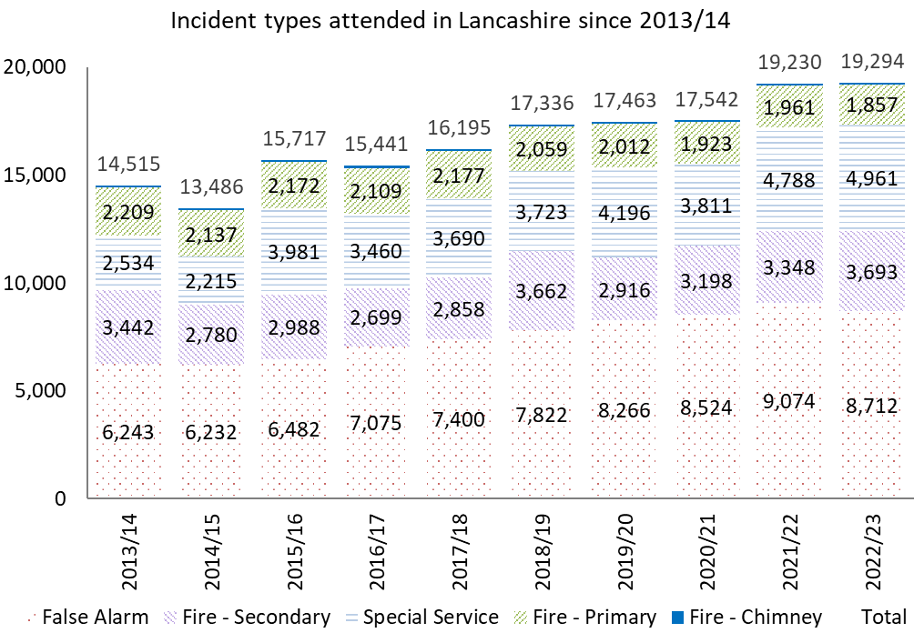
Figure 1: Chart showing incident types attended in Lancashire since 2013/14

Injuries and fatalities
The introduction of IRS has allowed FRSs to record additional granularity and data on victims at operational incidents. Within the last fourteen years, injuries at fires have reduced by 26%, with the number of people receiving first aid and precautionary checks reducing by 16%. Last year, there were 328 injuries resulting from fire, with 16% requiring a hospital visit. Unfortunately, last year saw ten fatalities in fires.
A large rise in the recording of victims from special service incidents has been witnessed over the previous fourteen years. Recordings of injuries have risen by 97%, with fatalities rising by 105%. Whilst in the past many of these have occurred in RTCs, they are now mainly recorded as a result of providing support or assistance to other agencies, mainly in affecting entry to domestic premises on behalf of North West Ambulance Service.
The additional granularity and data recorded on victims as a result of the introduction of IRS has enabled greater analysis and insight to be obtained. This has led to the introduction of more tailored and targeted campaigns and initiatives through data-led decision making. Of all the accidental dwelling fires, 57% started in the kitchen last year. Of these incidents, the most common correlation was the negligent use of a cooking appliance. Due to this, home fire safety checks and safe and well visits place an added emphasis on kitchen or cooking safety.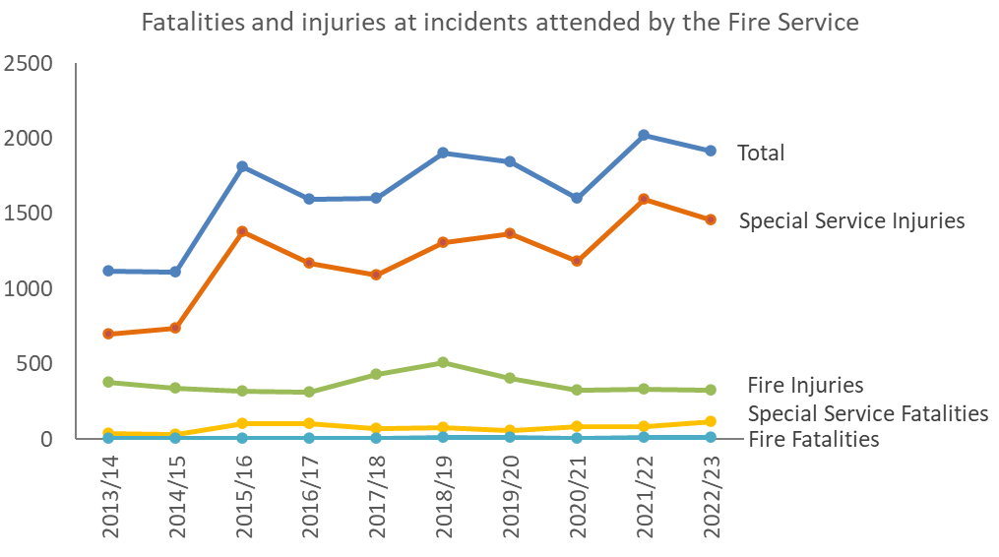
Figure 2: Chart showing fatalities and injuries at incidents attended by the Fire Service since 2009/10

Resource to risk
LFRS aims to allocate resources to risk, providing the most effective and efficient service and value for money to the people of Lancashire. Our offering is based around prevention, protection and response arrangements which are all tailored to current and emerging risks and applied proportionately to maintain risk at levels that are as low as reasonably practicable.
We aim to primarily prevent fires and other emergencies from happening. We allocate resources through our prevention and protection teams, supported by operational crews and partner agencies to educate inform and advise our diverse communities.
When incidents occur, we operate a range of operational crewing systems both wholetime and on-call. This allows us to allocate resources effectively based on the risk associated with geographical areas within Lancashire. To maintain a highly trained operational provision we are supported by our service training centre, which incorporates specialist training facilities and highly skilled and accredited instructors.
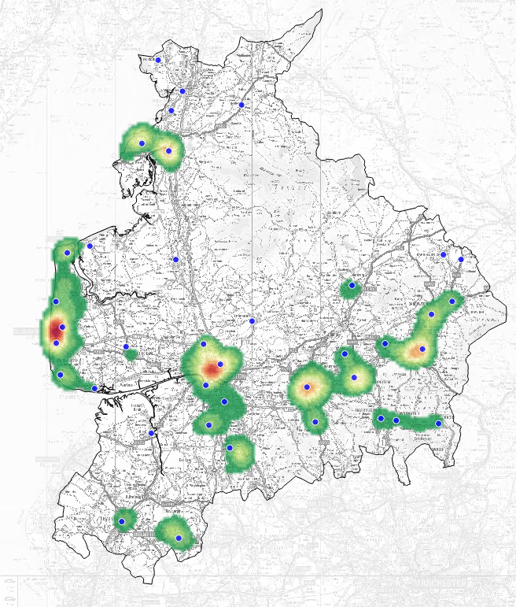
Figure 3: Heat map showing centres of high incident activity (Lancaster, Morecambe, Blackpool and Fylde coast, Preston, Chorley, Blackburn, Hyndburn, Burnley and Nelson) across Lancashire and location of Fire Stations.
This heat map shows the location of our fire stations mapped against overall incident activity levels. The areas of lowest demand are represented by the light green shading and moves through darker green, to amber to red to display the areas of our highest demand. Many of our stations are in areas of high activity, but we also have stations where incident levels are comparatively lower, but the impact of fires and other emergencies could be significant.

National and local risks

National Risk Register
The National Risk Register (NRR) 2023 provides a government assessment of the most serious risks facing the United Kingdom.
The UK faces a broad and diverse range of risks, including threats to lives, health, society, critical infrastructure, economy and sovereignty. Risks may be non-malicious, such as accidents or natural hazards, or they may be malicious threats from malign actors who seek to do us harm. The risks that meet the threshold for inclusion in the NRR would have a substantial impact on the UK’s safety, security and/or critical systems at a national level. The NRR includes information about 89 risks, within 9 risk themes. The risks are thematically grouped to bring together risks that share similar risk exposure and require similar capabilities to prepare mitigate and respond.
NRR Risk Assessment Matrix
Impact | Catastrophic  5 |  |  | 28, 29 |  | - |  | 9, 26a |  | 54 |  | -
 | Significant  4 |  |  | 21 |  | 24, 38, 56a |  | 27, 49, 51a, 51b, 51c, 61 |  | 10, 47, 50, 55, 63 |  | -
 | Moderate  3 |  |  | 17, 32,33, 34, 35, 36, 56c |  | 12, 22, 23, 52 |  | 25, 26b, 21a, 45, 53, 56b |  | 4, 8, 11, 40, 43, 48, 60 |  | 3, 31b, 46, 62
 | Limited  2 |  |  | 18, 19, 30, 37 |  | 5, 16, 41, 42 |  | 14, 20, 56d, 58, 59 |  | 7, 13, 57b |  | 2, 6
 | Minor  1 |  |  | 44 |  | 39 |  | - |  | 15 |  | 1, 57a
- |  |  | 1  <0.2% |  | 2  0.2-1% |  | 3  1-5% |  | 4  5-25% |  | 5  >25%
 |  |  | Likelihood

Number | Thematic group of risk
- | Terrorism, cyber and state threats
1 | International terrorist attack
2 | Northern Ireland related terrorism
3* | Terrorist attacks in venues and public spaces
4* | Terrorist attacks on transport
5 | Strategic hostage taking
6 | Assassination of a high-profile public figure
7* | Smaller-scale CBRN attacks
8* | Medium-scale CBRN attacks
9 | Larger-scale-CBRN attacks
10* | Conventional attacks on infrastructure
11* | Cyber attacks on infrastructure
- | Geographic and diplomatic
12 | Disruption to global oil trade routes
- | Accidents and systems failures
13 | Major adult social care provider failure
14 | Insolvency of supplier of critical services to public service
15 | Insolvency affecting fuel supply
16* | Rail accident
17 | Large passenger vessel accident
18 | Major maritime pollution incident
19 | Incident of a vessel blocking major port
20* | Accident involving high consequence dangerous goods
21* | Aviation collision
22 | Malicious drone incident
23 | Disruption of space-based activities
24* | Loss of positioning, navigation and timing services
25* | Simultaneous loss of all fixed and mobile forms of communication
26a* | Failure of the National Electricity Transmission system
26b* | Regional failure of the electricity network
27* | Failure of gas supply infrastructure
28 | Civil nuclear accident
29 | Radiation release from overseas nuclear site
30 | Radiation exposure from transported, stolen or lost goods
31a | Technological failure at a systemically important retail bank
31b | Technological failure at a UK critical financial market infrastructure
32* | Accidental fire or explosion at an onshore major hazard (COMAH) site
33 | Accidental large toxic chemical release from an onshore major hazard (COMAH) site
34 | Accidental fire or explosion on an offshore oil or gas installation
35* | Accidental fire or explosion at an onshore fuel pipeline
36* | Accidental fire or explosion at an onshore major accident hazard pipeline
37 | Accidental work-related (laboratory) release of a hazardous pathogen
38* | Reservoir/dam collapse
39* | Water infrastructure failure or loss of drinking water
40 | Food supply contamination
41* | Major fire
- | Natural and environmental hazards
42* | Wildfire
43 | Volcanic eruption
44* | Earthquake
45* | Humanitarian crisis overseas – natural hazard event
46* | Disaster response in the Overseas Territories
47* | Severe space weather
48* | Storms
49* | High temperatures and heatwaves
50* | Low temperatures and snow
51a* | Coastal flooding
51b* | Fluvial flooding
51c* | Surface water flooding
52* | Drought
53* | Poor air quality
- | Human, animal and plant health
54* | Pandemic
55* | Outbreak of an emerging infectious disease
56a* | Animal disease – major outbreak of foot and mouth disease
56b* | Animal disease – major outbreak of highly pathogenic avian influenza
56c* | Animal disease – major outbreak of African horse sickness
56d* | Animal disease – major outbreak of African swine fever
57a | Major outbreak of plant pest – Xylella fastidiosa
57b | Major outbreak of plant pest – Agrilus planipennis
- | Societal
58* | Public disorder
59* | Industrial action
60 | Reception and integration of British Nationals arriving from overseas
- | Conflict and instability
61 | Deliberate disruption of UK space systems and space-based services
62* | Attack on a UK ally or partner outside NATO or a mutual security agreement requiring international assistance
63 | Nuclear miscalculation not involving the UK
* The most pertinent risks identified by the NRR for LFRS.
A full breakdown can be found on the UK government website

Lancashire Resilience Forum
Every Resilience Forum has a Community Risk Register which describes risks for the community and assesses how likely they are to lead to an emergency and the potential impact they would have. The register is created through a risk assessment, and the information is used by the Lancashire Resilience Forum (LRF) to plan and prepare for emergencies that may occur.
The LRF refers to the National Risk Register in order to consider national issues alongside the local risk context and identify the risks within the county. These risks can come from lots of factors – from natural events such as weather, human diseases, animal diseases and accidents, to deliberate acts such as terrorism. This risk assessment can help identify new issues or highlight situations where risk may be changing.
The highest risks identified can be seen below:
Risk | Overall risk rating | Level of Risk
Rail networks incidents | 16 | High risk
Failure of the national electricity transmission system | 15 | High risk
Influenza-type pandemic | 15 | High risk
Coastal flooding/ Fluvial flooding | 12 | High risk
Volcanic eruption | 12 | Medium risk
Technological failure at a retail bank | 12 | Medium risk
Severe space weather (eg geomagnetic storm) | 9 | Medium risk
Emerging infectious diseases | 9 | Medium risk
Food supply contamination | 9 | Medium risk
Poor air quality | 9 | Medium risk
Surface water flooding/localised flash flooding | 9 | Medium risk
Aviation incident | 8 | Medium risk
Maritime incident | 8 | Medium risk
Further information can be found on the Lancashire Resilience Forum website.
To ensure that LFRS are prepared for any national or local events we work in partnership with the LRF to train and exercise for foreseeable events and have robust business continuity planning to ensure we can still fulfil our statutory duties.
13/16 agreements - LFRS has ‘memorandum of understanding’ (MOU) arrangements in place with its regional and neighbouring FRS in terms of reinforcement schemes to ensure serious emergencies are attended in an efficient and effective manner. This also includes specialist functions such as rope rescue.

Lancashire Fire and Rescue Service - community risk identification process
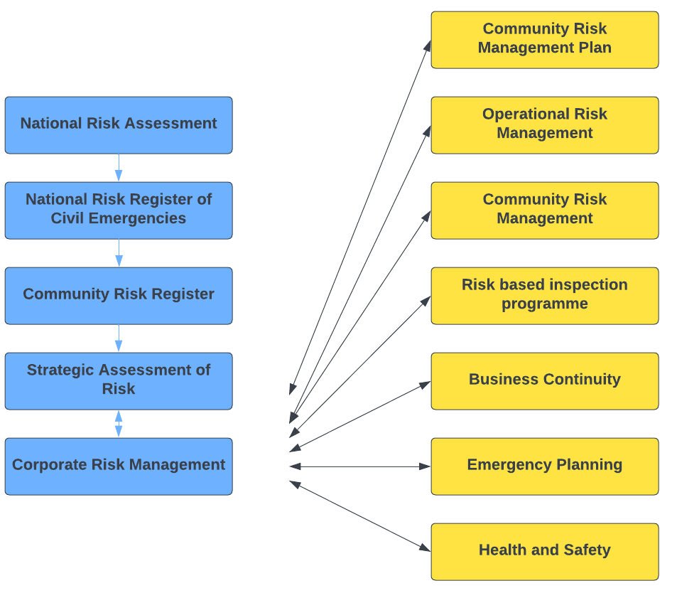
Figure 4: A Flow chart that describes how national assessment of risk links to the National Risk Register of Civil Emergencies and Community risk register and feeds into Lancashire Fire and Rescue Service's corporate risk management which includes examples such as operational risk management and community risk management.

District profiles
Lancashire is divided into 6 Areas. Within these areas are the Lancashire-14 districts:
- Northern – Wyre and Lancaster
- Southern – Chorley, South Ribble and West Lancashire
- Eastern – Blackburn with Darwen, Hyndburn and Ribble Valley
- Western – Fylde and Blackpool
- Pennine – Pendle, Burnley and Rossendale
- Central - Preston
Each district faces its own unique risks and to effectively assess the risk, district plans are developed based on local intelligence and supported by a district intelligence profile that is produced annually.
The purpose of the profiles is to highlight activity and risk across each district both in terms of incident, geographical and people risk. This evidence-based document is designed to support the district plans by highlighting the most significant issues, the highest risk groups to target and the most significant areas to target.
Using previous incident activity, prevention and protection data, known demographic data and Mosaic estimate lifestyle data this report aims to inform who and where are those most vulnerable from fire, the location of risk and the resource demand against availability (applicable to on-call stations only).
Incident data is based upon an average over the preceding three years. Partnership working helps to inform demographic data and makes use of the vulnerable person adult social care data supplied by Lancashire County Council, also the Personal Demographics Service data which is taken from those registered with a General Practitioner and are aged over 65 years. Datasets which are too small at a district level to analyse are aggregated to county level.
Additional lifestyle data analysis is based on the Mosaic data, supplied by Experian Ltd.

Risk assessment methodology
The below assessment of risk was applied to 32 different incident types which cover the main incident types that we respond to as a Fire and Rescue Service and covered by National Operational Guidance (NOG). The purpose of the methodology is to develop and utilise a reliable model that can be applied equally across all incident types whilst considering the likelihood, consequence, and emerging and declining risk. The model uses single source reliable data (IRS), coupled with sector competent professional judgement.
Likelihood (risk)
Our likelihood calculation is based upon incidents historically attended over the previous three calendar years and the categorisation can be seen below:
Table 1: Likelihood score calculation.
Likelihood class | Likelihood Score | Frequency | Frequency definition
High | 5 | 365 or more | At least once per day
Medium high | 4 | 52-364 | At least once a week but less than once a day
Medium | 3 | 12-51 | At least once a month but less than once a week
Medium low | 2 | 1-11 | At least once a year but less than once a month
Low | 1 | Less than 1 | Less than once a year
After the frequency has been calculated a directional multiplier is applied as to whether the incident type is emerging or declining and an overall likelihood – direction score is generated.

Consequence score
The consequence score is derived as the average score from our seven consequence categories. These scores have had professional judgement applied from sector competent persons and each category individually scored from1-5.
Table 2: Consequence categories
Category | Definition
Loss of life | this reflects the loss of life consequences of an event occurring.
Injury | this reflects the potential casualties of an event.
Economic | this reflects the economic impact of an event.
Environmental | the reflects the environmental damage caused by an event.
Societal | this reflects the impact on societal function caused by an event.
Political | this reflects the impact of an event on the image of the service.
Personnel | this reflects the impact of an event on staff within the service.
The total risk score is then calculated as can be seen below:
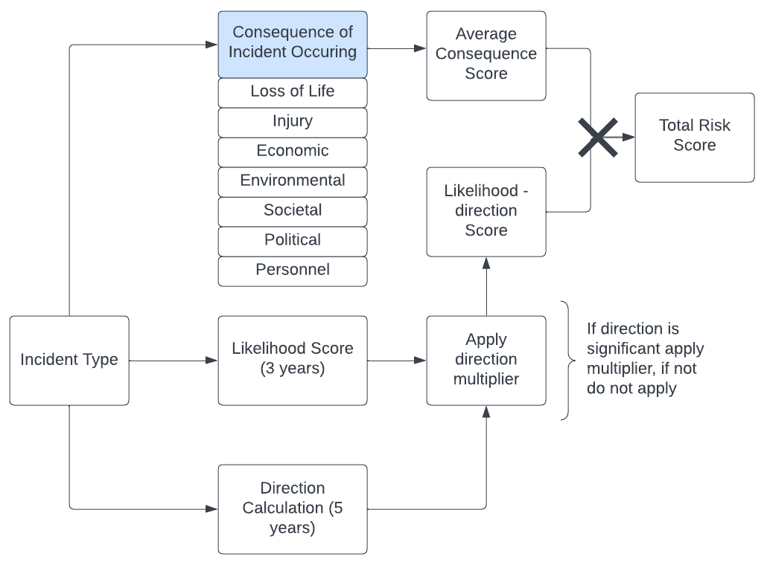
Figure 4: Mapping diagram of the risk assessment methodology detailing the factors that contribute to calculating an overall risk score for a given incident type. Some of the factors include: the incident type; the consequence of the incident occurring; a likelihood rating; all of which lead to a total risk score for each incident type.
To support our findings and to deliver our services effectively we also utilise many other data sources and tools:
- National Risk Register (NRR) - The NRR is an assessment of the key risks that have the potential to cause disruption in the UK.
- Census - The census in the UK is a count of all people and households. The latest census in the UK was held on 21 March 2021. Top level results are now available.
- Mosaic - Geodemographic segmentation data from Experian that classifies UK households into different geodemographic groups.
- Incident Recording System (IRS) - The IRS is an electronic system for recording data at incidents. The system is operated by the Home Office and all fire services have a requirement to gather incident data.
- Partner agencies - Consultation and working practices are shared between partner agencies that are linked in some way to our local risks.
- Cadcorp SIS and Web Map Layers - Cadcorp SIS is a desktop geographic information system (GIS) used for spatial data analysis. Cadcorp Web Map Layers is a web-based GIS used to display spatial data.
- Corvu - Corvus is the Service’s primary data extraction, combination and presentation tool.
- Community Fire Risk Management Information System (CFRMIS) - CFRMIS is an electronic information system used to store and manage business fire safety and community safety data.
- Local Resilience Forum (LRF) Community Risk Register (CRR) - The CRR provides information on emergencies that could occur and provides an assessment of how likely they are to happen and the impacts if they do.
- Lancashire Insight - Lancashire specific data portal providing key statistical data regarding demographics, populous and health data.
- District Intelligence Profiles and Plans - These identify risks that are perceived at a local level and help drive prevention, protection and response arrangements in localities.
- Site Specific/ Operational Risk Information - This relates to information we gain during visits to high-risk premises, and which is then made available to crews when dealing with incidents.
Due to the extensive and detailed documentation that underpins the SAoR not all information has been placed within this document. Should more detailed information be required it can be made available upon request through Planning, Performance and Assurance (internal) or via our website

Executive risk assessment summary
Based on our risk assessment methodology, all incident categories have been scored. The highest risk incident types can be seen below. The highest risk incident types have been recorded within the Community Risk Management Plan (2022-2027) which highlights our proactive and reactive measure in response to the risk.
Risk Number | Incident Type | Overall Rating | Rank | Trend | Rank 2022
1 | Commercial Property Fires | 14.10 | Very High | ¬ | 1
2 | Wildfire | 13.65 | Very High |  | 4
3 | Accidental Dwelling Fires | 13.49 | Very High |  | 2
4 | Flooding | 12.00 | Very High |  | 3
5 | Deliberate Building Fires | 10.79 | Very High |  | 6
6 | Road Traffic Collisions (RTC’s) | 10.24 | Very High |  | 7
7 | Rescue from Collapsed Structure/Confined Space/Other | 9.97 | Very High |  | 5
8 | Road Vehicle Fires | 9.60 | Very High | ¬ | 8
9 | Assist Other Agencies | 9.13 | Very High | ¬ | 9
10 | Industrial Fires | 9.07 | Very High | ¬ | 10
11 | Waste Disposal Site Fires | 8.76 | Very High | ¬ | 11
12 | High Rise Fires | 8.70 | Very High | ¬ | 12
13 | Rescue from Height | 8.62 | Very High | ¬ | 13
14 | Hazmat Incident (Minor) | 8.25 | High |  | 15
15 | Hazmat Incident (Major) | 8.16 | High |  | 16
16 | Building Under Construction Fires | 7.76 | High |  | 18
17 | Other Outdoor Fires (Primary) | 7.75 | High |  | 19
18 | Removal of Objects from People | 7.67 | High |  | 20
19 | Removal of People from Objects | 7.17 | High |  | 14
20 | Animal Rescue | 7.17 | High |  | 21
21 | Other Transport Fires (Air, Boat, Train) | 7.11 | High |  | 22
22 | Secondary Fires (ASB) | 7.06 | High |  | 23
23 | Secondary Fires (Accidental) | 6.98 | High |  | 17
24 | Effecting Entry/Exit | 6.94 | High | ¬ | 24
25 | Suicide/Attempts | 6.68 | High |  | 28
26 | Heritage Fires | 6.57 | High | ¬ | 26
27 | Rescue from water | 5.86 | High | ¬ | 27
28 | Other Transport or Making Safe (Not Fire) | 5.78 | High |  | 25
29 | Lift Release | 5.71 | High | ¬ | 29
30 | Malicious Attacks/Terrorist Incidents | 4.79 | Medium | ¬ | 30
31 | Rescue from Depth | 4.42 | Medium | ¬ | 31
32 | Rescue from Mud | 3.84 | Low | ¬ | 32

Items within the risk assessment have been linked in the CRMP outcomes due to similarities in response *1 have been merged, *2 have been merged, and *3 have been merged.

Overall risk rating percentiles

Rating | Score | Percentile
Very High | > 8.46 | > 60%
High | 8.45 to 5.64 | 40% - 59%
Medium | 5.63 to 4.23 | 30% - 39%
Low | < 4.23 | < 30%

Commercial property fires
Commercial property accounts for roughly 13% of the value of all buildings across the UK and is worth almost £900bn, according to the British Property Federation. Commercial property comprises a diverse range of property types including office space and retail establishments, from high street shops to large out-of-town complexes. It also refers to leisure establishments, such as restaurants, pubs, hotels, and gyms, and even car parking.
As with most counties throughout England, Lancashire boasts thousands of commercial premises, all of which must comply with the Regulatory Reform (Fire Safety) Order 2005. Fire and rescue services are responsible for enforcing this legislation and LFRS has a robust inspection programme in place for those premises deemed to be high risk. Fire inspection forms the basis of our protection programme designed to reduce the risk and impact of fire upon communities, businesses, and our environment, and safeguard firefighters who respond to incidents involving them.
Over the past five years, we have attended an average of 247 incidents a year which have involved commercial premises where the cause has been recorded as accidental or unknown. This equates to a five-year total of 1,232 incidents.
Non-residential properties accounted for 86% of the incidents, of which food and drink establishments accounted for 18%, with retail outlets also with 18%, and industrial manufacturing 15%.
Other residential properties accounted for the other 14% of the total number of incidents, of which residential homes accounted for 34%, hotel/motel 26%, and student hall of residence 17%.
Fires at commercial property types resulted in 3 fatalities, 4 serious injuries and 16 minor injuries over the previous five years.

Risk – Commercial building fires | Rating
Likelihood | Medium High
Consequence | Moderate
Risk score | 14.10
Overall assessment | Very High

Wildfire
The wildfire season, severity and size of wildfires is increasing in duration, this could be attributed to climate change and other factors that have sustained or increased the fuel layer on the moors such as changes in land management, reduced animal grazing and competing priorities for moorland management.
Wildfires have historically occurred in spring and summer months. The spring fires usually involve surface fine fuel fires such as Molina grass/heather that have been dried out by the wind, sun, and frost. The fires that occur are also supported by a blanket of dead vegetation on the moors from the previous year. These types of fires can spread rapidly over large geographic areas.
The summer fires are caused by prolonged periods of drought conditions due to low rainfall and high temperatures. Ground fuel fires that occur in large and remote geographic areas where water sources are not readily available can be extremely resource intensive, require support from partner agencies and be difficult to extinguish due to being deep seated below ground. These types of incidents require vast quantities of water far in excess of what conventional fire-fighting appliances can deliver.
We know that wildfires can start for many reasons, such as mishandled campfires or barbecues, malicious activity such as deliberate fire setting, infrastructure incidents such as sparks from electricity lines or rail transport, and natural phenomena such as lightning (although this is rare). Hot, dry and windy weather are ideal conditions for wildfires to start and spread.
Over the previous five years, we attended 609 wildfire incidents which is an average of 122 incidents a year. 80% of the incidents only involved 1 pump. 45% of all the wildfire incidents were deliberate, including some large-scale, multi-pump incidents attended by LFRS.

Risk - Wildfire | Rating
Likelihood | Medium High
Consequence | Moderate
Risk score | 13.65
Overall assessment | Very High

Accidental dwelling fires (ADF’s)
Dwelling fires are those occurring in buildings that are normally occupied, typically houses, flats and bungalows. Fires of this nature can also result in both physical and mental harm and the injuries sustained could be fatal. As well as the human cost associated with dwelling fires, there is a significant economic burden associated with property damage. LFRS continues to provide a community fire safety service to the residents of Lancashire, where smoke alarms can be fitted, and home fire safety advice tailored to individual households as part of a Safe and Well visit. Reduction activity is carried out by community fire safety staff alongside operational personnel in conjunction with local and national campaigns.
Over the previous five years, we have attended an average of 803 incidents a year of this type. Single occupancy houses accounted for 63% of all accidental dwelling fires. Followed by purpose built flats with 12% and self-contained sheltered housing 7%.
Blackpool district experienced the highest number of ADF’s followed by Lancaster then Preston. Ribble Valley has seen the lowest number of ADF’s over the last five years. 35% of the total number of ADF’s were caused by 18-64 year olds with 22% caused by the elderly (65+). The biggest cause of ADF’s are cooking appliance related, followed by spread from a secondary fire and smoking related.

Risk – Accidental dwelling fires | Rating
Likelihood | High
Consequence | Minor
Risk score | 13.49
Overall assessment | Very High

Flooding
Whilst LFRS has no statutory duty to provide emergency response to water or flooding events, as a category 1 responder the Service is bound by the Civil Contingencies Act 2004 to have plans in place to respond to all emergencies. Through close consultation and collaboration with our partners and the LRF, a Multi-Agency Flood Plan has been developed which outlines the agreed coordinated multi agency response should a flooding event occur in the Lancashire area. This plan has been identified as an essential requirement as it has been recognised through the LRF Community Risk Register that there are approximately 65,000 properties at high or very high risk from flooding within Lancashire. The average cost of flooding to a home is around £30,000 and to a business £82,000. The effects on mental health can last for months and even years. Environmental impacts include pollution, harm to livestock and wildlife, and destruction of habitats. Disruption to power supplies and transport networks is a risk and in the most severe cases, floods can cause injury and death.
Due to the diverse nature of the Lancashire landscape, our communities can be at risk from coastal / tidal flooding, river flooding (fluvial), surface water (pluvial) and reservoir flooding, albeit the likelihood of these events occurring varies from 1 in 5 years to 1 in 1000 years.
In the last five years, LFRS has responded to 216 flooding related incidents relating to high tides, rising river levels or surface water. This equates to 43 incidents of this type a year. Domestic dwellings were affected at 62% of these incidents. Rossendale has been the most affected (14% of the incidents), mainly due to the surface water and rising river levels.

Risk - Flooding | Rating
Likelihood | Medium
Consequence | Significant
Risk score | 12.00
Overall assessment | Very High

Deliberate building fires
Inevitably, when thinking of deliberate fires, the term arson is often used. This is the act of using fire to destroy or damage any property belonging to another. However, there are many different reasons why individuals or groups display fire-setting behaviour, from curiosity to anti-social behaviour, to mental health issues. The term ‘deliberate fire setting’ covers a wider proportion of scenarios.
Regardless of the reason, a deliberate fire can cause significant damage to property, communities, the economy and in the worst-case scenarios cause injury or death. Using our IRS and Geographical Information Systems (GIS) LFRS can scan for trends in anti–social and deliberate fire setting. By doing this, areas can be quickly identified through emerging trends, meaning prevention activities can be planned and undertaken, often with our partners. Activities can include anything from removal of rubbish to increased youth engagement activities, all with an aim to reduce the incidence of deliberate fires and help our partners build stronger more sustainable communities.
Over the previous five years, we have attended an average of 223 deliberate building fires a year. Non-residential buildings accounted for 50% of the fires with public admin, security and safety properties being targeted the most (24% of the non-residential fires). Deliberate dwelling fires accounted for 45% of the total incidents with houses of single occupancy taking a 52% share of these incidents.
Deliberate building fires have been responsible for 9 fatalities, 13 serious injuries and 33 minor injuries over the last five years.

Risk – Deliberate building fires | Rating
Likelihood | Medium High
Consequence | Moderate
Risk score | 10.79
Overall assessment | Very High

Road traffic collisions (RTC’s)
Nationally, RTC’s are the most frequently attended non-fire incident by Fire and Rescue Services. LFRS has a statutory duty to provide an emergency response to RTC’s. Whilst we are not the lead agency for road safety prevention work (this falls to Lancashire County Council and Unitary Authorities), we do recognise the importance of road safety prevention work in mitigating collisions and the devastating effects that road traffic collisions can have on individuals and communities. We are part of the Lancashire Road Safety Partnership.
The area covered by LFRS is large and includes 5 motorways, over 700 km’s of 'A' roads and a significantly high number of rural roads. Statistics have shown that car occupants are the most likely to be killed in an RTC, followed by pedestrians, motorcyclists and cyclists. Children aged under 15 are most likely to be involved in RTC’s as pedestrians.
Over the previous five years, LFRS have attended an average of 635 incidents of this type a year, which accounts for 15% of all Special Service calls. There has been 58 fatalities and 419 serious injuries from RTC’s attended by LFRS over the last five years, that involved either the extrication of trapped individuals or making the vehicle(s) safe. Other types of work undertaken by operational crews at RTC’s have included making the scene safe, offering medical assistance only and the release of individuals where there was no requirement for an extrication to take place.

Risk – Road traffic collisions | Rating
Likelihood | High
Consequence | Minor
Risk score | 10.24
Overall assessment | Very High

Rescue collapsed structure/confined space
Incidents occurring in confined spaces and within/around collapsed or unstable structures are some of the most complex areas that fire and rescue services work in and include both geological and manmade structures.
Fire and rescue services frequently attend incidents that involve a combination of these contexts, where danger to operational crews and the public is significant. LFRS aims to promote and develop good practice and support the development of safe systems of work to minimise the dangers faced in these environments.
Over the previous five years, we have attended an average of 86 incidents a year of this type, attending 430 incidents in total. LFRS attended 60 incidents involving somebody trapped in or under machinery or another object e.g., hopper, conveyor, crusher. Nine incidents involved a rescue from a confined space and 14 incidents from a collapsed structure. Due to the nature of this incident type, there have been 9 fatalities, 37 serious injuries and 37 minor injuries.

Risk – Rescue collapsed structure/confined space | Rating
Likelihood | Medium High
Consequence | Minor
Risk score | 9.97
Overall assessment | Very High

Road vehicle fires
The road vehicle fires dataset covers primary fires attended by LFRS that involved any vehicle designed for road use. Fires in derelict road vehicles are only included if they are considered to be a primary fire (i.e., the fire involved a fatality, casualty or rescue, or the fire was attended by five or more pumping appliances).
Every year in the UK, thousands of road vehicles are involved in fire and unfortunately people die as a result. Around half of these fires are started deliberately to cover criminal activity, to make a fraudulent insurance claim or as an act of vandalism. One in 12 reported stolen vehicles will be burnt out. Many other vehicle fires break out because of a fault or simply due to a lack of basic maintenance. The financial loss of having a car fire is bad enough and although insurance may compensate for this, nothing can help with the shock and inconvenience that follow even a small fire.
Over the previous five years we have attended an average of 474 incidents a year involving road vehicle fires. This equates to 2372 in total, with 59% involving cars, 12% vans and 10% motorcycles, with 42% of the fires being deliberate.
The district of Preston experienced the most road vehicle fires with 45% being deliberate. There were some casualties from this incident type with 6 fatalities, 16 people sustaining serious injuries over the last five years, and 33 people with minor injuries.

Risk – Road vehicle fires | Rating
Likelihood | High
Consequence | Limited
Risk score | 9.60
Overall assessment | Very High

Assist other agencies
LFRS, Lancashire Constabulary and North West Ambulance Service (NWAS) have entered a Memorandum of Understanding (MOU) which provides the agreement for LFRS to replace Lancashire Constabulary as the supporting agency for NWAS. This refers to instances where it is necessary to assist NWAS to gain entry to a property to provide patient care. This incident type primarily relates to calls where there is concern for the welfare of a patient inside premises and NWAS cannot gain access. NWAS staff on scene will request assistance to gain entry.
Over the previous five years we have attended an average of 1,296 incidents a year where we have assisted other agencies. Of the 6,479 incidents attended, 80% were assistance to the Police/Ambulance-. LFRS also attended 549 incidents to assist NWAS with a bariatric patient. Unfortunately, to the nature of this incident type, there were 268 fatalities, 873 serious injuries and 1,018 minor injuries dealt with by both LFRS and NWAS.

Risk – Assist other agencies | Rating
Likelihood | High
Consequence | Limited
Risk score | 9.13
Overall assessment | Very High

Industrial fires
Industrial incidents can take a wide variety of forms, and their potential impact on our communities varies considerably in both scale and nature. In some cases, these incidents will have very limited impacts beyond the immediate area and can be dealt with locally, although others can have cascading effects that may impact the wider community. Within our Service area, there are 8 Top tier COMAH (Control of Major Accident Hazards Regulations 1999) sites and several Lower tier sites covered by the Dangerous Substances (Notification and Marking of Sites) Regulations 1990 (NAMOS). These businesses are required to take all necessary measures to prevent major accidents involving dangerous substances to limit the consequences to people and the environment of any major accidents that do occur.
There are several industrial estates in our area that pose risks because of the diverse range of manufacturing and/or processes undertaken by the businesses that occupy the premises at these sites. The experienced level of demand remains relatively low at these premises due to many sites being well-protected from the risk of fire and other incidents. The significant level of prevention activity that we undertake as an FRS helps to ensure this level of protection remains high.
Over the previous five years, we attended an average of 44 industrial based incidents a year. Of the 221 incidents attended, manufacturing accounted for 78% and processing 22%, with fires within engineering premises and factories accounting for 51% of the overall total.

Risk – Industrial fires | Rating
Likelihood | Medium
Consequence | Moderate
Risk score | 9.07
Overall assessment | Very High

Waste disposal site fires
Waste disposal sites nationally are recognised as being susceptible to fires, whether accidental or through negligence. Such fires are an increasingly growing risk and have the potential to impact upon resources and local communities for a significant period.
As well as the health risk to the residents of Lancashire, and firefighters dealing with this type of incident, waste disposal site fires also place a strain on partner agencies such as the Police, Environment Agency, public health, local authorities and the site owners.
There are several waste disposal and recycling centres across the Service area, including a mix of local authority-owned and privately-owned sites. The local authority-owned sites are often regulated by regulatory bodies such as the Environment Agency, while the private sites are regularly managed through unclear management structures.
For this document, ‘waste disposal site fires’ are defined as primary fires where a recycling or refuse structure has been affected.
Over the previous five years, we attended an average of 18 waste disposal site fires a year, equating to a total of 89, of which 71% (63) involved a refuse/rubbish tip with the remaining 29% (26) involving industrial processing.

Risk – Waste disposal site fires | Rating
Likelihood | Medium
Consequence | Minor
Risk score | 8.76
Overall assessment | Very High

High rise fires
LFRS regard any building that has six floors (ground + 5 floors above) as a high-rise building. Buildings of this size present many challenges to FRSs in the event of a fire. To successfully deal with an incident in a high-rise building, realistic training is essential along with gathering and storing risk information, educating the occupants and enforcing any breaches of legislation. We have identified high rise properties that have cladding that could promote external fire spread and put measures in place to ensure an appropriate, risk-based attendance is sent upon receipt of information that there is a confirmed fire in one of these buildings. There are 45 high rise buildings in Lancashire, ranging from domestic accommodation to hospitals, car parks to entertainment venues, hotels to education.
Over the previous five years, we attended an average of 2 fires a year involving high rise buildings. Of the 10 incidents attended in total, 7 were accidental fires. Domestic dwellings accounted for 70% of the incidents and Student Halls of residence 20%. Car Parks accounted for 10% of the non-residential high-rise fires.
Despite the fears of rapid fire growth following the Grenfell tragedy, none of these incidents resulted in the fire spreading beyond the floor of origin.

Risk – High Rise fires | Rating
Likelihood | Medium Low
Consequence | Significant
Risk score | 8.70
Overall assessment | Very High

Rescue from height
Nationally, FRS respond to a wide range of incidents at height involving a variety of environments, such as industry, buildings/dwellings (including buildings under construction) and natural environments (such as steep ground, rock faces). Locally, LFRS covers a wide geographical area, including coastlines to the west, and fells and dales to the north. We respond to incidents where people are stranded in inaccessible locations without specially trained rope rescue equipment, and where there is a high level of risk. Every wholetime firefighter in LFRS is trained to carry out a rescue using a rope pack and associated equipment, backed up by specialist teams from Chorley, Bamber Bridge or St Annes.
Over the previous five years, we attended an average of 63 rescues from height incidents a year. This equates to 315 incidents in total. Of these, 35% involved non-residential buildings, 27% involved domestic dwellings and 31% involved the outdoors, including rescues from trees and equipment in parks. This incident type saw 11 serious injuries and 29 minor injuries.

Risk – Rescue from height | Rating
Likelihood | Medium High
Consequence | Limited
Risk score | 8.62
Overall assessment | Very High

Hazardous materials incident (Hazmat)
There are several pieces of legislation that place a duty on LFRS to protect lives, property and the environment from the damaging effects of hazardous materials. We work very closely with partner organisations, particularly the Environment Agency, to try to reduce the impact caused by hazardous materials. Dangerous hazardous materials are regularly transported through the Service area via rail or road. There are several other associated risks from hazardous materials, with some examples being COMAH sites and a multitude of other industrial sites, farms (especially in some of the more rural locations), waste sites and water treatment plants. There are also several high-pressure natural gas transmission pipelines crossing the region. This hazard arises from the high pressure and the possibility of fire and explosion from a release if one of the pipelines failed or sustained damage.

Hazmat incident (Minor)
LFRS have categorised a hazmat incident to be minor if less than four pumping appliances attended. Over the previous five years, we have attended an average of 82 incidents of this type a year. Of the 409 incidents attended, eight resulted in fatalities and there were fourteen serious injuries sustained. 67% of the incidents occurred in a domestic dwelling environment, whilst others included outdoors and road vehicles. 62% of the incidents involved a gas release.

Risk – Hazmat incident (Minor) | Rating
Likelihood | Medium High
Consequence | Limited
Risk score | 8.25
Overall assessment | High

Hazmat incident (Major)
LFRS have categorised a hazmat incident to be major if four or more pumping appliances attended. Over the previous five years, we have attended a total of 20 incidents of this type resulting in three people sustaining slight injuries.

Risk – Hazmat incident (Major) | Rating
Likelihood | Medium Low
Consequence | Significant
Risk score | 8.16
Overall assessment | High

Building under construction fires
When dealing with any fire in buildings under construction or demolition, whatever its size or complexity, they pose risks to FRS personnel. There is often a presumption that construction, demolition or building work complies with relevant regulations. This may not always be the case and if work is unregulated or in direct contravention of regulations, this could have a significant impact on the incident and firefighter safety.
Some small construction sites or buildings undergoing building work may be unknown to fire and rescue services, making pre-planning difficult. Sites known to fire and rescue services may alter significantly throughout the life of the project such as changes to access and egress, hazardous material storage, layout and fire protection features. Information obtained from site visits and inspections should be regularly reviewed, updated and communicated to relevant fire and rescue service personnel.
Existing buildings may contain hazardous substances that are associated with either the previous use of the building or building materials. This could include substances such as asbestos, which may not have been highlighted in a survey. If disturbed during building work or firefighting, asbestos presents a significant risk to health. Although sites should be well-secured, using high fencing, hoardings, or other security measures, these may be compromised allowing the public to gain unauthorised access.
LFRS has invested time and money in identifying risks associated with buildings under construction by assembling a built environment assessment team.
Over the previous five years, we attended 78 incidents involving buildings under construction. This averages out at 16 incidents of this type a year. Single occupancy dwellings accounted for 5041% of the incidents.

Risk – Building under construction fires | Rating
Likelihood | Medium
Consequence | Minor
Risk score | 7.76
Overall assessment | High

Other outdoor fires (Primary)
Other outdoor fires are fires in either primary outdoor locations, or fires in non-primary outdoor locations that have casualties, or five or more pumping appliances attending. Outdoor primary locations include outdoor structures such as post or telephone boxes, bridges, tunnels etc.
Over the previous five years, we have attended 340 incidents of this type, with an average of 68 incidents a year. 59% of these incidents were recorded as accidental. 218 incidents (64%) involved outdoor structures and 69 incidents (20%) involved outdoor equipment and machinery. Unfortunately, there were two fatalities over the last five years, along with 10 serious injuries and 12 slight injuries.

Risk – Other outdoor fires (primary) | Rating
Likelihood | Medium High
Consequence | Limited
Risk score | 7.75
Overall assessment | High

Removal of people from objects and Removal of objects from people
People often get stuck, some very seriously and sometimes through no fault of their own. Fire and rescue services log call-outs in a number of categories, including ‘removal of people from objects’ and the rather more wince-inducing ‘removal of objects from people’. Quite often, these incidents are as simple as removing a ring from a finger, however sometimes over-confidence is to blame, having been spurred on by other people and showing off, resulting in people getting stuck in objects that take FRS’s a little more time and resources to successfully deal with.
Removal of people from objects
Over the previous five years, we have attended an average of 69 incidents a year involving the removal of people from objects. Of the 344 incidents attended, 68% involved a trapped limb, with the other 32% being recorded as ‘other’. 43% of these incidents occurred in the domestic dwelling environment.
Removal of objects from people
Over the previous five years, we have attended 396 incidents of this type. This equates to an average of 79 incidents a year. Ring removal accounted for 73% of these incidents with other incidents attended including impalements, handcuff removal and removal of other objects such as railings.

Risk – Removal of objects from people | Rating
Likelihood | Medium High
Consequence | Limited
Risk score | 7.67
Overall assessment | High

Risk – Removal of people from objects | Rating
Likelihood | Medium High
Consequence | Limited
Risk score | 7.17
Overall assessment | High

Animal rescue
For many years, firefighters have responded to a variety of incidents involving pets, livestock, and wild animals. Animals in distress can pose a potentially serious risk to the public, staff from other agencies and firefighters. There is also an element of risk of members of the public suffering serious injury should they decide to attempt an animal rescue themselves. As Lancashire has large rural areas as well as densely populated areas, LFRS inevitably responds to incidents where a range of animals are in distress. We therefore have a range of resources available to deal with this risk, including six specialist animal rescue trained stations based at strategic locations across the county.
Over the previous five years, we attended an average of 181 animal rescues per year, equating to 906 incidents in total. Incidents involving trapped animals accounted for 44% of the total, with the majority involving domestic animals. 26% of animal rescues involved a rescue from height with the majority involving domestic animals. We attended 148 incidents (16%) involving rescues of animals from water or mud with over half of these involving livestock.

Risk – Animal rescue | Rating
Likelihood | Medium High
Consequence | Limited
Risk score | 7.17
Overall assessment | High

Other transport fires (air, boat, train)
Although air is one of the safest modes of transport, incidents relating to air travel are still present across the UK, with many occurrences related to smaller aircraft such as microlights and gliders. Within Lancashire, to the far west of the county, sits Blackpool airport, where the risk of an air transport fire is high due to the amount of traffic utilising the airport.
Lancashire has over 120 km’s of coastline, several rivers, lakes, reservoirs, canals and other water bodies that have the potential to have boats of varying sizes being used for business and pleasure purposes.
Incidents on the railways can also pose significant risks and potential danger to the community. The west coast main line dissects Lancashire, with trains running between Edinburgh and London stopping at Preston. There are also a few other local lines in operation, all of which pose their own unique levels of hazards and risks.
Over the previous five years, we have attended an average of 4 incidents a year involving vehicles other than those that are road based. Of the 20 incidents that occurred over the five year period, 11 were accidental and 9 were deliberate. One incident involved a military aircraft, 2 incidents involved trains/trams, with the remainder (17) involving boats.

Risk – Other transport fires (Air, Boat, Train) | Rating
Likelihood | Medium Low
Consequence | Moderate
Risk score | 7.11
Overall assessment | High

Secondary fires (accidental) and Secondary fires (anti-social behaviour - ASB)
This type of incident incorporates fires with no casualties, rescues or valuable property loss. These include outdoor fires, derelict property and derelict vehicle fires. Outdoor fires may involve grass, refuse, wheelie bins and straw.
Although there may be less damage incurred by secondary fires than primary fires, and these incident types generally occur outdoors, not involving people or property, the impact of deliberate secondary fires on LFRS is substantial. Secondary fires are one of the biggest burdens placed on our resources.
As with primary fires, the number of accidental secondary fires that we experience is low in comparison to those set deliberately.
Over the previous five years, we have attended an average of 1,588 deliberate secondary fires a year, equating to 7,940 in total. Of these, 66% involved rubbish, in the form of either loose refuse, a skip, a small refuse container or a wheelie bin. Over 40% of the total number of incidents occurred in the districts of Preston, Burnley or Blackburn with Darwen.
Over the same five-year period, we have attended an average of 1,631 accidental secondary fires a year, equating to 8,154 in total. Over half of these incidents occurred in the five districts of Blackburn with Darwen, Blackpool, Burnley, Preston, and Lancaster. As with deliberate secondary fires these mainly involved refuse.

Risk – Secondary fires (ASB) | Rating
Likelihood |  | High
Consequence |  | Limited
Risk score |  | 7.06
Overall assessment |  | High

Risk – Secondary fires (accidental) | Rating
Likelihood | High
Consequence | Limited
Risk score | 6.98
Overall assessment | High

Effecting entry/exit
The fire service is the ‘go to’ service when people need to get in to, or out of a building or vehicle in an emergency. Incident types range from getting access to a house because somebody is in distress, children locked in their bedroom along with animals locked in cars.
Over the previous five years, we have attended an average of 273 incidents a year of this type, totalling 1,367. Of these incidents, 58% involved LFRS effecting entry/exit to a dwelling due to somebody being in distress, being a child or, a medical case. Children in vehicles accounted for 14% of the incidents. Over this five-year period, this incident type has resulted in 16 fatalities, 64 serious injuries and 80 slight injuries to members of the public.

Risk – Effecting entry/exit | Rating
Likelihood | Medium High
Consequence | Limited
Risk score | 6.94
Overall assessment | High

Suicide or suicide attempts
Across England, fire and rescue services responded to a record number of suicides or suicide attempts – the tenth successive yearly increase nationwide. Suicide and suicide attempts can have lasting effects on individuals, their social networks and communities and the emergency responders attending.
Over the previous five years, we have attended 214 suicides or suicide attempts. This is an average of 43 incidents of this type a year. The districts of Preston (18%) and Blackpool (14%) had the highest number of incidents. Incident recording shows that we attended 170 incidents where there was a threat of/attempted suicide and 44 incidents of suicide. 45% of the total number of incidents occurred within a domestic residence.

Risk – Suicide or suicide attempts | Rating
Likelihood | Medium
Consequence | Limited
Risk score | 6.68
Overall assessment | High

Heritage fires
Heritage buildings or their contents may be of economic or cultural importance. These buildings present unique hazards, having been built in a period with no fire safety regulations, using traditional materials and construction methods. Utilities and associated protection measures are unlikely to meet current standards. Wiring may have deteriorated, and circuits can have no isolation point, or isolation may not control all circuits.
Heritage buildings that are open to the public or have had recent alterations may have been modified to meet current regulations. During a building’s lifetime, it may have been altered or extended, using different materials and methods which can cause the structure to behave in unexpected ways. In older properties, internal studded walls may support part of the weight of the property. It is common for heritage buildings to have mezzanine floors, basements, tunnels, and attics.
The materials and design of heritage buildings can increase the expected rate of fire growth and spread. Fire spread may travel in hidden voids, behind facades and in cavities to unexpected sections of the building. Vaults and ducts can cause unchecked fire spread underfoot. Lack of compartmentation can cause fires to spread to additional rooms. Fire spread may also occur between properties where shared roof spaces or voids exist.
Over the previous five years, we have attended 32 incidents where there has been a fire within a 50-metre radius of a heritage property. This is an average of 6 incidents of this type a year.

Risk – Heritage fires | Rating
Likelihood | Medium Low
Consequence | Moderate
Risk score | 6.57
Overall assessment | High

Rescue from water
There are a number of water-related risks across Lancashire, with the Rivers Ribble, Lune, Wyre, Irwell and Calder, each posing their own risks. The risk of members of the public entering the water and getting into difficulty appears to be on the increase. The combination of the River Lune and River Ribble running directly through the cities of Preston and Lancaster respectively, and the growing student population in those cities brings an increased risk of water-related incidents occurring. Lancashire has over 120 km’s of coastline, and there are several lakes, reservoirs and other water bodies across the Service area that pose risks to the community. The west of the county also has three ports, Heysham, Fleetwood and Glasson.
Our crews carry out training in these areas to ensure their knowledge of the hazards posed and ability to respond are first class. LFRS continues to prepare for water rescue incidents daily and provides an emergency response 24 hours a day.
Over the previous five years, we attended an average of 47 water rescue related incidents a year. Overall, this equates to 237 water rescue incidents in total. These incidents have seen 27 fatalities,16 serious and 43 minor injuries. The main type of incident we attended involved rescues from rivers/canals (48%) and rescues from lakes/ponds/reservoirs (8%).

Risk – Rescues from water | Rating
Likelihood | Medium
Consequence | Limited
Risk score | 5.86
Overall assessment | High

Other transport or making safe (not fire)
This incident type is split in to two categories, ‘making safe (not RTC)’ and ‘other transport incident’. Attendance at these incidents could be following a request from other emergency services or through the 999 call route. Incidents in these categories include cordoning off, body retrieval and stabilising an unsafe structure as well as making the scene safe, releasing a person and making a vehicle safe.
Over the previous five years, we have attended an average of 188 incidents a year of this type, totalling 939. Of the 939 incidents attended, 86% have resulted in LFRS making the scene safe, with 54% of these incidents requiring us to stabilise, or otherwise make safe an unsafe structure. The majority of these have been in a domestic environment however, numerous incidents involved retail, food and drink establishments and outdoor structures. This incident type has resulted in 14 fatalities, 8 serious injuries and 31 minor injuries.

Risk – Other transport or making safe (not fire) | Rating
Likelihood | Medium High
Consequence | Limited
Risk score | 5.78
Overall assessment | High

Lift release
Fire and rescue services are not required to attend incidents where a person is shut in a lift, and not in any immediate physical or medical danger. They should only be called in an emergency. Maintenance and non-emergency lift releases are the responsibility of the building or lift owner, who should ensure there is a 24/7 lift release service provided, as well as communications facilities inside the elevator so a person can raise the alarm.
Over the previous five years, we have attended 673 incidents involving a lift release, equating to an average of 135 incidents a year. 76% of these incidents involved a rescue of someone that was not in distress. 68% of the total number of incidents involved a residential building.

Risk – Lift release | Rating
Likelihood | Medium High
Consequence | Limited
Risk score | 5.71
Overall assessment | High

Malicious attacks/terrorist incidents
The UK faces a serious and sustained threat from terrorism, including from international groups, domestic extremists and Northern Ireland related groups. The current UK threat level for terrorism is ‘substantial’, which means an attack is likely. While most incidents have occurred in and around major cities in the UK, it is vital that all emergency services are prepared to deal with an incident in their area. For the purposes of this document, ‘terrorist’ refers to any individual or group seeking to use threats or violence as a means of inflicting terror for the purpose of advancing political, religious, racial or ideological causes. This includes a wide variety of individuals and groups of varying ideologies and backgrounds. Incident types may include Marauding Terrorist Attack (MTA), Chemical Biological Radiological Nuclear and explosives (CBRNe), vehicles as a weapon of choice, or smaller-scale attacks.
We prepare for such incidents by taking advice from the relevant authorities on the potential risks posed and assessing the impact that such an attack/incident may cause through working with key partners as part of the LRF.
We have not attended any incidents of this type over the previous five years.

Risk – Malicious attacks/terrorist incidents | Rating
Likelihood | Low
Consequence | Significant
Risk score | 4.79
Overall assessment | Medium

Rescue from depth
Special service incidents involving rescues from below ground could involve shafts, caves, tunnels, sewers or wells. Rescues of this type are often protracted in nature with access difficult for fire appliances. They may require the use of technical rope skills, and/or additional appliances such as an aerial ladder platform.
Over the previous five years, we have attended 23 incidents, with 15 involving outdoor rescues, 7 rescues from buildings and 1 from a vehicle. There was one fatality, nine people sustained serious injuries and three sustained minor injuries.

Risk – Rescues from depth | Rating
Likelihood | Medium Low
Consequence | Limited
Risk score | 4.42
Overall assessment | Medium

Rescue from mud
Mud rescues involve the use of specialist equipment to recover people and animals from the mud or sinking sand that lies along coasts, river embankments, and lakes. A typical rescue involves using an inflatable raft to support the sinking casualty whilst the crew then use either water or air to soften the mud, allowing the casualty to be pulled to safety. Incidents where people get stuck in deep mud are particularly hazardous. If not rescued quickly enough, a victim may sink further down, which can be hastened by panicking and moving. In addition, trapped victims could be swept away by the water in areas of large tidal variation or by strong currents.
Teams of rescuers require special expertise that is different, but related to water rescue and as such, LFRS have a range of resources available to deal with this type of incident, including six specialist trained stations based at strategic locations across the county along with close working relationships with Bay Search and Rescue Teams and the Coastguard.
Over the previous five years, we have attended 36 incidents, which equates to 7 incidents a year on average. The districts of West Lancashire, Lancaster and Fylde accounted for 50% of the incidents.

Risk – Rescues from mud | Rating
Likelihood | Medium Low
Consequence | Limited
Risk score | 3.84
Overall assessment | Low

HLE indicates the amount of time a person will live in good health (rather than with a disability or in poor health)
To be disestablished 1 March 2024 as part of the Specials Review

