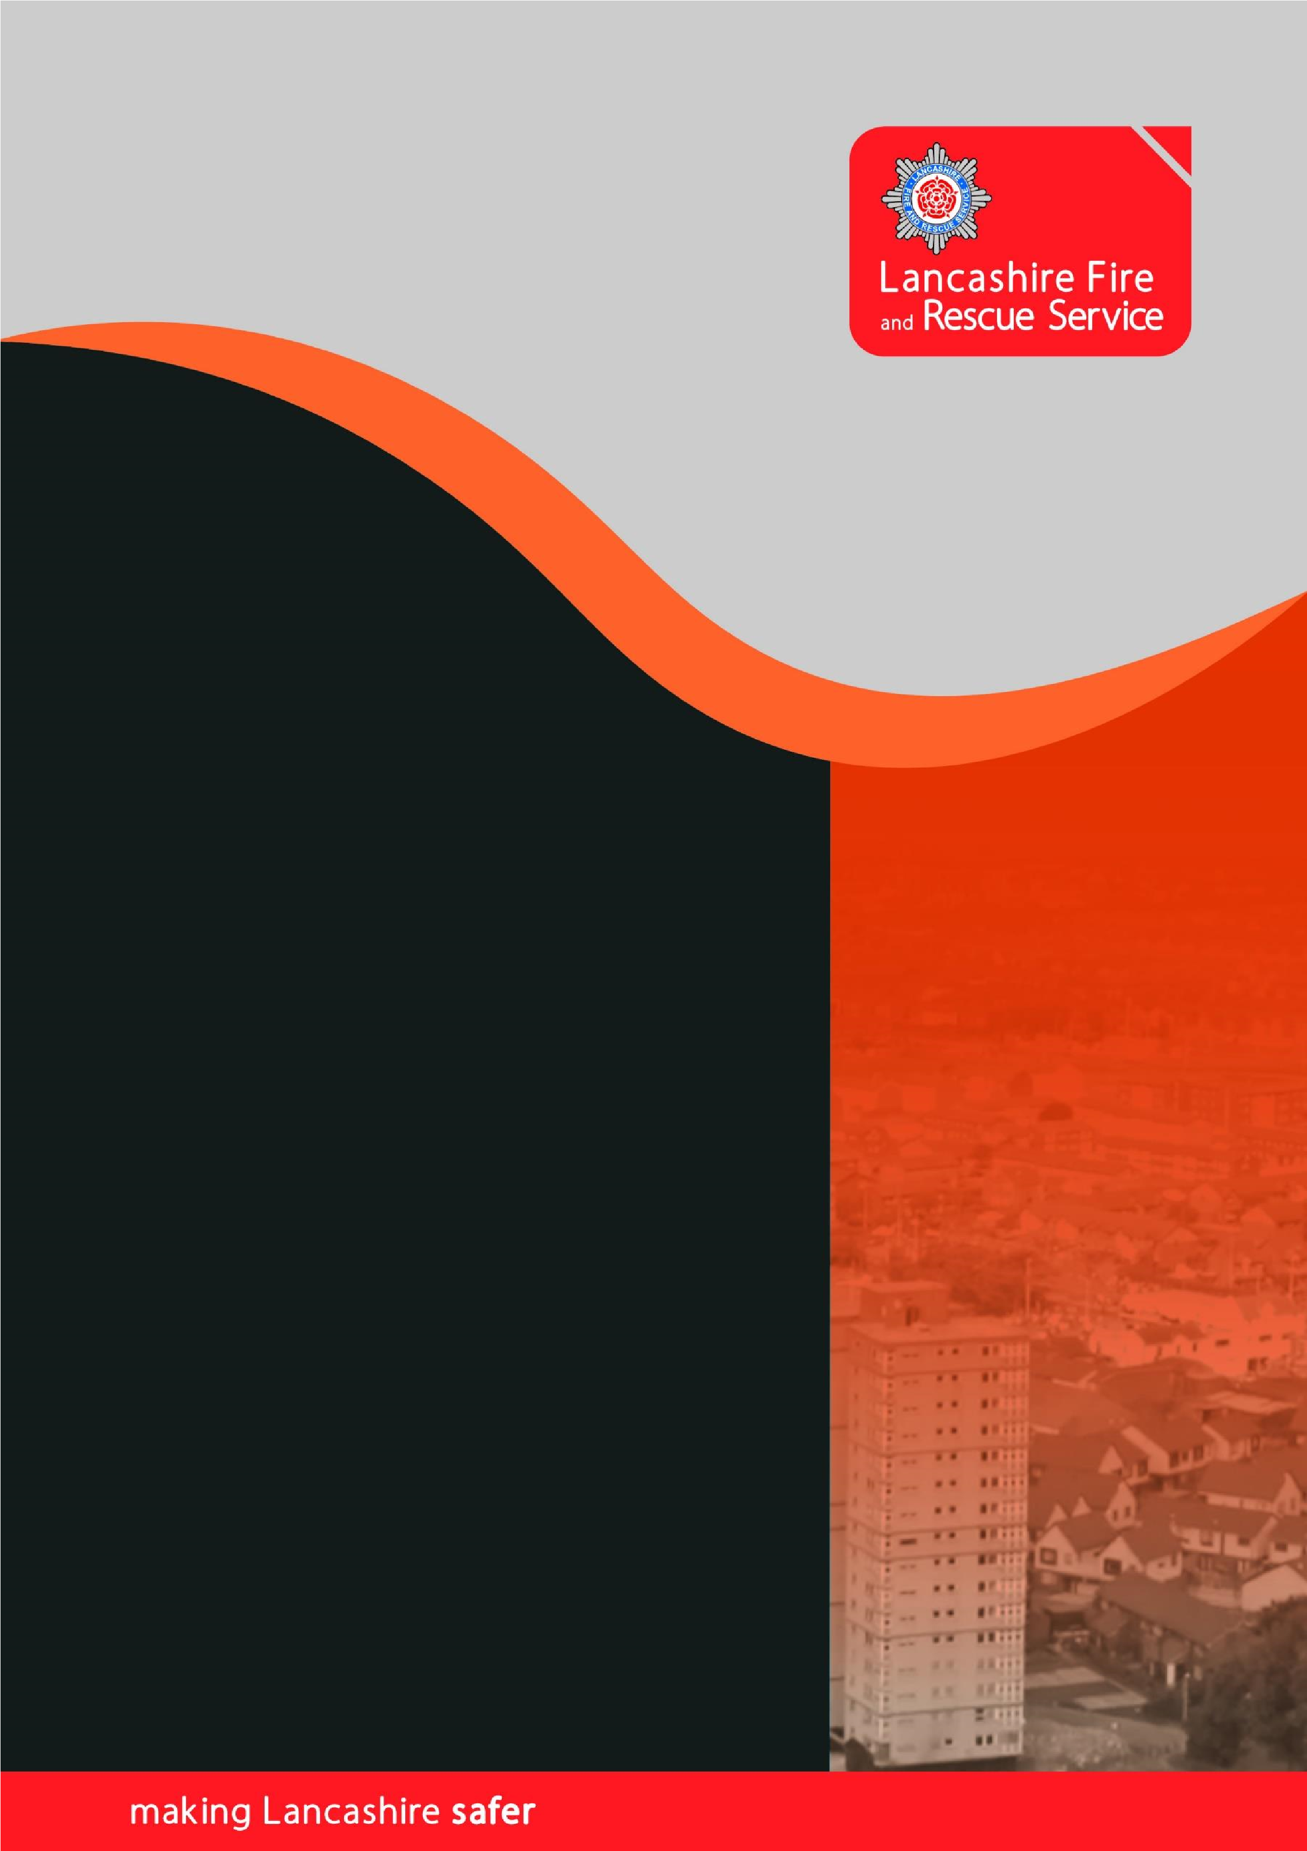

Safely investigating the source of a sounding fire alarm

.

Introduction

Being able to safely investigate the source of a sounding fire alarm is an important part of a building’s fire procedures. Knowing if an alarm is sounding due to a developing fire enables appropriate action to be taken immediately to keep people safe. If the cause is a false alarm however, investigating the source also enables the ‘all clear’ to be given minimising disruption. It also helps avoid the wider risk to the community which occurs when the Fire Service are asked to attend with valuable resources that may be needed elsewhere for a genuine emergency.

If signs of fire are discovered a prompt 999 call should be made immediately giving accurate information which enables the Fire Service to send appropriate resources. If no signs of fire are discovered there is no requirement to contact 999 unless the premises has an auto-dial which has already sent an automatic signal. If a signal has been sent then contacting the Fire Alarm Monitoring Organisation with the updated information that there is no fire will enable them to cancel the call to the Fire Service.

When a fire alarm sounds it is important to immediately apply the fire procedures. These should be pre-planned, relevant to the building type, practiced regularly and contained in staff (and temporary staff) induction and training. Appropriate signage should support the plan and indicate assembly points. This document focusses on how to investigate a sounding alarm safely, more detailed guidance on how to plan appropriate fire procedures is available in the relevant fire safety guidance document.

When an alarm sounds the presumption should be that it has detected a fire and appropriate evacuation procedures for the building type should be undertaken. Presuming that a sounding alarm is a ‘false alarm’ because it happens regularly causes delays in the event of a genuine fire and puts people at risk. Well planned, installed and maintained fire alarms do not cause frequent false alarms. If a fire alarm system generates frequent false alarms it will be due to poor system design, installation, maintenance or human factors (e.g. wedging kitchen doors open). All can be managed or resolved, and the cause of the problem addressed to prevent recurrence, ensuring the fire alarm system only activates when a genuine fire occurs.
Pre-planning

Being able to safely investigate the source of a sounding fire alarm is made much easier by effective pre-planning, backed up by regular training. Always ensure that:

- The alarm panel has a zone plan next to it (a simple plan of the building) so that the affected zone or detector location is easily identifiable.
- Those allocated the role of investigating know what an activated smoke or heat detector looks like (normally a red light on the detector, but this can vary)

Safely investigating the source of a sounding fire alarm

- Leave the building if signs or symptoms of fire are discovered at any time
- Work in pairs where possible
- Check the fire alarm panel – identify which zone or room is indicated
- Proceed to check the indicated area taking a means to summon the fire service
- Be familiar with all escape routes and emergency exits
- Be aware that signs and symptoms will rarely be visible flames and smoke
- Signs and symptoms include unusual smells or a haze in the area where the detector has activated (may be a fire in its early stages or hidden in a void)
- Before opening a door feel it with the back of the hand, as high up as possible, checking for heat. If the door or handle are hot, do not enter

If a flame, smoke, heat, or any other signs / symptoms are identified at any time, leave the building and follow your premises emergency plan.

Make a 999 call clearly stating that an investigation has taken place, and this is a call to a FIRE, not just an alarm sounding. Give the full address, type of building and state if anyone is still inside or may need assistance evacuating.
Actions to take after a false alarm

This section contains advice to help you comply with fire safety legislation, keep your staff and premises safe, and avoid future fire alarms.

It is good practice to allow the evacuation process to complete as interrupting an evacuation is confusing and leads to a false sense of security that every alarm is false. It also helps people to become familiar with the emergency procedures and if anyone has not implemented them correctly this can be noted, and improvements put in place.

Ensure that whoever has been given the responsibility to reset the fire alarm is trained and competent to do so. If arrangements have been made with a third party to ensure the alarm is reset (such as an on-call fire alarm company) details of how to contact the company should be displayed immediately adjacent to the fire alarm panel.

Any third-party company contracted to reset the alarm should be able to attend within a reasonable time period as most fire alarms will not detect another fire if they are in 'silenced' mode or have not been fully reset.

Fire-fighters will not reset your fire alarm system for you. It is your responsibility to reset your own system or employ an on-call alarm company to reset it for you.

Ensure the details of any false alarm are recorded in the fire alarm logbook. Record why it happened and the specific location. This is essential to demonstrate your compliance with fire safety law and to ensure the correct information is available to ensure the same problem doesn't happen again.

All false alarms should be reported to the premises manager so that appropriate action can be taken to avoid further false alarms.

